**Why use JavaScript?**

Traditionally when we clicked on a webpage to perform some action (e.g., click a button), it would fetch another html page and return it to us (this takes time due to network latency). However, with the introduction of JavaScript (which manipulates the DOM, or the elements that are rendered on the screen) and hence allows us to change what the user sees without having the need to load a completely new HTML page.

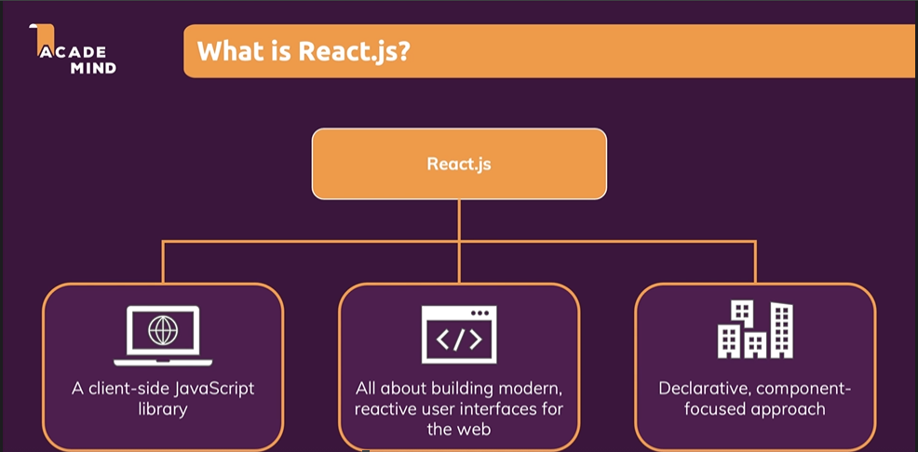

**Why React is preferred over JS?**

In javascript the code quite often becomes lengthy even for performing a small action (e.g., delete a work from to-do list). Moreover, we need to write every action in js (imperative approach: i.e., we need to do everything from creating a button to setting its text and all).

On the other hand, while working we react we only interact with the high-level code and write what we want as an end result in the form of small components which are rendered (or we can say the heavy lifting) by the react libraries. We basically write what we want to have in the form of HTML components. Moreover, if we want to add another to-do to the to-do list, we only have to copy the component and just change its parameter or name. In js, we would need to select the delete buttons specifically using the query selectors and then for each to-do check the window which is open and perform the action accordingly, whereas in the case of react we can just write the same component with a different to-do name and we are done.

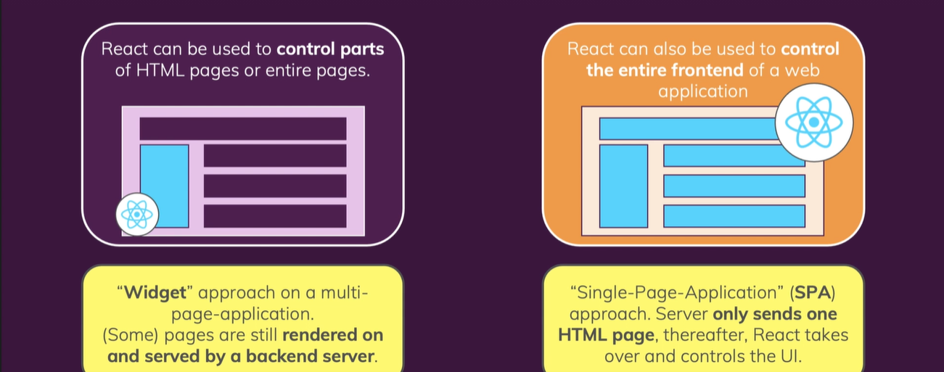

**Revising Javascript**

**1) Let and Const –** Earlier we only used var, however with the introduction of ES6, we now prefer using let and const. Const is mostly used for constant values and let is used for variable values. NOTE: if we assign a different value to a constant value which we have already defined, then the program throws an error.

**2) Arrow Functions –** Normal function syntax: function myFunc() {};

Arrow function syntax: const myFunc = () => {};

* It is shorter as it omits the function keyword.
* Solves issues with the ‘this’ keyword. Earlier it always didn’t refer to what we wanted it to be. Now it will always keep its context and not change during runtime.

If we only have 1 parameter, we can skip the parenthesis.

If we are returning something and it is the only thing we are doing, then we can further concise our code in 1 line as (remove return) : const myFunc = (num) => num*2;

**3) Imports and Exports –** Writing modular code across multiple files and then importing them to our html files in the correct order.

Default export: Default keyword while exporting means that if we import something from that corresponding javascript file then it will just be our default export. We can choose our own name while importing as it doesn’t matter because we are importing a default component.

However, if we are exporting multiple things and we are not using default, we need to write the name in {}. This will explicitly target specific things from the file (named exports). We have to use the exact name defined in the file with the export keyword.

A file can only contain one default and an unlimited amount of named exports.

**4) Classes –** Blueprints for objects. Has both properties (variables) and functions.

Example:

Class person {

constructor() {

this.name = ‘max’;

}

printMyName() {

console.log(this.name);

}

}

const person = new person();

person.printMyName();

Example of inheritance: *we need to add the* ***Super*** *keyword to call the super class constructor in the derived class.*

Class Human {

constructor() {

this.gender = ‘male’;

}

printGender() {

console.log(this.gender);

}

}

Class person extends Human {

constructor() {

**super(); executes parent constructor to correctly initialise the parent class**

this.name = ‘max’;

}

printMyName() {

console.log(this.name);

}

}

const person = new person();

person.printMyName();

person.printGender();

**5) Classes, properties and methods –** For properties: Instead of using the constructor and this keyword, we can directly write  **myProperty = ‘value’**. This will use a constructor in the background, however we don’t need to worry about it.

For modules: Now the next generation javascript way is to use the syntax from the left where you set up a property and simply think of a method as a property which stores a function as a value and then you end up with that.

My method equals and then an arrow function. The great advantage of this syntax is that since you use an arrow function as a property value here you've got no problems with the this keyword and that's the exact reason why we will use this syntax here.

Earlier – myMethod() {};

Now – meMethod = () => {};

We are no longer using constructor and no longer is the need for the super keyword.

Class Human {

**gender = ‘male’;**

printGender = () => {

console.log(this.gender);

}

}

Class person extends Human {

**name = ‘max’;**

printMyName = () => {

console.log(this.name);

}

}

const person = new person();

person.printMyName();

person.printGender();

**6) Spread and Rest Operator –** …

Spread – to take elements from previous array and add a 1 and 2 to it in another array. Used to split array elements or object properties.

const newArray = […oldArray, 1, 2]

const newObject = {…oldObject, newProp : 5} // add key-value pairs of old > new obj

Eg const person = {

name: ‘Max’

}

const newPerson = {

…person,

age: 28

}

Rest – used to merge a list of function arguments into an array. The dots are used here as rest operator and merges the arguments into an array and therefore, we can use the array methods on it.

function sortArgs (…args) {

return args.sort();

}

This will be used for both arrays and objects to for example conveniently copy arrays or add properties to an object whilst safely copying that old object.

**7) Destructuring** - Spread takes out all elements all properties and distributes them in a new array or object or wherever you're using it. Destructuring allows you to pull out single elements or properties and store them in variables for arrays and objects.

Easily extract array elements or object properties and store them in variables.

Array: [a,b] = [‘Hello’, ’Max’]

const numbers = [1,2,3]

[num1, num2] = numbers;

Object: {name,age} = {name:’Max’, age:28}

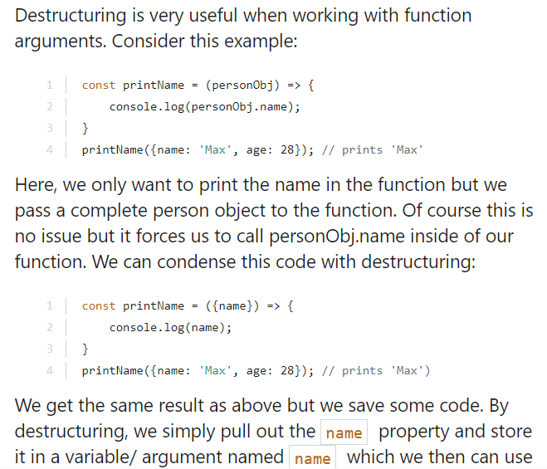

**8) Reference and Primitive types Refresh –**

Now numbers, strings, booleans, these are so-called primitive types whenever you reassign or you store a variable in another variable it will copy the value.  For example, if const num = 1 and const num2 = num, then num2 will create a copy of num. (copied value to num2).

Objects and arrays are reference tpyes.

const person = {

name: ‘Max’

}

const secondPerson = person;

I create my personal object which just has a name here and I now create a secondPerson and assigned person as a value here. If I console log. secondPerson and hit run, it will print the same value as the first person but it will not actually have copied the person instead. Person the object is stored in memory and in the constant person we store a pointer to that place in memory. And if we then assign person to secondPerson that pointer will be copied.

For instance, if we add the line:

const secondPerson = person;

person.name = ‘Harry’

console.log(secondPerson); // this prints harry even though we wrote the 1st line earlier

Even though I'm printing the secondperson so for secondPerson the name also changed the reason for it is that it just copied the pointer and points to the exact same object in memory as person does.

However, we sometimes need to create immutable objects which are real copy of another object and for that we use:

const secondPerson = { …person }; // spreads the properties of person object (copies the properties and not the entire object)

The spread operator is extremely useful for cloning arrays and objects. Since both are [reference types (and not primitives)](https://youtu.be/9ooYYRLdg_g), copying them safely (i.e. preventing future mutation of the copied original) can be tricky. With the spread operator you have an easy way of creating a (shallow!) clone of the object or array.

**9) Refreshing Array Functions -** We can take the numbers array and call map.

Map is a built-in array method.

All these methods work in the same way though they take a function as an input and this function which is an arrow function here but could be a normal function is then simply executed on each element in the array here. So on each element in the numbers array, on 1 and 2 and 3. So therefore what we get in this arrow function is a number in the end. We can then simply return something. And what you have to do in this internal function depends on which area of function you are using. So in the map function we have to return the new value we want to turn the old one into so we could return num * 2 and since this is executed on every element here.

Const numArray = [1,2,3];

Const doubleNumArray = numbers.map((num) => {

Return num*2;

});

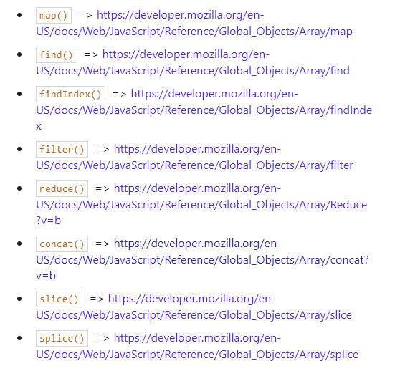

**React**

React is a javascript library for building user interface. We can make a website/UI without react, however react makes building complex, interactive and reactive UI simpler.

Less error prone and we can focus on our major core steps.

React is all about components. Components are re-usable building blocks in our user interface. Component is a combination of html, css and js. We make these smaller components and tell react how to compose them together to form a UI.

This helps in:

* Reusability of code.
* Separation of concerns. (we have small separate units and every component has 1 task it has to do rather than creating 1 file which holds all the logic for the complete UI).

HTML + CSS + JS => Component => (Combine them) => UI

Uses declarative approach. you will not tell React that a certain HTML element should be created and inserted in a specific place on the user interface as you would be doing it with Vanilla JavaScript, so with just JavaScript, for example. Instead with React and that's really important, you will always define the desired end state, the target state or possibly also different target states depending on different conditions and it's then React's job to figure out which elements on the actual webpage might need to be added or removed or updated. And you don't write these concrete DOM updating instructions on your own as you would be doing it with just JavaScript, instead with React and React components, you just define these end states and under which conditions which state should be used and then React will do all of the rest under the hood.

Node js is a runtime for js that allows us to run js outside the browser.

React code is js code that runs in the browser.

Package.json holds all the dependencies.

Src holds the actual source code.

Npm install looks into all the package.json file and download and install all the packages and dependencies. We didn’t do this earlier as it was included with create-react-app. However, since now we are installing a project from github, we need to run this once to install all the dependencies. (They are not a part of the zip file else they would just increase the zip file size). A node_modules folder is created which holds these dependencies.

**Analyzing a standard react project**

Index.js is the first file to be executed whenever the page is loaded. So whenever you visit local host three thousand here at the moment, this index JavaScript file holds to code which is executed initially. Though I will also say right away that it's not exactly that code but a transformed version of that code. Remember when I said that our project set up here involves some scripts which transform and optimize the code, yeah, that is happening behind the scenes. Basically we will write to code, in a easy to read developer friendly way with some syntactic sugar, which makes our life as a developer easier, but we'll write code which wouldn't run like this in the browser, and especially not in all supported browsers. Therefore the npm start process, which we started here, which started this development server, which is watching our code, this process will not just watch our code and then take it and deliver it to the browser, but before it delivers it, it will transform it. So that certain extra features work in the browser, even though they wouldn't work, if just this code would be taken. For example, this import here where we import a CSS file into a JavaScript file. That's not something which would work in regular JavaScript, that would be an invalid syntax. You can't import CSS into JavaScript. Well, here in this project set up, it does work. Here in the end, it tells this npm start process we could say, that we simply want to include this index CSS file into our overall application.

Import reactdom from ‘react-dom’ means importing an object from a 3rd party installed library. React and react-dom dependencies/packages together form the react library.

Reactdom.render is used to call a method on the imported reactdom object.

Reactdom.render(<App />, document.getElementById(‘root’); // The second argument is a default JavaScript DOM API which we're calling on the global document object, which is a way to blend JavaScript in browser site JavaScript.

Well, there also is a public folder which I haven't talked about this far. This folder is a folder in which we will rarely work, but it holds one important file. This index.html file. This is the single HTML file, which is in the end loaded by the browser here because with the React we build a so-called single page application at least typically. And I talked about that in the first core section. It basically means that only one HTML file is delivered to the browser and hosted by the browser day or for rendered by the browser. But on this single file, we import the finished React application code and it's start code which then updates what we see on the screen. So we have one HTML file, but what we see on the screen constantly changes because of React.

So, basically we are telling ReactDom, that we want to render something **<App />** in **The div which exists in index.html with class = root**. So basically, the content of the div should be replaced by the content within the App.

NOTE: this syntax of **<App />** is **JSX** and moreover, this app is a component.

As I mentioned in modern Java script, if you have something like a function or a class or an object defined in one file and you want to use it in another file you have to export and import it. So here, in App.js where this function is defined, we export it, and then we imported in index.js. And that's how these two files are connected and how we can use a feature in this case a function to find an App.js inside of index.js.

**JSX**

The html inside javascript is working because of the transformations running behind the screen by the npm-start command. Hence, we can write this JSX syntaxed code which isn’t supported by the browser, however due to the transformations it gets converted to browser supported code which is quite lengthy and cannot be written by us.

**How react works**

We have this HTML-ish code here in this App function. And we have that code here because with React, we ultimately built our own custom HTML elements as you learned. We built those components and a component is basically just a custom HTML element. And we do that with this **declarative approach**, as I mentioned, which means with React we defined the desired target state and React is then responsible for generating and running the actual DOM instructions which update what's visible on the screen. And we can see this here. This here is our desired target state. **We want to render a div with an h2 tag with this text inside of it on our screen**. Because in index.js, we rendered as App component, this custom App HTML element, you could say, and inside of this custom element, which turns out just to be a function, more on that in a second, inside of that, we in the end just return this HTML code. So therefore ultimately, it's this HTML code which is rendered on the screen

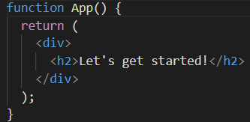

In react we simply write **<p> This is also shown </p>** to display something. However, in vanilla js we need to write: (**imperative approach** as we are giving complete instructions what javascript and the browser needs to do)

Const para = document.createElement(‘p’);

Para.textContent = ‘This is also shown’;

Document.getElementById(‘root’).append(para);

The above is an **imperative approach** as we are giving complete instructions what javascript and the browser needs to do.

With React instead, we just define the desired end state, that we want a div, an h2 tag, and a paragraph, and React will then generate these instructions behind the scenes to bring that onto the screen.

**Building the first component**

It is a good practice to put new components in a new file so that we have 1 component per file. Our app.js will be a different component in a manner that it will be the root component, or we can say the main component being rendered in the index.js file. Other components will be either nested in app.js or within each other and finally in app.js.

Big application state for, of course can result in quite big Component Trees where only the top most Component is rendered directly into the HTML page, with help of that React dom render instruction. All the other Components will not be rendered with this instruction but instead will be used as regular HTML elements inside of our HTML code, inside of our Components.

**How is a component written in react?** We just saw that it is a function. **A component in react is a javascript function.** A special kind of function special regarding what it returns that it does return this JSX code, but other than that, it's just a Java script function.

***Components are just functions which then return HTML code.*** And of course the HTML code do you do return in a Component depends on what the Components should render on the screen.

We export components so that they can be used within multiple files.

import ExpenseItem from "./components/ExpenseItem";

This path in the end tells JavaScript that we're looking for expense item file

in a Components folder which sits next to this app JS file in which we have does import statement.

Now that this is imported, the cool thing is that we can just use this like an HTML element. So we can, for example, replace this paragraph with expense item like this opening and closing written like this.

<ExpenseItem></ExpenseItem>

The key difference to the built in HTML elements just is that it's not starting with a lowercase character, but with an uppercase character. And indeed your own custom Components must start with an uppercase character when you're using DOM JSX code like this, so that React is able to detect that this is a custom Component. Because the simple rule which React applies is that lowercase elements are built in HTML elements. So it will look for them as built in elements. Whereas elements starting with an uppercase character are elements defined by you or some other developer.

You create a Component, which is in the end, just a function of returning some HTML code, you then export it. And then ultimately you import it in the file where you wanna use it so that they're in the JSX code, you can use it like an HTML element, just starting with this uppercase character.

However, one thing to note regarding the HTML, the JSX code that we return inside the component, we must only have 1 root element per return statement.

For example we cannot write: return <div> </div> <div> </div> as we are having 2 root elements. We can write this as a wrapped up <div> <div> </div> </div>.

Or by also wrapping this all in brackets, simply to signal to JavaScript that this is one and the same statement, even if it should span multiple lines.

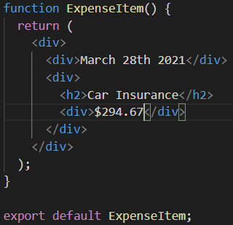

So inside of this main div, which we returned here, you may then have multiple elements and the divs elements then, also maybe side by side, as you can tell. It's really just the root element in a JSX code snippet like here, when we return it, which must only be, one element, instead of multiple, side-by-side elements.

To add classes to the div, we write **className** and not **class** like we do in regular HTML. This is because we are not actually using HTML within the component, but JSX and under the hood its still javascript code. The class attribute here is renamed as the className attribute because class is a reserved keyword in javascript.

**Random Note: A component is typically a function which is the combination of HTML, CSS and JS.**

**Replacing with dynamic data**

The special thing about {} is that, within our JSX code, if we use {}, we can run our basic javascript expressions. For eg {1+1} will be executed as 2 on the output when we write it in place of car insurance. Hence, we are performing basic javascript inside JSX with the help of {}.

Here, we are referring to the value stored in the constant and hence we can just point to that constant. This is also a valid JS expression. Now JS will extract the value stored in the constant and inject it here into the html code.

Instead of hardcoding the information, we can use the {}.

Instead of writing the following code,

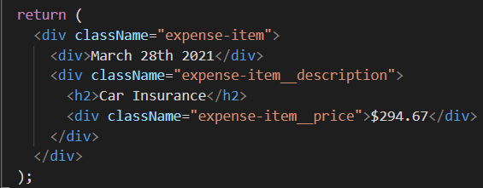

we can write the following.

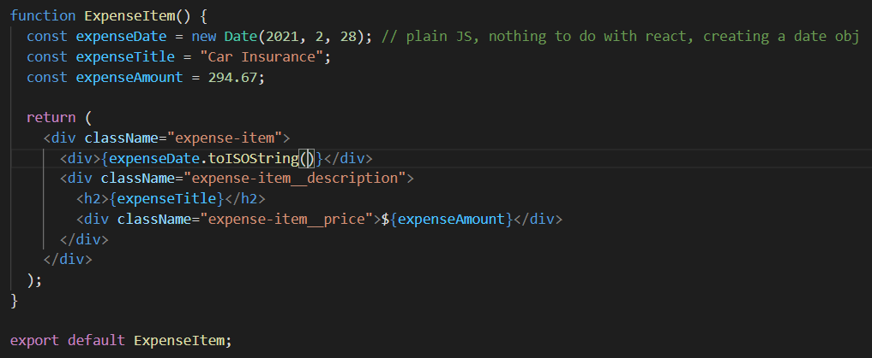

So if I now save that, we again see car insurance here just like before but now it's not hard coded in the HTML code but instead here its output dynamically and the concrete value is taken from that constant. There of course it's still hard coded, but it's just a first step.

NOTE that here expenseData is a date object and hence we cannot output it as text directly. Hence, we used the toISOString method which helps to print date objects as string.

We now no longer work with hard coded text in our HTML code but instead we have these dynamic placeholders, you could say. Where the concrete value can be the result of a calculation of a HTTP requests or as it is here at the moment the value stored in a constant or variable.

So that it's not always the same data which we're outputting. And so that we can have multiple expense items based on one of the same component with different data.

**Passing Data via Props**

Re-using the component is quite simple.

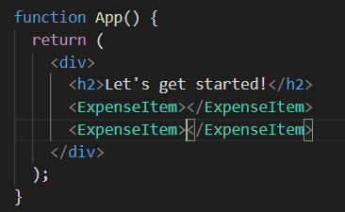

But, of course, at the moment it's not really reusable. Yes, it's technically more than once, but it's always displaying the same data. And the reason for that is that the data is baked into this component.

Just like we use parameters for function in js, we can use props for components to make then re-usable.

However, components cant just use data stored in other components (eg value of a constant stored in another component). Hence, we use the concept of props. Our custom components can have **attributes** which can store these values. This concept is known as **props.** We can set properties (props) of our own custom component.

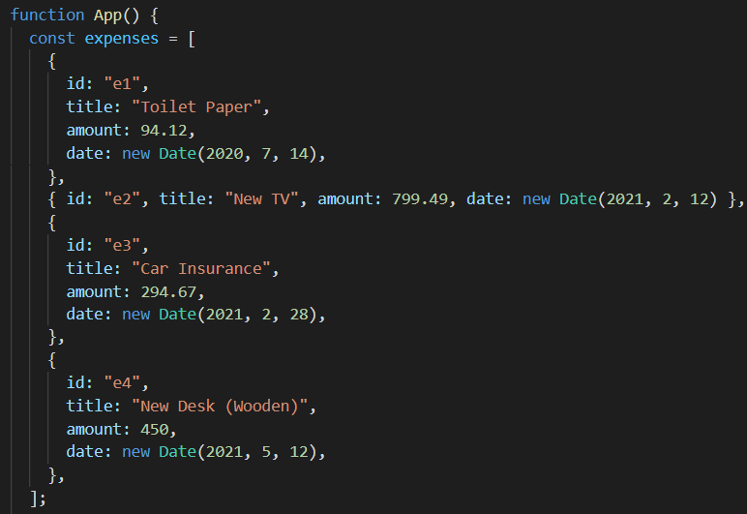

We have 4 objects inside this array and we pass the data of these different objects to the expenseItem component. We want to make these expenseItem configurable from outside, i.e., the data should not be stored within them, rather outside.

**SideNote : Components are also referred to as Custom HTML elements.**

Expenses is the array, it has 4 objects, title/amount/date are object properties.

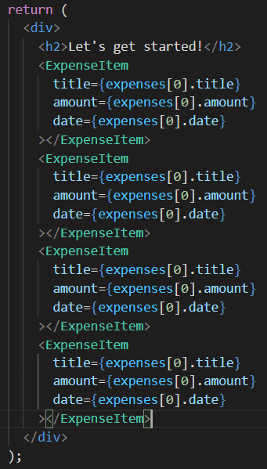

Note that here we have again used **{}** for assigning values to the attributes within the components. Hence, **{}** can not only be used within the opening and closing tags, but also to assign values to attributes.

Expenses[0].title // expenses array has 4 objects/items and we are accessing the title property of the first object from the expenses array.

But inside of that component code, so inside of ExpenseItem.js, we also now need to do something with these received attribute values, and that's the half which is missing. Now, the question is how do we get access to the values defined in the place where we use our custom components?

And the answer is parameters. However, we're now not getting a title and an amount and a date parameter, as you might think, but, instead, we get one parameter. React will ensure that we get one parameter in every component which we use as a component, like we're doing it here for ExpenseItem. And that one parameter will be an object which holds all the received attributes as properties, hence the name props for the overall concept.

Hence, **props** here used as a parameter inside the ExpenseItem component, is an object which holds all the values we get for the attributes on our custom element / component.

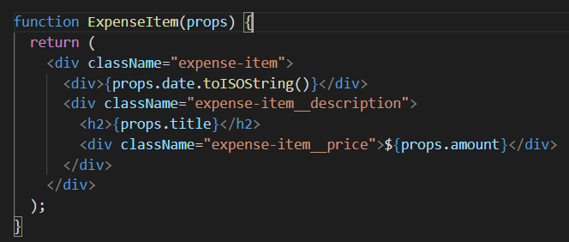

**NOTE : if we have named title/date/amount in our app.js, we have to use the same name while accessing them in ExpenseItem.js, i.e., we have to write props.title. We cannot write props.name or any other mismatched thing.** But, of course, you typically wanna choose prop names and therefore attribute names which are self-explanatory and which makes sense.

Props is a super important concept because it allows you to make your components reusable, and it allows you to pass data from another component to this component.

**The main idea behind props is to pass data into our components to make them usable.**

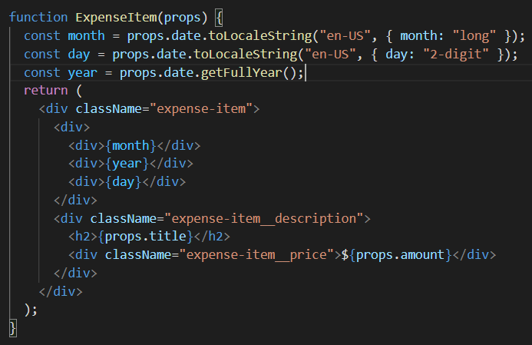

This is our code till now, however we now split the date component.

**Splitting components into multiple components**

Every component focuses on a single core task and then later these are combined to form our UI. This allows us to keep the code simple for a particular component and still be able to generate complex user interfaces.

Split this ExpenseItem component here into two components, the ExpenseItem component which we already have, and then a new component for rendering this date in this calendar item.

**NOTE: Components in react are just functions with a twist of returning JSX code.**

This allows us to keep the expenseItem component clean and we can moreover use this date component separately within other components in our program.

**App.js**

import ExpenseItem from "./components/ExpenseItem"; // This path in the end tells JavaScript that we're looking for expense item file

// in a Components folder which sits next to this app JS file in which we have does import statement.

function App() {

  const expenses = [

    {

      id: "e1",

      title: "Toilet Paper",

      amount: 94.12,

      date: new Date(2020, 7, 14),

    },

    { id: "e2", title: "New TV", amount: 799.49, date: new Date(2021, 2, 12) },

    {

      id: "e3",

      title: "Car Insurance",

      amount: 294.67,

      date: new Date(2021, 2, 28),

    },

    {

      id: "e4",

      title: "New Desk (Wooden)",

      amount: 450,

      date: new Date(2021, 5, 12),

    },

  ];

  return (

    <div>

      <h2>Let's get started!</h2>

      <ExpenseItem

        title={expenses[0].title} // these are props

        amount={expenses[0].amount}

        date={expenses[0].date}

      ></ExpenseItem>

      <ExpenseItem

        title={expenses[1].title}

        amount={expenses[1].amount}

        date={expenses[1].date}

      ></ExpenseItem>

      <ExpenseItem

        title={expenses[2].title}

        amount={expenses[2].amount}

        date={expenses[2].date}

      ></ExpenseItem>

      <ExpenseItem

        title={expenses[3].title}

        amount={expenses[3].amount}

        date={expenses[3].date}

      ></ExpenseItem>

    </div>

  );

}

export default App;

**ExpenseItem.js**

import ExpenseDate from "./ExpenseDate";

import "./ExpenseItem.css"; // We explicitly have to tell React, you could say, or that build process that a certain file should be considered.

function ExpenseItem(props) {

  return (

    <div className="expense-item">

      <ExpenseDate date={props.date}></ExpenseDate>

      <div className="expense-item__description">

        <h2>{props.title}</h2>

        <div className="expense-item__price">${props.amount}</div>

      </div>

    </div>

  );

}

export default ExpenseItem;

**ExpenseDate.jss**

import "./ExpenseDate.css";

function ExpenseDate(props) {

  const month = props.date.toLocaleString("en-US", { month: "long" });

  const day = props.date.toLocaleString("en-US", { day: "2-digit" });

  const year = props.date.getFullYear();

  return (

    <div className="expense-date">

      <div className="expense-date__month">{month}</div>

      <div className="expense-date__year">{year}</div>

      <div className="expense-date__day">{day}</div>

    </div>

  );

}

export default ExpenseDate;

**NOTE: Here we have passed the date prop to our ExpenseDate component using the ExpenseItem component.** This is because we are funnelling our data through multiple components. Now we don’t just have an app component and another component, but rather a set of nested components. Therefore, inside the app component we are using the ExpenseItem component, and within the ExpenseItem component we are using the ExpenseDate component. We have forwarded the data with the use of props.

**Assignment 1 Solution**

**ExpenseItem**

import ExpenseItem from "./ExpenseItem";

import "./Expenses.css";

function Expenses(props) {

  // object of an array

  return (

    <div className="expenses">

      <ExpenseItem

        title={props.item[0].title} // these are props

        amount={props.item[0].amount}

        date={props.item[0].date}

      ></ExpenseItem>

      <ExpenseItem

        title={props.item[1].title}

        amount={props.item[1].amount}

        date={props.item[1].date}

      ></ExpenseItem>

      <ExpenseItem

        title={props.item[2].title}

        amount={props.item[2].amount}

        date={props.item[2].date}

      ></ExpenseItem>

      <ExpenseItem

        title={props.item[3].title}

        amount={props.item[3].amount}

        date={props.item[3].date}

      ></ExpenseItem>

    </div>

  );

}

export default Expenses;

**App**

//import ExpenseItem from "./components/ExpenseItem"; // This path in the end tells JavaScript that we're looking for expense item file

// in a Components folder which sits next to this app JS file in which we have does import statement.

import Expenses from "./components/Expenses";

function App() {

  const expenses = [

    {

      id: "e1",

      title: "Toilet Paper",

      amount: 94.12,

      date: new Date(2020, 7, 14),

    },

    { id: "e2", title: "New TV", amount: 799.49, date: new Date(2021, 2, 12) },

    {

      id: "e3",

      title: "Car Insurance",

      amount: 294.67,

      date: new Date(2021, 2, 28),

    },

    {

      id: "e4",

      title: "New Desk (Wooden)",

      amount: 450,

      date: new Date(2021, 5, 12),

    },

  ];

  return (

    <div>

      <h2>Let's get started!</h2>

      <Expenses item={expenses}></Expenses>

    </div>

  );

}

export default App;

**Components are custom HTML elements where we combine html or jsx code, styling and extra javascript logic (eg expensedate outside return).**

**Composition**

Generally, this approach of building a user interface from smaller building blocks is called composition.

Now we got this card container component you could say, which should act as a shell around either our ExpenseItem content or our Expenses content. And that's the key. This card component will now not be configured through some attributes. Instead, my idea would be that, let's say in ExpenseItem, we can simply replace this built-in div with our custom card component. And then we get these predefined styles for the card automatically.

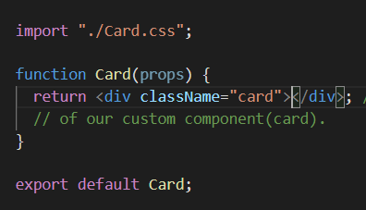



The thing just is if I save that, you will see that all the expense items are lost. And the reason for that is that out of the box, just like that, you can't use your custom components as wrappers around other kind of content. Having content between opening and closing tags doesn't work just like that.

To solve this, we use childrens prop within our card.js component. Children, as I said, is a reserved name and the value of this special children prop will always be the content between the opening and closing tags of your custom component.

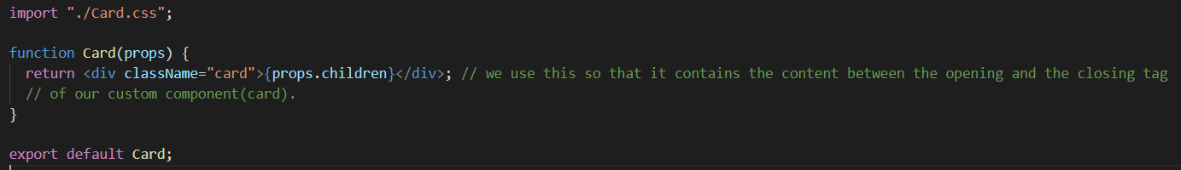

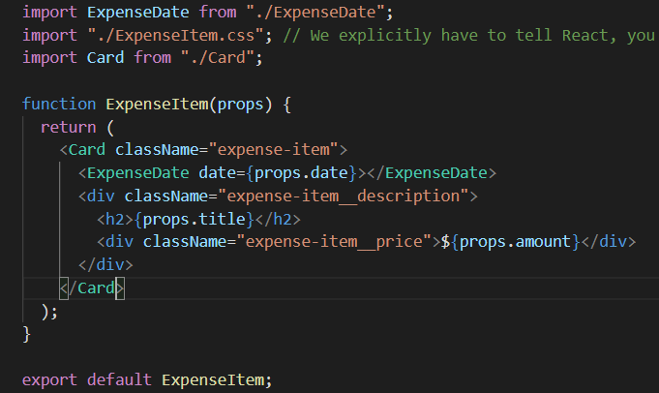

Note the usage of card component.

The corresponding output is:

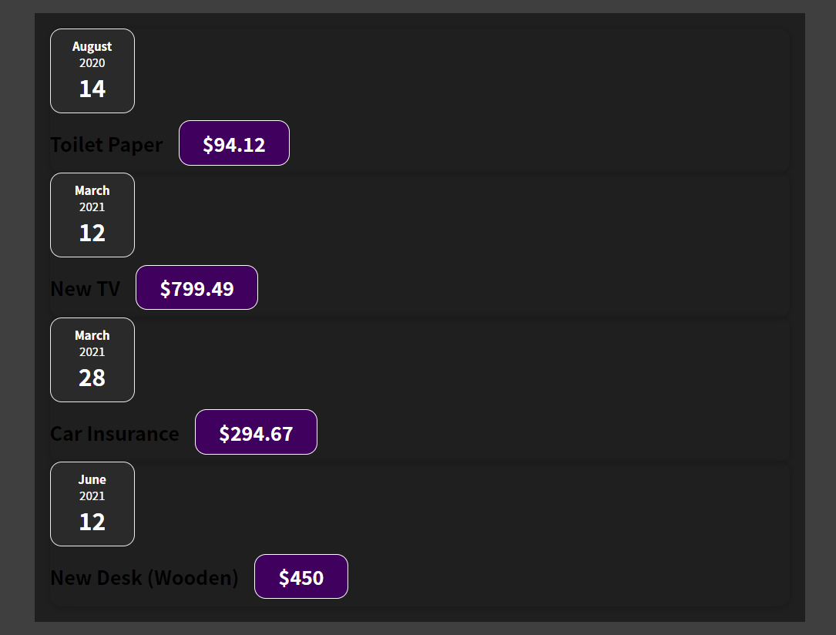

However it's also a bit broken. And the reason for that is that I extracted some styles which ExpenseItem and Expenses had in common, but I had more styles to find for expense items and these styles are important. But they're missing now. I am setting a class name prop on card here but you must not forget that card is now a custom component defined by you. All the default HTML components out of the box supports class name for adding CSS classes to the rendered HTML elements. But your custom components only support what you tell them to support. So if you wanna make sure that a class name can be set on your card component and then has an effect, we have to tweak the code in the card component.

So here we could add a classes constant which is card as a default class which is always applied, white space plus props.className. So now anything we receive as a class name from outside is added to that string. And here we can then dynamically point at this class, this constant. So with that, we're now making sure that any value set on the class named prop is added to this long string of class names which is then finally set on the div inside of the card. Hence, we now have a re-usable wrapper component.

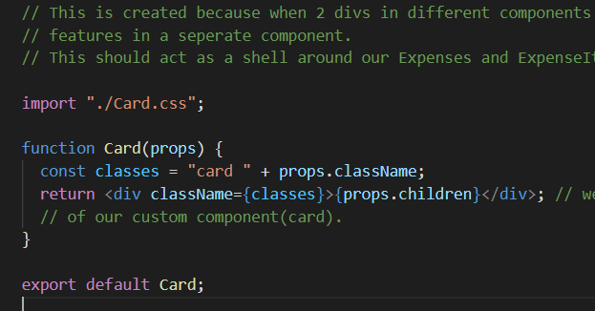



Hence, we are successfully able to extract code duplication from the CSS files into our wrapper content. **NOTE: children is a reserved keyword.**

With all these components, which we are building, in the end we're just splitting up our code across multiple files and building blocks so that if we want to have more than one expense item, we can just use our custom ExpenseItem component multiple times instead of repeating all that code multiple times, that's the idea behind components.

These custom components are not really HTML elements, which end up on the screen, you just use them in your code in your React code, in your JSX code. What ends up on the screen are just the HTML elements because, ultimately, every custom component you build either uses these built in HTML elements or it uses another of component which, at some point, if you drill into your components deeply enough will end up using these built in elements.

**Separate NOTE: We needed react import in the past because this JSX code, as I mentioned, is just syntactic sugar. And under the hood, it has actually transformed two methods called on this React object, which is why we needed to import React in the past.**

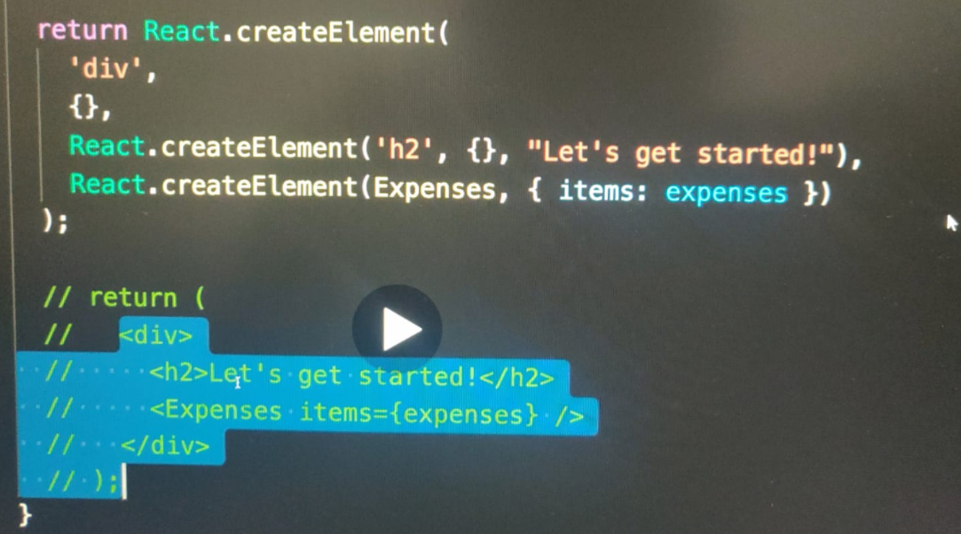

**First the code is transferred to this and then more transformation is done under the hood.**

**That’s the reason we need a wrapper like div to return multiple things**. **That's why you always need such a wrapper, because in createElement world, you always create one element which then may have more child elements.**

**Section 4**

**React State and working with Events**

Declarative approach – define the desired target state and let react figure out the actual javascript DOM instructions.

And if we click on Element, for example, we actually will see that there are a bunch of events to which we can listen, for example, click and blur. And basically, for all these default events, there is a prop equivalent in React, which we can add to these built-in HTML elements to listen to these events. So instead of adding a listener as we would normally do it, by for example selecting an element by ID and then adding an event listener like this,

*document.getELementByID(‘root’).addEventListener();*

which would be the imperative way of doing that, in React, we add an event listener by going to the JSX element, like this button. And there we add a special prop. But now it's not a prop which sets some value for this button, but instead it's a prop which starts with on. Because React exposes all these default events as props which start with on. And for example, here we can add onClick. Now, what this does is it adds an event listener for click events to this button. Now we just need to define what should happen when such a click occurs. And we do that by assigning a value to this click event. And the value here, and that's now important, of course, has to be code which should be executed when that click occurs. And how do we define codes that should eventually be executed in programming? Well, we create a function.

*<button onClick = { () => {console.log(“Hi”)} }> Change Title </button>*

**So all these on props, all these event handler props, want a function as a value, a function passed as a value for onClick and all these other on props which then is executed when that event occurs.**

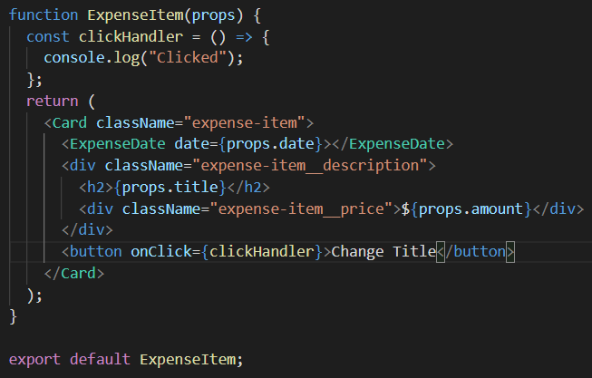

**NOTE: We don’t write {clickHandler()}, rather we point simply to its name, i.e., {clickHandler}. This is because, if we add (), javascript will execute the function when the line is parsed, i.e., when the jsx is returned and not when the click occurs but rather when the jsx is returned (which is too early). Hence, we just point at that function and react executes that function whenever the onClick event occurs.**

**How component functions are executed and values are changed**

We can store the props.title value in a variable and since it is a variable, we can now change its value using the eventHandler function whenever the button is clicked. However, this does not work.

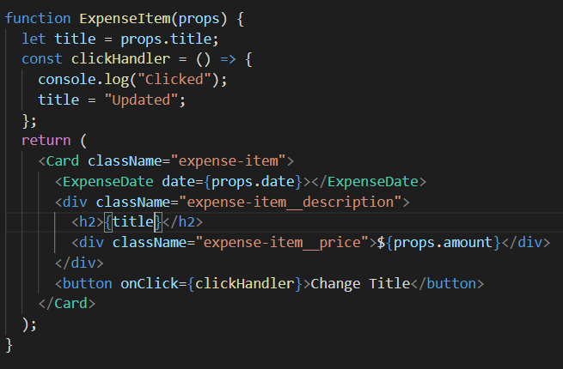

The components are just special functions which return JSX. Now since it's a function someone has to call it, and you might notice that we never called our component functions, instead we just used these functions like HTML elements in this JSX code. Well, the thing is, under the hood this is almost like a function call. By using our components in JSX code, we make React aware of our component functions.

For example here, we make react aware of the expense item function. And whenever react evaluates this JSX code, it will call these component functions. And these component functions stand to return JSX code, which is all the evaluated, up until there's no more JSX code to be evaluated. So react keeps on calling any component functions it encounters in JSX, then calls any functions that those functions might have returned so any elements those components might have used in their JSX code until there are no more functions left. So in the case of expenses.js, if react encounters this expense item, it calls this expense item component function, executes all the code in there, encounters this JSX code and calls this card function and this expense state function and then it goes through the JSX code of this components until there's no more component code left to call. And then it re-evaluates the overall result and translates that into DOM instructions which renders something like this on the screen. That's how react works. Now it's all started by the index.js file, where we initially point at this app component. That's the first component function which is being called and that happens when the react app is been loaded on the screen which happens when the page is been visited. So that's how react goes through all these components executes all these components functions and draws something on to the screen. The only problem with that is, that react never repeats that. React goes through all of that when the application is initially rendered, but thereafter it's done. However, in modern applications, of course you sometimes want to update what's visible on the screen, for example because a button was clicked and that button should change some text which is being output. So, we need a way of telling react that something changed and that a certain component should be re-evaluated and that's where react introduces a special concept called state.

**Working with State**

Because this title here which changes when the clickHandler executes is actually data that should result in this component being re-evaluated (this component is return under it) and re-drawn on the screen when it's changes, when that's title data changes.



And by default, regular variables like this one (title), are not triggering such a re-evaluation. React doesn't care about that. If you have a variable in your component function and the that variable changes, React ignores it. It doesn't care about that, that code executes, sure, but the overall component function doesn't execute again just because some variable changed.

This ExpenseItem component function currently is not called a second time after the initial rendering just because a click occurred or because a variable changed does not trigger this component function to run again.

So, we want to import a function from the react library. (using named import)

This is a function provided by the React library and this function allows us to define values as state where changes to these values should reflect in the component function being called again, which is a key difference to the regular variable we're using here.

**Usestate is a react hook. All these hooks must be called inside the react component functions like ExpenseItem. They can't be called outside of these functions, like this (where we write normal js, when we define const variables before return) . And they all just shouldn't be called in any nested functions (like in clickHandler). They must be called directly inside such component functions.**

Now, useState doesn't work just like that. Instead, useState wants a default state value, because with useState we basically create a special kind of variable, you could say, a variable where changes will lead this component function to be called again. Hence, just like we assigned an initial value for the **regular variable let title,** we assign an initial value for the special variable **useState(props.title);** This creates the special variable.

Hence, useState returns 2 things, a special variable which we can use and also a function which we can call to assign a new value to that variable. Array where 1st is variable then fn.

So we'll not be assigning values like this with the equal sign (**let title = “Hello”)**, instead, we will be assigning new values by calling a function. That's just how this state variable thing works. And for that useState actually returns an array where the first value is the variable itself, you could say, the value itself. And the second element in the array is that updating function. And we can use a modern JavaScript feature called array destructuring, which looks like this, **(const [title, setTitle] = useState(props.title);)**

The first element, as I just said, is a pointer at that managed value. So initially at props title, the value stored in props title, and the second element here is a function which we can later call to set a new title. These are the 2 elements returned by the useState.

And useState, this hook, always returns an array with exactly two elements. The first element is the current state value. And the second element is a function for updating that.

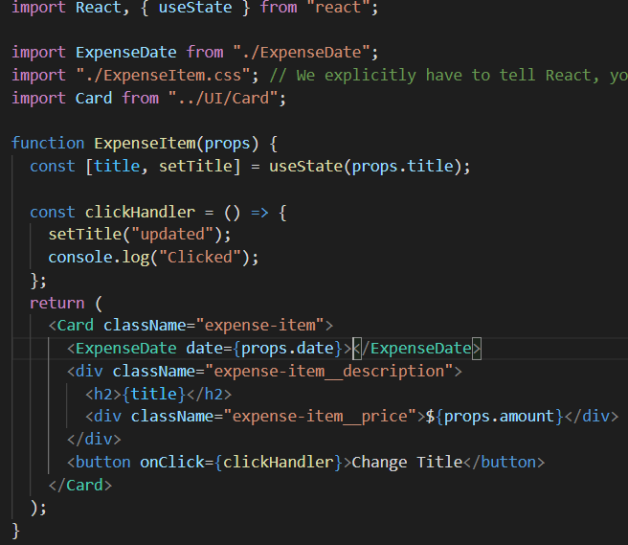

Now, as I said, with the value returned by useState, we're not going to assign a new value with an equal sign. Instead, we assign a new value by calling setTitle. So by calling this state updating function and then we just passed a new value as argument, in this case updated.

**Now, why does it work like this though? Why do we have this state updating function instead of assigning a new value like this? The reason for that is, that calling this function does not just assign a new value to some variable, but that instead it is a special variable to begin with. It's managed by React somewhere in memory. And when we call this state updating function (setTitle() is the state updating function) , this special variable will not just receive a new value but, and that's important, the component function in which you called this state updating function and in which you initialized your state with useState will be executed again. And that is exactly what we need. We want to call this component function again when our state changes. And by calling this state updating function that's happening. Because by calling this function, you're telling React that you wanna assign a new value to this state. And that then also tells React that the component in which this state was registered with useState should be re-evaluated. And therefore React will go ahead and execute this component function again, and therefore also evaluate this JSX code again. And then it will draw any changes which it's detects compared to the last time it evaluated this onto the screen.**

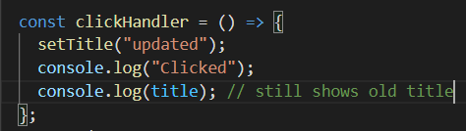

Now you will notice that these console locks still show the title before it was updated. The reason for this is that calling this state updating function actually doesn't change the value right away, but instead schedules this state update. So in the very next line thereafter, this new value isn't available yet. That's why we see the old value being locked even though we updated it before logging. But you do see that eventually this component is called again and is evaluated again. And that therefore we see our updated value on the screen.

**And this is another key concept in React. If you have data, which might change, and where changes to that data should be reflected on the user interface then you need state because a regular variable will not do the trick with state, however you can set and change values. And when they do change, React will re-evaluate the component in which the state was registered. And only that component, by the way not any other components, just this component in which this state was registered.**

**With useState we create a special variable, a variable where changes will cause the component function to be called again.**

**A closer look at Use State**

UseState registers some State, so some value as a State for the component in which it is being called. And I wanna be even more precise here. It registers it for a specific component instance. For example, ExpenseItem here is being used four times, right? And Expenses.js we have four ExpenseItems. Now, every item receives its own separate State which is detached from the other States. We have one ExpenseItem definition here, but then this function is basically called four times when we create four ExpenseItems. And every time it's called, a new separate State is created of course in the same way but managed independently by React. So if we change the title in the first ExpenseItem the other ones are not affected because they have their own State. That's really important. It's on a per component instance basis. So we have separate States, even if we create a component more than once.

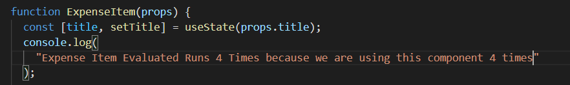

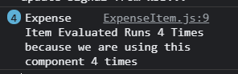

Now, in addition, whenever State changes because we click a button in this case it's only this component function and only that specific instance where this component is being used where React will re-evaluate it. And you can tell that this is the fact if you add a number of console.log here in the component, function itself, where you say ExpenseItem evaluated by React. This will be called whenever the ExpenseItem component function is being executed. And therefore if I reload, we see it's called four times which makes a lot of sense because we're using ExpenseItem four times in expenses. So four separate instances of this component are being created. But if I now click on change title in one of the ExpenseItems, we see it's only printed once. Which is basically happening because of what I just explained. Only that specific instance is being updated and therefore for being re-evaluated, and the other instances are not effected by that State change. And that's important to keep in mind that State really is separated on a per component instance basis.

One more thing is, we used const [title, setTitle] even though we change its value. This is because react is changing its value under the hood when we call the state updating function.

When setTitle is called, the component is rerendered/re-evaluated and the line **const [title, setTitle]** also, and hence we fetch the newly updated title value.

Also the initial value which we provide as , const[title,setTitle] = useState(**props.title),.**

And here, the special thing is that React keeps track of when we call useState in a given component instance for the first time. And when we call it for the first time ever, it'll take that argument as an initial value. But if a component is then re-executed because of such a State change **(setTitle(“Updated”))**, for example, React will not reinitialize the State. Instead, it will detect that this State had been initialized in the past, and it will just grab the latest State which is based on some State update, for example, and give us that State instead. So this initial value is really only considered when this component function is being executed for the first time, for a given component instance.

**In a nutshell, using State is simple though. You just register State with useState, you always get back two values; the value itself and the updating function. You call the updating function whenever the State should change, and you use that first element whenever you wanna use the State value, like here for outputting it in the JSX code. And React, will do the rest and it will re-execute the component function and re-evaluate the JSX code therefore; whenever the State changes. That's State and that's an important concept because it's State which adds reactivity to our application. Without State, our user interface would never change. But with State and with listening to events, we can make sure that we can react to user input and that such input can result in a visible change on our screen.**

**Adding Form Inputs**

NewExpense component is made to return a form, a form for our inputs.

At the end we import the component to App.js where we are combining all the components.

Now we need to add listeners to listen for every change of input. And you'll learn that you can do that, on the element where you wanna add a listener. So for example, on this input here by adding a prop that starts with "on" and then the question just is to which event you want to listen. Now we could listen to on input and therefore react to basically every keystroke, but there also is the just the on change event which basically does the same here. It will also trigger on every keystroke, but the advantage of the on change event is that we can for example use that same event for all inputs types. For example, all the four Dropdowns. So here I will add on change this event listener to this input or this prop, to this input and under the hood, this will then add an event listener for the change event to the input element which is rendered in the DOM. And then we need to point at to code at the function that should be executed when that event occurs. Now, you'll learn that we can define it in line here with function or with an arrow function, but that it's better to define it upfront. And therefore that's what I'll do.

**onChange is Prop for the particular input element it is used for.**



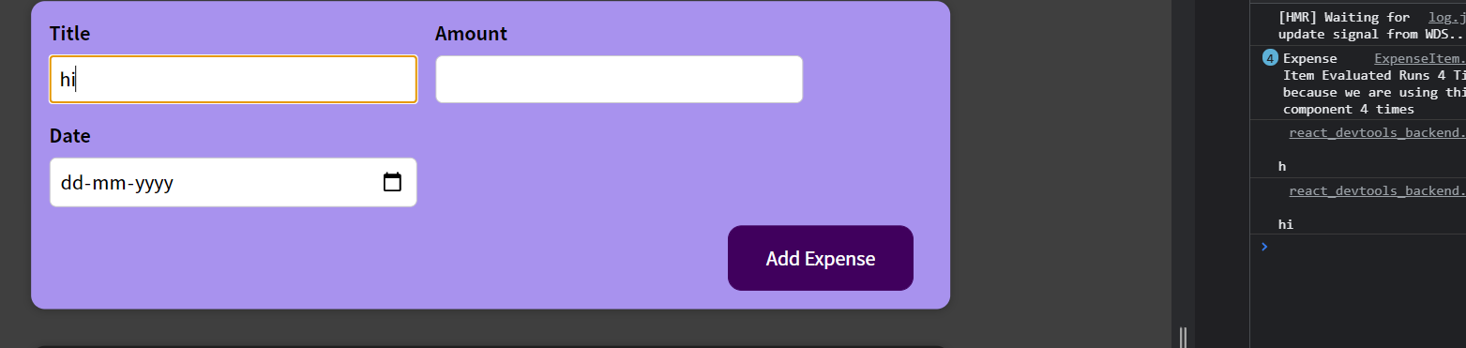

Now that's great, but typically we wanna get the value the user entered. And the question now is how can we get that value? Which possibilities do we have here? And the answer is quite trivial. At least if you know Vanilla JavaScript. So JavaScript without react. If you would add an event listener, to some element in Vanilla JavaScript like this, then you would listen to let's say the click event and in the function which you pass as a second argument, which by the away is basically the function you pass as a value to this prop. There, you automatically get an event object which describes the event which occurred. That's a default JavaScript behavior, you get in the browser when you listen to events. And we get this default event object here as well. Automatically, we don't need to do anything to get this. Since we passed this function to react basically, CRUD is on change prop, react will make sure or actually even the browser itself will make sure that we get such a event object when this change event occurs. Now we can lock this object to see what's inside it. So I'll lock this event argument. And if I now reload and I start typing, I get to does object here. And this object has a bunch of data. The interesting thing for us is this target field here. This target here simply points at the DOM element for which the event occurred. So in this case this input, and this input element in turn has a long list of properties which we can read and set. But most importantly for us, it also has a value property. And this value property, holds the current value of this input. At the point of time this event occurs and that's super useful because that means that we can drill into this target. And then this value I just showed you to get the value which was currently entered when that event occurred for that element on which we're listening. So now if I reload, you'll see that I get the current value with every keystroke and that's super useful. Now we got this value.

**Working with Multiple States**

The question now is what do we want to do with that value? What's the goal now? And the answer is, well, we want to make sure that we store it somewhere so that when later when the form is submitted, we can use that value. Because of course, we want to gather all the values for all inputs and then combine them into an object when the form overall is submitted.

To make sure that we store the value and that it survives if that function would be re-executed and the component would be re-evaluated, we can again, use State.

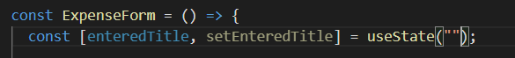

Initially we set it to empty string ‘’ because when the component is rendered for the first time, nothing is entered.

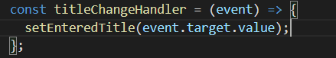

So the currently entered value as a parameter, as argument, to setEnteredTitle. And therefore this will be stored in our State. Now, here I'm not really doing it to update this component though the component will update. That will always happen when you update the State but I'm doing it to ensure that we're storing this in some variable, which is kind of detached from the life cycle of this component function. So that no matter how often this component function might execute again, this State is stored and survives.

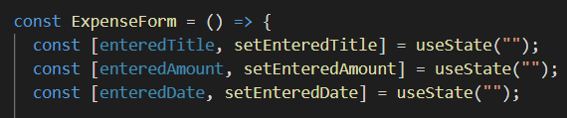

We can have more than 1 state per component and within that component also these state will be separated/independent of each other. When I update amount it doesn’t effect rest.

**NOTE: event.target.value always stores a string.**

**Using one state (and whats better)**

We added multiple state slices last time. However, there is also an alternate.

We can say that all 3 states are related to our forms as we store user input and it’s the same concept.

We can create a single useState. We have to now pass an object as a value and not a string. In this object we can now group together our three states. you could have a title key, or maybe alter it entered title key, And that holds an empty string initially.

The difference now, of course is that whenever you update this state you need to update all three properties and not just one.

And now when, the user enters a title, you wouldn't store it like this,

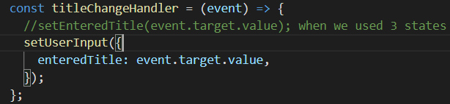

but you would call set user input.

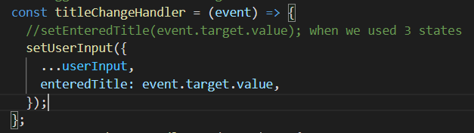

And in the end here, you then want to pass in a new object where you set the entered title in this case to event dot target dot value. But that's not the tricky part where you also ensure that the other two pieces of data don't get lost. If you would just set your new user input state to this object, you would basically dump the Abra keys because when you update your state react will not merge this with the old state. It will simply replace the old state with the new one. And if your new one is a object with one key value pair here the old state will be replaced and therefore The other are two key value pairs for amounted to date would be lost. So if you go for this one state approach and you manage such a object it's all your responsibility to make sure that the other data does not get lost. And to do that, you manually need to copy the other values which you're not updating here. So if you are updating the title, you also want to copy in the existing values for amount and date. And one way of doing this would be to use the spread operator which is a default JavaScript operator in modern JavaScript.

We write this spread operator first and then over-write the title.

**…userInput just takes an object, pulls out all the key value pairs, and adds them to this new object. And then we can still override key value pairs like in this case enter title. And by doing it like this, we ensure that the other values aren't thrown away, but are always a part of that new state.**

However, in this we depend on the previous state to copy the existing values and then we overwrite any particular value.

Now whenever, and that's another key rule which you should memorize, whenever you update state and you depend on the previous state, so for example, as we do here in this object, but also if you would be managing a counter which you increment by one, for example, whenever you update your state and you depend on the previous state, you should not do it like this but you should use an alternative form of this state updating function. Instead of calling it like this,



you should call it and pass in a function to that function. So you call the setUserInput function and you pass a function to it, for example, such an anonymous arrow function. And this function, which you pass to setUserInput here, will automatically be executed by React. And it will receive the previous state snapshot for that state for which you're calling the updating function, so in this case, for this object state here. So we'll get the previous state snapshot, and now here, we should return the new state snapshot. So instead of this function which we passed to the state updating function, we return the new state now. And that now could be, or in this case, should be, our object where I copy in the key value pairs from the previous state with the spread operator, but where we then also override, in this case here, enteredTitle with event.target.value.

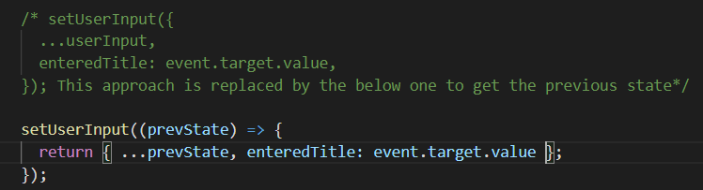

Now why should we do it like this instead of like this? In many cases, both will work fine, but keep in mind that I mentioned that Reacts schedules state updates, it doesn't perform them instantly. And therefore, theoretically, if you schedule a lot of state updates at the same time, you could be depending on an outdated or incorrect state snapshot if you use the first approach. If you use the second approach, React will guarantee that the state snapshot it gives you here in this inner function, will always be the latest state snapshot, keeping all scheduled state updates in mind. So this is the safer way to ensure that you always operate on the latest state snapshot.

**Code till now with comments**

import { useState } from "react";

import "./ExpenseForm.css";

const ExpenseForm = () => {

  const [enteredTitle, setEnteredTitle] = useState("");

  const [enteredAmount, setEnteredAmount] = useState("");

  const [enteredDate, setEnteredDate] = useState("");

  /* Instead of using 3 useStates we can use 1

  const [userInput, setUserInput] = useState({

    enteredTitle: "",

    enteredAmount: "",

    enteredDate: "",

  }); */

  // When we call the onChange prop then we need to point at to code at the function that should be executed when that event occurs.

  // Triggered when Title changes

  const titleChangeHandler = (event) => {

    setEnteredTitle(event.target.value); // when we use 3 states

    /* setUserInput({

      ...userInput,

      enteredTitle: event.target.value,

    }); This approach is replaced by the below one to get the previous state*/

    /*

    setUserInput((prevState) => {

      return { ...prevState, enteredTitle: event.target.value };

    }); */

  };

  const amountChangeHandler = (event) => {

    setEnteredAmount(event.target.value); // when we use 3 states

    /* Used when we use single state

    setUserInput({

      ...userInput,

      enteredAmount: event.target.value,

    }); This approach is replaced by the below one to get the previous state */

    /*

    setUserInput((prevState) => {

      return { ...prevState, enteredAmount: event.target.value };

    }); */

  };

  const dateChangeHandler = (event) => {

    setEnteredDate(event.target.value); // when we use 3 states

    /* Used when we use single state

    setUserInput({

      ...userInput,

      enteredDate: event.target.value,

    }); This approach is replaced by the below one to get the previous state */

    /*

    setUserInput((prevState) => {

      return { ...prevState, enteredDate: event.target.value };

    }); */

  };

  return (

    <form>

      <div className="new-expense__controls">

        <div className="new-expense__control">

          <label>Title</label>

          <input type="text" onChange={titleChangeHandler}></input>{" "}

          {/* onChange here is the prop for this input type */}

        </div>

        <div className="new-expense__control">

          <label>Amount</label>

          <input

            type="number"

            min="0.01"

            step="0.01"

            onChange={amountChangeHandler}

          ></input>

        </div>

        <div className="new-expense__control">

          <label>Date</label>

          <input

            type="date"

            min="2019-01-01"

            max="2022-12-31"

            onChange={dateChangeHandler}

          ></input>

        </div>

      </div>

      <div className="new-expense__actions">

        <button type="submit">Add Expense</button>

      </div>

    </form>

  );

};

export default ExpenseForm;

**Handling form submission**

If we are pressing submit button inside a form, then the overall form element will emit an event to which we can listen and that’s the submit event.

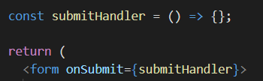

Now, the thing here is that I just set that this is a default browser behavior and unfortunately, a part of this default browser behavior is that if you do click this button, the page reloads because the browser actually automatically sends a request whenever a form is submitted to the server which is hosting this webpage. So in this case to this development server and that's not what we want here. Instead here, we wanna handle this form submission with Java script and manually collect and combine the data and do something with it.

Thankfully we can disable or prevent this default behavior because we again get an event object here, automatically just as for the change events and on this object, we can call a prevent default method. This is built into JavaScript nothing reacts specific this default JavaScript behavior. We can prevent the default of this request being sent and since that request is not sent the page will now also not reload because we stay on the currently loaded page without sending any request anywhere and we can continue handling this with Java script.

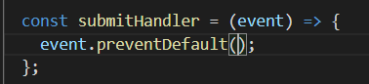

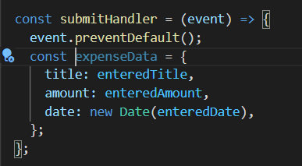

Constructing a new date with the built in date constructor to which then in turn I passed the entered date which will parse that date string and converted into a date object.

Hence, we created an expenseData object with all our data combined to form an object.

This is done so that we can input all these 3 values together as an object together.

**Adding two way binding**

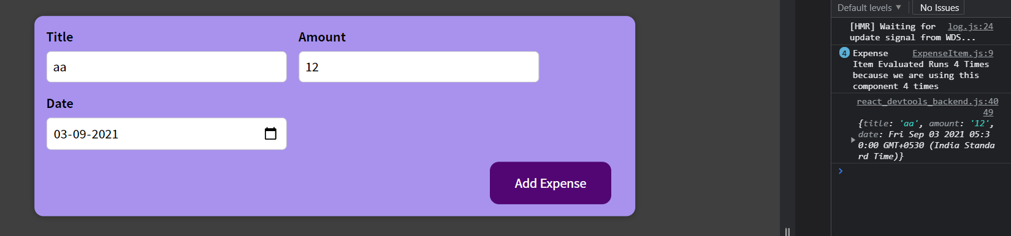

Now we want to remove these input values after submission.

By using state, we have an advantage. We can now implement something which is called two-way binding, which simply means that for inputs we don't just listen to changes, but we can also pass a new value back into the input. So that we can reset or change the input programmatically.

All we have to do is add the value attribute, which is a default attribute, to this input element. This will set the internal value property, which every input element has. And we can set it to a new value.

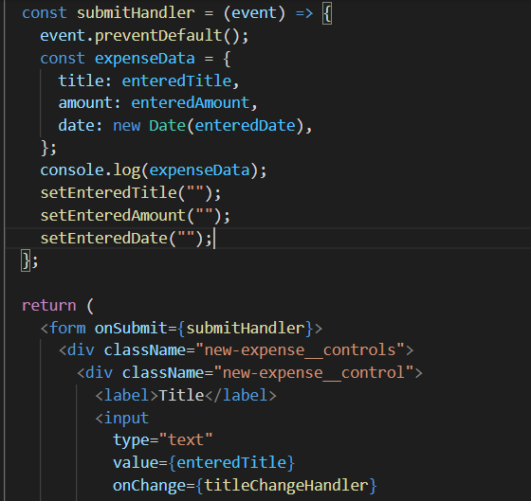

And here, I will bind this to enteredTitle. So now it is this two-way binding because now we don't just listen to changes in the input to update our state. But we also feed the state back into the input so that when we change the state, we also change input. But the advantage is that when the form is submitted for example, we can call setEnteredTitle. And set this back to an empty string, which also was our initial state. And by doing that, we override what the user entered after the form was submitted and therefore cleared the input.

**Hence, we used the value prop.**

**Code Till Now**

**ExpenseForm**

import { useState } from "react";

import "./ExpenseForm.css";

const ExpenseForm = () => {

  const [enteredTitle, setEnteredTitle] = useState("");

  const [enteredAmount, setEnteredAmount] = useState("");

  const [enteredDate, setEnteredDate] = useState("");

  const titleChangeHandler = (event) => {

    setEnteredTitle(event.target.value); // when we use 3 states

  };

  const amountChangeHandler = (event) => {

    setEnteredAmount(event.target.value); // when we use 3 states

  };

  const dateChangeHandler = (event) => {

    setEnteredDate(event.target.value); // when we use 3 states

  };

  const submitHandler = (event) => {

    event.preventDefault();

    const expenseData = {

      title: enteredTitle,

      amount: enteredAmount,

      date: new Date(enteredDate),

    };

    console.log(expenseData);

    setEnteredTitle("");

    setEnteredAmount("");

    setEnteredDate("");

  };

  return (

    <form onSubmit={submitHandler}>

      <div className="new-expense__controls">

        <div className="new-expense__control">

          <label>Title</label>

          <input

            type="text"

            value={enteredTitle}

            onChange={titleChangeHandler}

          ></input>{" "}

          {/* onChange here is the prop for this input type */}

        </div>

        <div className="new-expense__control">

          <label>Amount</label>

          <input

            type="number"

            min="0.01"

            step="0.01"

            value={enteredAmount}

            onChange={amountChangeHandler}

          ></input>

        </div>

        <div className="new-expense__control">

          <label>Date</label>

          <input

            type="date"

            min="2019-01-01"

            max="2022-12-31"

            value={enteredDate}

            onChange={dateChangeHandler}

          ></input>

        </div>

      </div>

      <div className="new-expense__actions">

        <button type="submit">Add Expense</button>

      </div>

    </form>

  );

};

export default ExpenseForm;

**NewExpense**

import "./NewExpense.css";

import ExpenseForm from "./ExpenseForm";

const NewExpense = () => {

  return (

    <div className="new-expense">

      <ExpenseForm> </ExpenseForm>

    </div>

  );

};

export default NewExpense;

**Child to parent component Communication**

Till now we are able to gather the user inputted data, combine it into an object and then clear the form after being submitted.

The only problem is that having this data is nice but we technically don't need it in the expense form component, do we? Instead we needed in the new expense or to be precise in the app JS component even because there we have our expenses array and ultimately our goal will be to add this new expense which the user entered to this list of existing expenses and we probably also wanna enrich it by adding an ID. So, we need to pass the data which we're collecting and generating in expense form to the app component.

Till now we only learned how we can pass data down. So how we can, for example, in the expenses folder pass title, amount and date from the expenses component to the expense items component. So from parent to child, that's something we learned. We can do that with props.

But how can we do it in the other direction if data is generated in the expense form and we then wanna pass it up to the app component?

In expense form, we are listening to user input to change this to the title input, for example and whenever the user types here, this function title change handler executes and there we get this default event object, that's something the browser gives us. Now, actually we can think about this input element here as a component as well. It's not one of our components but it is simply a pre-built component, we could say, provided to us by react and of course translate it to the input Dom element but it has this component character in the end and we do also set some props on that component including this special onchange prop.

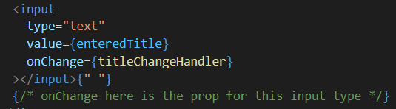

This onChange prop wants a function as a value and then internally the input element adds this event listener.

So react basically sees that we set a value on this onchange prop and adds that listener on the rendered input element. But that is a pattern we can replicate for our own components as well. We can create our own event props, if we wanna call it like, and we can expect functions as values and that would allow us to pass a function from a parent component to a child component and then call that function inside of the child component. And when we then call a function, we can of course pass data to that function as a parameter and that's how we can communicate up from child to parent.

So now let us say we have to pass the ExpenseForm data to App component. We first however have to transfer this add to NewExpense component because it uses the ExpenseForm component and from there transfer it to App component because it uses the NewExpense component. (cannot skip components)

--------------------------------------------------------------------------------------------------------------------------

**Step 1**

So therefore as a first step, let's make sure we can pass the **expense** data to **new expense** and we can do it as by adding a new prop to expense form. It's our component, so we can name it however we want, but I will name it **onSaveExpenseData,** because I wanna make it clear that the value for this prop should be a function, a function which will eventually be triggered when something happens inside of this component. In this case, when the user saves the entered expense data, so when the form is submitted in the end.

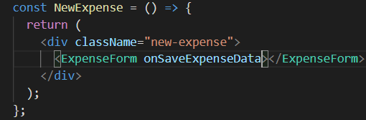

The value for this prop should be a function which can then be called inside of the expense form component.

Hence, it's a function we should define here in new expense just as we did it for the input elements with the functions we bound to the onchange prop, we define those in the expense form before we returned the JSX code as well. Now we're doing the same here one level above that in the new expense component for our own custom expense form component.

**\*\*\* ExpenseForm here is the custom component. onSaveExpenseData is the prop\*\*\***

So here I'll add a const save expense data handler and important as a parameter here, I will expect the entered expense data. The name of the parameter is up to you, it's your function but now I make it clear that this function expects to get this parameter. And then here we can add our expense data another object, copy in the entered expense data which I expect to be that object which we generate here into submit handler, so this object, I pull out all the key value pairs and add them to this new object and then I add in a new key, the ID key and simply set that to math random. Math random to string to convert it to a string. It's not a perfect unique ID, theoretically we could generate the same value twice but it's good enough for this demo. And then we can see what we do with that thereafter, for the moment I'll just log does enriched expense data. Now it's a pointer at this function, which I wanna pass as a value to all onSave expense data, so that this onSave expense data prop in my custom component receives this function as a value. Again, I don't execute it here, we don't add parenthesis, I just point at the function, so that the function itself a pointer edit is passed to expense form.

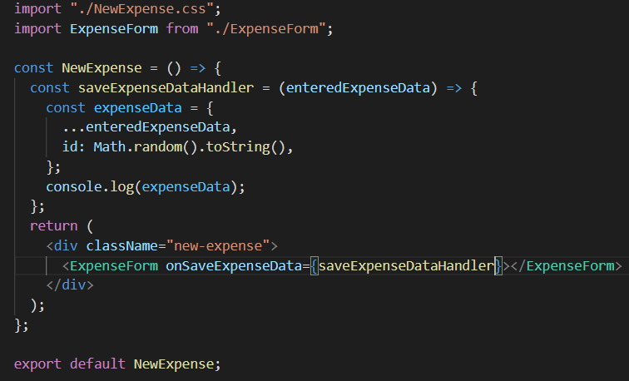

**Step 2**

The second step now is to use this function inside of our accustomed component. So inside of expense forum, we now can expect this onSave expense data prop because I am setting it when I used the expense form component, hence inside of expense form, we can extract the value past for this prop ie, this function.

That's a step we didn't have to do for the inputs because these are built in components basically, but they're also we pass a function (**titleChangeHandler)** to onchange and internally react and we'll add a listener and call this function which we pass in whenever that event occurs, that change event. Now, since we're doing this on our own custom component, we also have to call the past and function manually and that's what I'll do next.

So inside of expense forum, we now can expect this onSave expense data prop because I am setting it when I used the expense form component, hence inside of expense form, we can extract the value passed for this prop **(onSaveExpenseData)** ie, this function **(saveExpenseDataHandler)**.

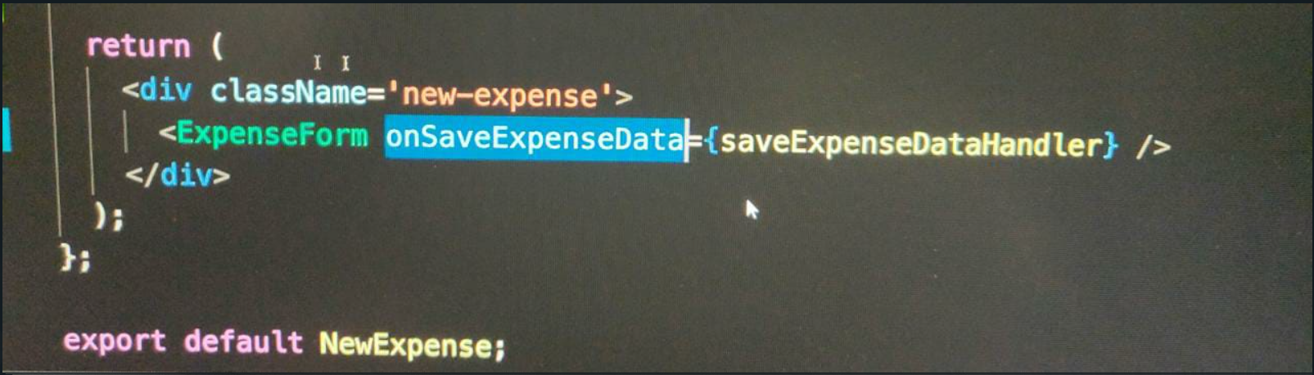

So, inside of expense form, I of course now expect to get some props because we're setting a prop now and now, inside of the submit handler.

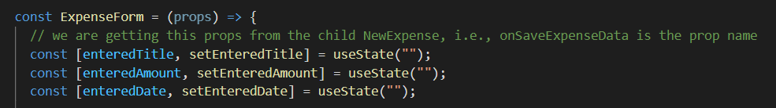

Instead of I logging my expense data, I will access props onSave expense data and executed here. And that's not important, now I executed I can execute it. I can execute it because the value which we get on this onSave expense data key will be a function. We are passing in a function here after all. (**function is saveExpenseDataHandler in NewExpense.js)**

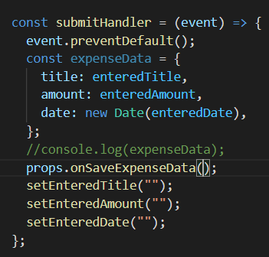

So it's this function defined in the new expense component which we will now execute in a different component, inside of expense them to be precise.

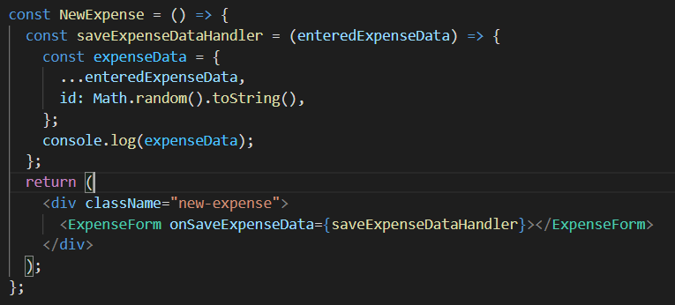

**The above is the function before the return statement.**

And we can execute the function even though it's not defined inside of **expense.js** form because we are passing a pointer edit through the **onSave expense data prop.**

This is how you can make sure that a child component, the expense form component here for example, can communicate up to the parent component, the new expense component in this case.

We can call a function in the new expense component and we can pass data as a parameter. So here, when we call **onSaveExpenseData** in the **ExpenseForm.js**, I can pass the **expenseData** which are generated here as our argument and that's the value which we'll receive as a parameter here in **NewExpense.js**.

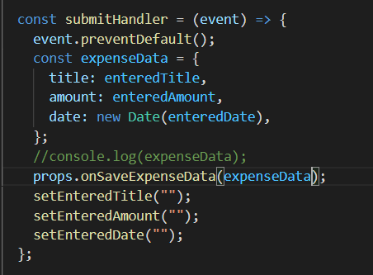

Shows the **expenseData** in the **ExpenseForm.js file.**

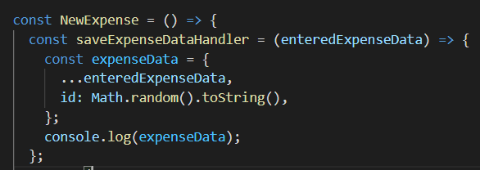

**expenseData** is the value received here as a parameter in the **NewExpense.js file**, in the **enteredExpenseData parameter.**

Now, of course, we can continue in this chain now and we can communicate up from inside **NewExpense** to **App** because it's this **App** component which needs the **NewExpense** in the end to add it to this expenses array.

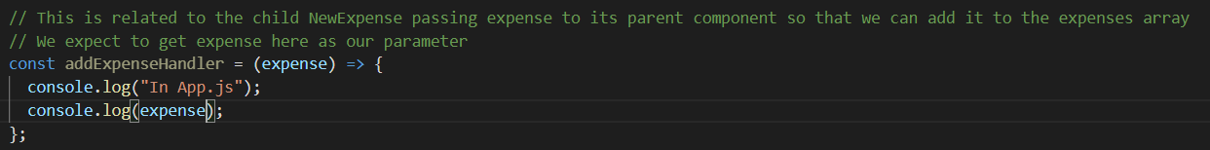

**The above is inside App.js. That is the function.**

We can pass a pointer at this function to a new expense so that inside of new expense, we can call this function and pass that expense data up to the app component. So we could name this prop here **onAddExpense**, again, the name is up to you, it's your component but again, I will follow this convention starting with on to make it clear that it's a function pointer which has passed as our argument and then I pass a pointer **atAddExpenseHandler** to the **onAddExpense** prop **on NewExpense**, and therefore inside of **NewExpense.js**, we can now call it.

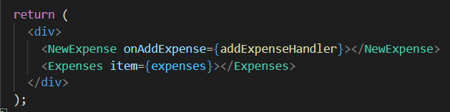

**The above is inside App.js. Shows passing of the pointer to the prop.**

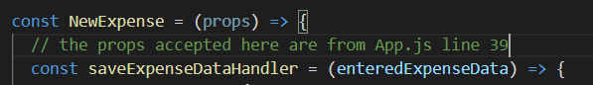

**The above is inside NewExpense.js. Shows accepting of the props argument.**

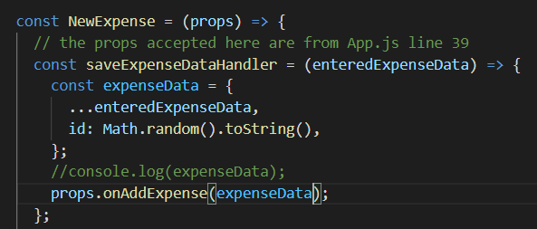

**\*FOCUS ON LAST LINE\***

In **saveExpenseDataHandler** which itself is called when something happens in the **ExpenseForm**, we can of course now also called props **onAddExpense** and of course here, we wanna use the name which we chose here in the app component. We're calling the function passed **(addExpenseHandler in App.js)** as a value for that **onAddExpense** prop. I'm calling us here, and it will forward my enriched **expenseData** here.

**We learned about a very important concept of moving data from a child to a parent component by utilizing props to receive a function from the parent component which we call in the child component.**

**We are calling a function (of the parent) in the child component which we receive through props. Then we are passing data (in the child component) to the function (of the parent component) we receive on the prop of the child component.**

**By doing this, we are lifting the data upwards and not keeping it in the NewExpense component, we are lifting it up to the app component so that in there we can use it.**

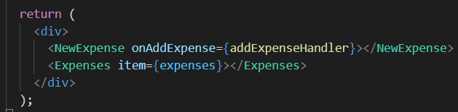

**This is App.js, where the data is uplifted. (Line 3)**

**This is done so that we can now use this data, eg we are doing console.log here.**

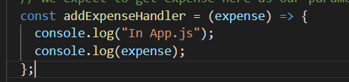

**Now we are passing this data down to the Expenses component. The below figure shows it. (Line 4)**

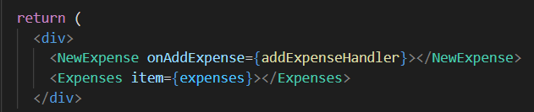

**Hence, we generated data in the ExpenseForm component, passed (uplifted) it up to the NewExpense component, and then further uplifting to the App component, because App component is the first component in line which has access to Newxpense, ExpenseForm component and most importantly to the Expenses component. And since the Expenses component in where we want our data to be in the end, it is the app component where we want to life our state (generated data) up to.**

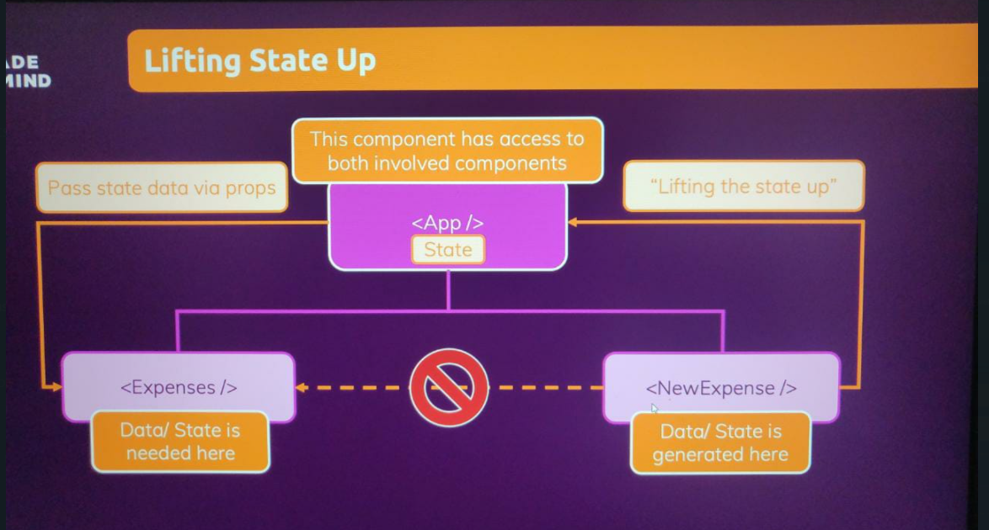

**The goal is to life the data as high as necessary until we have a component which has access to both the component that generates the data and the one that needs the data. This is because data sharing is not allowed within sibling component since they do not interact with each other (like parent calls child) and hence props cannot be passed like earlier (during up-lifting from child to parent).**

**Lifting the State Up**

**Two way binding (Controlled vs Un-controlled components)**

Basically, whenever you use two way binding you are controlling a component but here we're controlling our own custom component. Now, what does this mean? It means that a value which is used in the component like the value selected in the dropdown is passed on to a parent component, through props and is received from the parent component.

Both the currently set value, as well as the function which in the end handles the selected value is not part of expenses filter.

Expenses filter is really just a component that presents DUI, that presents the dropdown and then attaches a couple of listeners or props, but the real logic recites in the parent component and that turns ExpensesFilter into something which is called a controlled component. Now, technically there is no difference. ExpensesFilter is still a regular component as you learned it. It's just a special term that when you see it basically means what I just explained that both the value, as well as changes to the value are not handled in the component itself but in a parent component. This component controls the expenses filter component. This is just a term to know.

**Presentational (stateless) vs Stateful Component**

ExpenseItem component (below) is a stateless component because it does not have any internal state and is here to output data.

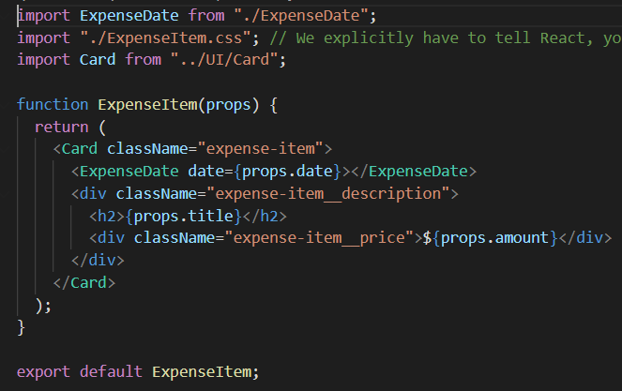

The Expenses component below is a stateful component (manages the filtered state). But it's only a couple of components which typically do manage state. And then this state is spread out and distributed through props in the end, like here in the expenses component where we managed to filter state

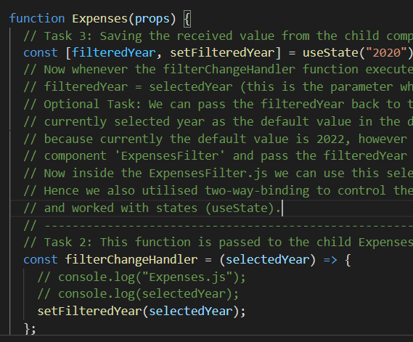

and then we pass the filtered year. So this state value through props, back to expenses filter.

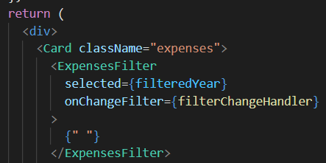

This is a standard pattern which you'll see a lot that you manage state and a couple of components, and then you might pass that around to other components.

**Code Till Now…**

**Expenses.js**

import ExpenseItem from "./ExpenseItem";

import "./Expenses.css";

import Card from "../UI/Card";

import ExpensesFilter from "./ExpensesFilter";

import { useState } from "react";

function Expenses(props) {

  // Task 3: Saving the received value from the child component in a state

  const [filteredYear, setFilteredYear] = useState("2020");

  // Now whenever the filterChangeHandler function executes (i.e., whenever input changes in ExpensesFilter.js dropdown), we can set the

  // filteredYear = selectedYear (this is the parameter which we received from the child)

  // Optional Task: We can pass the filteredYear back to the ExpensesFilter component below to set up two-way binding and pass the

  // currently selected year as the default value in the dropdown. (For eg, here default is 2020 and hence our dropdown will show 2020)

  // because currently the default value is 2022, however we want it to be 2020. Hence, we pass another prop 'selected' to our

  // component 'ExpensesFilter' and pass the filteredYear as a value corresponding to this prop to ExpensesFilter.js.

  // Now inside the ExpensesFilter.js we can use this selected prop to set the value of the dropdown.

  // Hence we also utilised two-way-binding to control the default value. Hence, we listened to events, passed data from child to parent

  // and worked with states (useState).

  // ------------------------------------------------------

  // Task 2: This function is passed to the child ExpensesFilter.js so that it is triggered when an input changes in that file (dropdown)

  const filterChangeHandler = (selectedYear) => {

    // console.log("Expenses.js");

    // console.log(selectedYear);

    setFilteredYear(selectedYear);

  };

  return (

    <div>

      <Card className="expenses">

        <ExpensesFilter

          selected={filteredYear}

          onChangeFilter={filterChangeHandler}

        >

          {" "}

        </ExpensesFilter>

        <ExpenseItem

          title={props.item[0].title} // these are props

          amount={props.item[0].amount}

          date={props.item[0].date}

        ></ExpenseItem>

        <ExpenseItem

          title={props.item[1].title}

          amount={props.item[1].amount}

          date={props.item[1].date}

        ></ExpenseItem>

        <ExpenseItem

          title={props.item[2].title}

          amount={props.item[2].amount}

          date={props.item[2].date}

        ></ExpenseItem>

        <ExpenseItem

          title={props.item[3].title}

          amount={props.item[3].amount}

          date={props.item[3].date}

        ></ExpenseItem>

      </Card>

    </div>

  );

}

export default Expenses;

**App.js**

//import ExpenseItem from "./components/ExpenseItem"; // This path in the end tells JavaScript that we're looking for expense item file

// in a Components folder which sits next to this app JS file in which we have does import statement.

import Expenses from "./components/Expenses/Expenses";

import NewExpense from "./components/NewExpense/NewExpense";

function App() {

  const expenses = [

    {

      id: "e1",

      title: "Toilet Paper",

      amount: 94.12,

      date: new Date(2020, 7, 14),

    },

    { id: "e2", title: "New TV", amount: 799.49, date: new Date(2021, 2, 12) },

    {

      id: "e3",

      title: "Car Insurance",

      amount: 294.67,

      date: new Date(2021, 2, 28),

    },

    {

      id: "e4",

      title: "New Desk (Wooden)",

      amount: 450,

      date: new Date(2021, 5, 12),

    },

  ];

  // This is related to the child NewExpense passing expense to its parent component so that we can add it to the expenses array

  // We expect to get expense here as our parameter

  const addExpenseHandler = (expense) => {

    console.log("In App.js");

    console.log(expense);

  };

  return (

    <div>

      <NewExpense onAddExpense={addExpenseHandler}></NewExpense>

      <Expenses item={expenses}></Expenses>

    </div>

  );

}

export default App;

**Section 5: Rendering Lists and Conditional Content**

In this course section, we're now going to dive into rendering lists and rendering conditional content. So we'll have a look at how we can output arrays of data on our page and how we can show different content based on different conditions,

**Rendering Lists of Data**

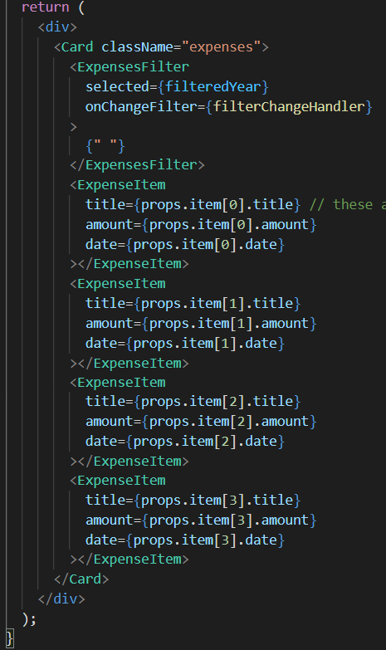

In the expenses JS file we currently render our list of expenses by individually adding these expense item elements here in our JSX code, and that's of course not dynamic at all. In most web applications we don't know in advance how many items we wanna render.

Hence, we want to render the expenses (array defined in the app.js component) in the expenses component.

First step is to pass the expenses array down using a **items** prop which point to the array from app.js to expenses.js.

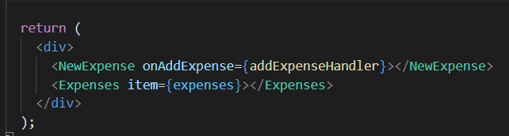

On our props we got this items prop, and the value of that will be that array,

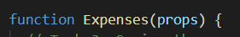

which will be in the end when I render here, but we don't wanna output the array as text or anything like that. Instead, we wanna render one expense item per element in the array, and that's straightforward to do.

**NOTE: The map method which is applied on an array, takes a function as an argument and that function is then executed on each item of the array and the result of this function is the element which will be added to our newly created array.**

**const array1 = [1,2,3,4]**

**const map1 = array1.map(x => x*2)**

**console.log(map1)**

We can utilize it here to transform our array of objects (from App.js), which we have here, we got a bunch of objects in there, into an array of JSX elements (in Expenses.js), to be precise, into an array full of expense item JSX elements, because if you do output an array of JSX elements here, like a couple of cards,

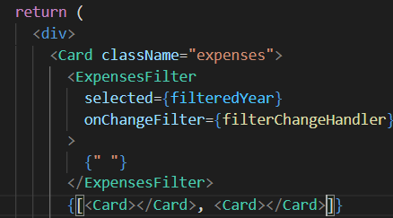

then React is capable of simply rendering these elements. So if you had something like this, an array of JSX elements as part of your JSX code, react would simply render these elements side by side, and that's what we utilize here to transform our array of objects into such an array of expense items, which then are rendered by React.

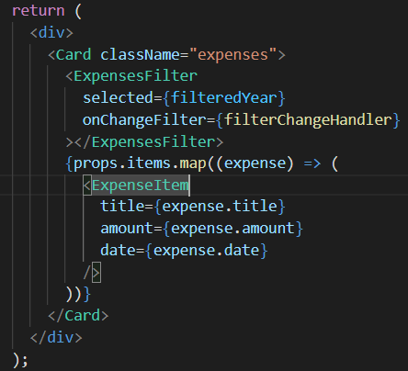

**Items here is the name of the prop**

So here we get our expense, for example, and then in the function body, so on the right side of this arrow if we're using our arrow function, we then have to return the JSX element into which we want to map this expense. So in this case, I wanna map every expense in my expenses array, I want to map every expense into an expense item JSX element. So I wanna transform the expense object to this special kind of object, to this JSX element, and then we can just configure this as we did it here. We add a title prop, but the title is now expense.title, so this expense, which has passed as a parameter into this function automatically, because that's how map works, that expense is used to extract the title, and we do the same for the amount with expense amount, and of course we do the same for the date by setting the date prop to expense date.

And we're only left with this map expression here, where we transform our array to an array full of JSX items.

But we also see that we get all these items being rendered just as before but now it's actually happening dynamically, which simply means that now it's based on the actual array, and that of course means that we can now also change that array and such changes will be reflected in that list.

**Using stateful lists**

Now we need to update the expenses array in App.js.

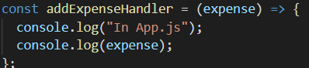

This function in app.js is triggered whenever a new expense is added and we also receive an expense as the parameter. Hence, we need to add this to our expenses array in our App.js.

However, if we change the variable just like this, react wont update the component. Hence, we need to use state.

We add the nex expense using the addExpenseHandler function.

Well, we could pass a new array here and then let's say we wanna add the new expense as the first item in the array. For that we could add the expense which we're getting here as an item to this array and then use the spread operator on the existing expenses to pull out all the existing array elements and populate the rest of this new array with those existing elements. We can use the spread operator not just on objects but also on arrays.

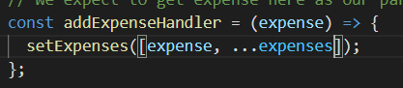

However, we learnt that the above approach is not always good as the react holds the updated changes for sometime. Hence, we use the following approach wherein the prevExpenses fetches the most recently updated values.

You should use this special function form for this state updating function. So it would be passed a function as argument to this state updating function and that function will automatically receive the latest state snapshot. And we would return our new array where we add this expense which we're getting as a parameter here and where we then add our previous expenses with that spread operator.

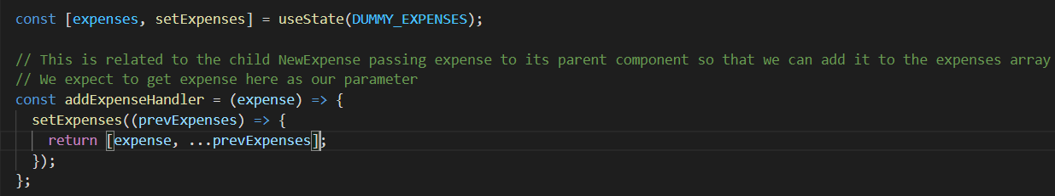

Hence, we get a dynamic list.

**Understanding Keys**

So what actually happens here when I add a new item is that React, renders this new item as the last item in this list of div's and updates all items and replace their content, such that it again matches the order of the items in my Array. The final result, therefore is correct here but from a performance perspective this is not great because all items are visited and updated and it can even lead to bugs. And the question therefore is, why does React, behave like this? The answer is because it has no other way. It currently simply checks the length of the Array and then has a look at the number of items that were already rendered. The individual items all look similar to React though so it can't know where a new item should be added or anything like that. That's why we get this warning because we have a way of telling react where a new item it should be added.

We use the key prop which we can add to custom components or build in HTML elements like div and this helps react identify individual items.

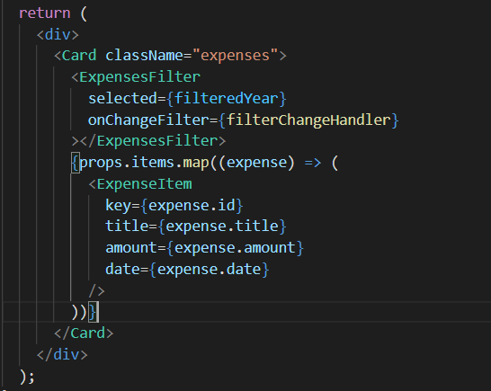

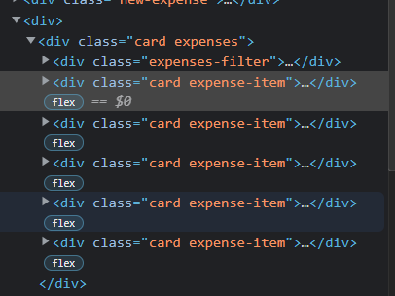

Now React is able to uniquely identify all these items and it's therefore aware, not just how long the Array is but also aware which items should be placed.

**ExpensesFilter is a controlled component, controlled by the expenses component.**

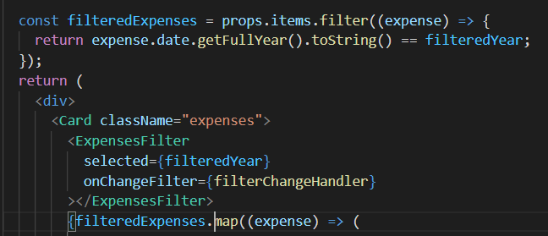

Also note we have filteredExpenses.map instead of props.items.map.

Filter is a function which takes in an array of element and based on the function passed to it, if it is true, then that element is added to the new array, else not.

**Conditional Rendering**

The first approach is using the ternary operator within the return statement as follows:

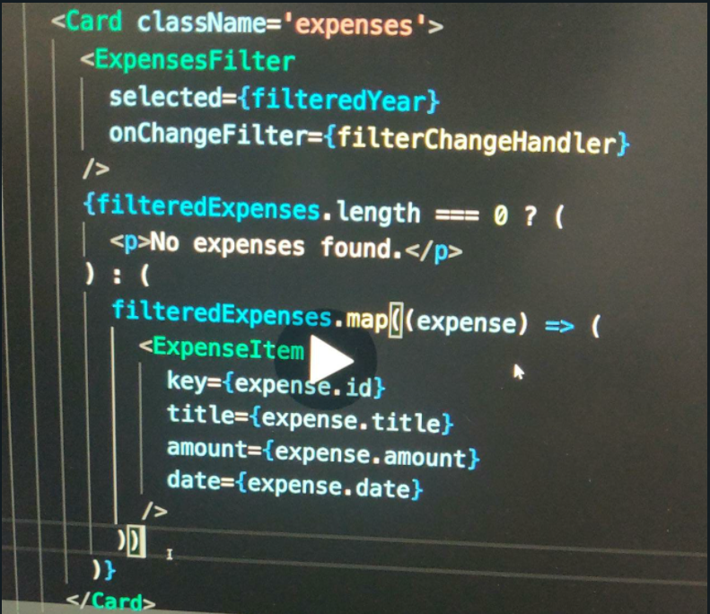

The second approach is using the && operator. If the first condition of the && is true then the second statement is performed.

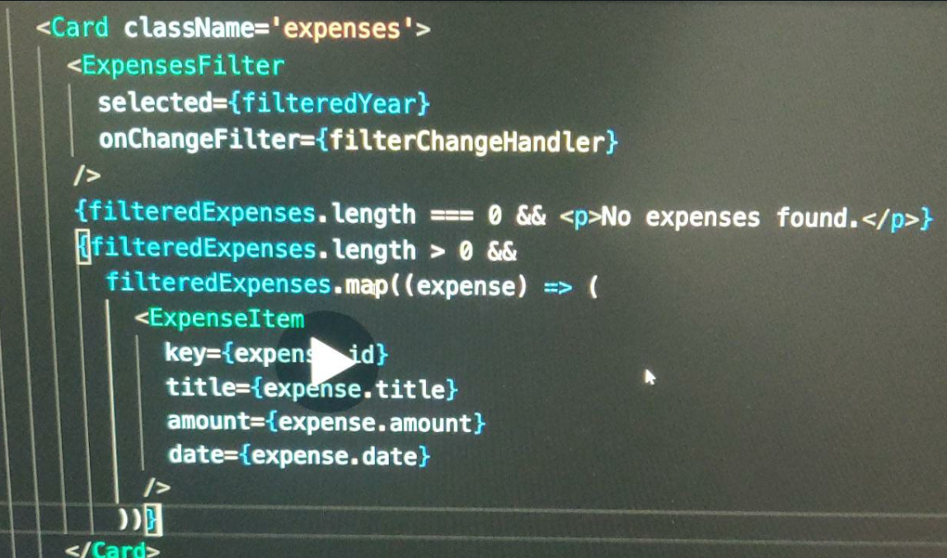

The third approach is the best as it allows us to get a cleaner return statement. We just initialise expensesContent to some initial value and then change if it satisfies a condition.

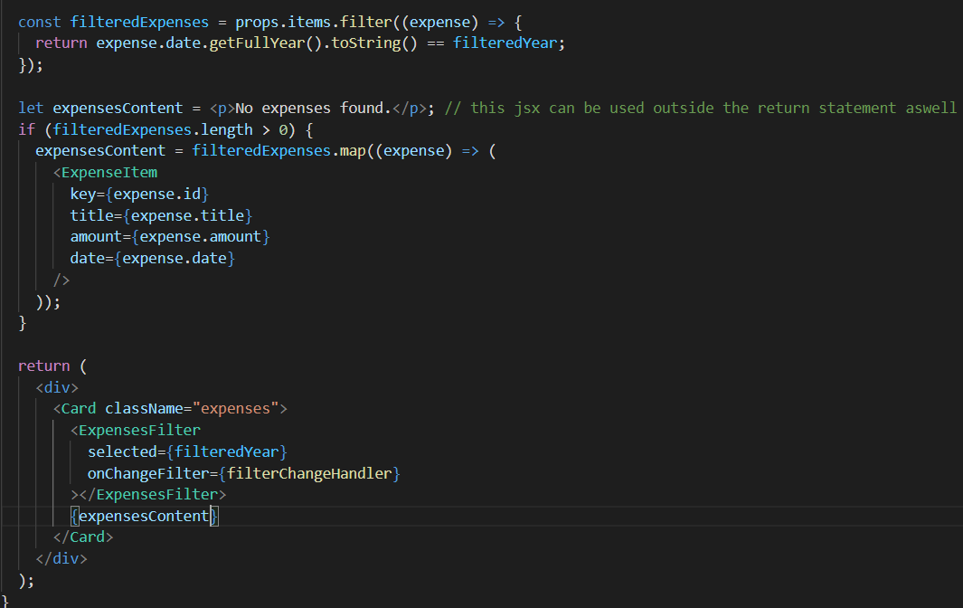

So the variable, **expensesContent** holds either this JSX code (<p>No expenses</p>) or this array of JSX elements (later one).

Both is a renderable and therefore both can be used here (inside the return statement).

**Adding conditional return statements**

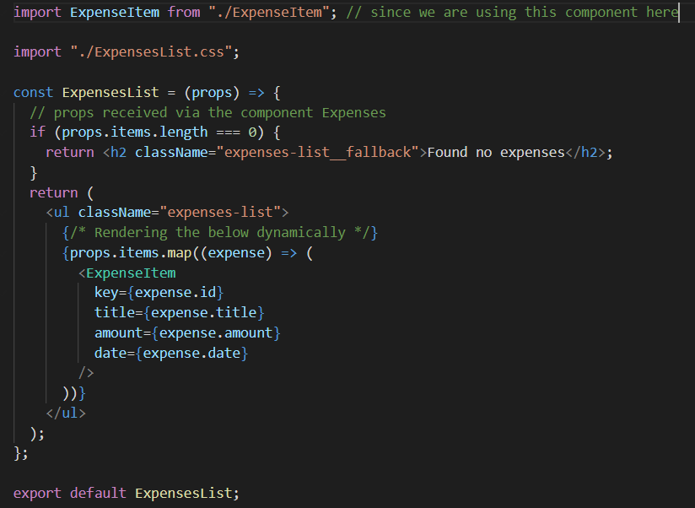

It would have not been appropriate here in **Expenses.js** before, because only a part of the JSX snippet, which we returned changed. So there, the approach I showed in the last lecture was better, but if your entire JSX content changes (like in **ExpensesList.js**), when data is missing, you can always add an if check where you return a different JSX block if some condition is met.

**Assignment 4: Adding a cancel button and new state to show button**

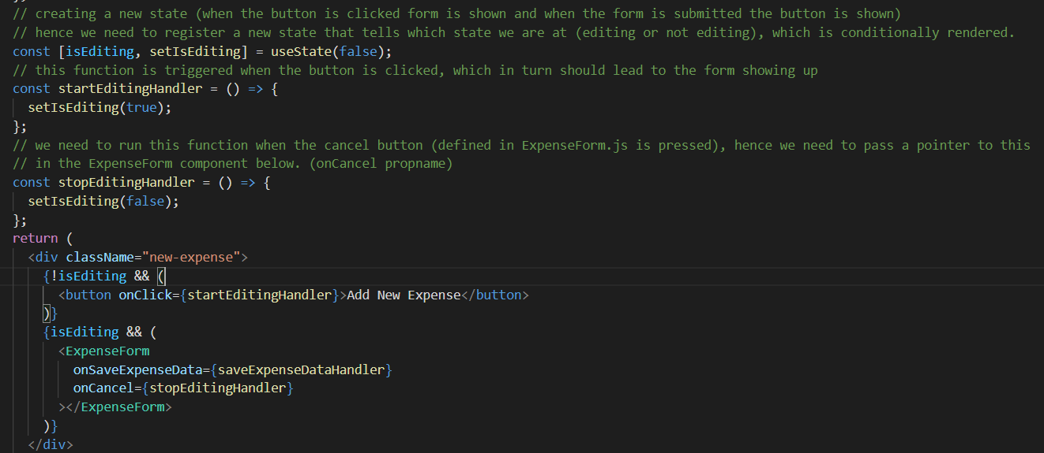

Above is the code in NewExpense.js.

We point the onCancel prop to the **stopEditingHandler** function, so that this function is passed as a value to the **onCancel** prop in the **ExpenseForm** component.

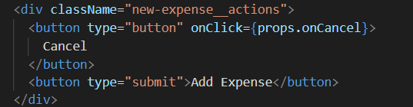

Above is the code in ExpenseForm.js.

We now point the **onClick** prop to the **props.onCancel** so that the function which we receive on the **onCancel** prop is forwarded to the **onClick** prop of this button, so that for a click on this button, the **stopEditingHandler** function is executed.

**Chart**

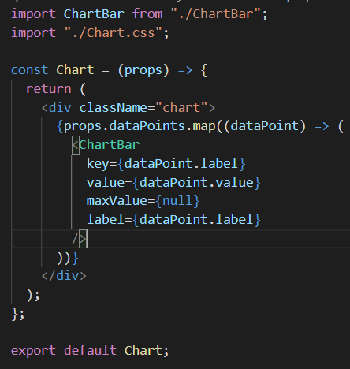

**All these 4 are name of props passed to the ChartBar component.**

We could simply render 12 individual chart bars for the 12 months which we have. But I will actually create a bit of a more flexible chart which is actually not necessarily restricted to months and to 12 data points. Instead, we could say that when the chart component is being used somewhere in our application, we wanna receive the data points that should be plotted as props. So, that the chart component is fairly configurable and the components that use the chart component can decide how many data points with which values should be rendered. And therefore, I actually will output the chart bars dynamically by going through an array of data points and mapping every data point to a chart bar. And that's of course, basically what we already learned in this module how we output lists of contents dynamically and that's all why I'm doing it here so that we again practice this. So, on props we could expect a data points prop of course, that name is up to you since it's your component but I expect the data points prop and I expect that to hold a value which is an array. Hence, we can call map on that and then we map every single data point into a chart bar component. So, that we create as many chart bar components as we have data points. And then of course we wanna pass some data into the chart bar to control how it will be rendered. So, which value will be rendered there. And for that we of course wanna extract some data from the incoming data points.

Since we're outputting a list here we also should add a key because you learned that this special key prop helps react render these list items efficiently. And therefore I do expect that every data point also has a unique ID or maybe we actually use the label so that we say that the label should be unique every chart bar has its own unique label and therefore we can also use the label as a unique identifier for this special key prop here.

**We wanna fill the chartbar as per the value prop in relation to the maxValue prop.**

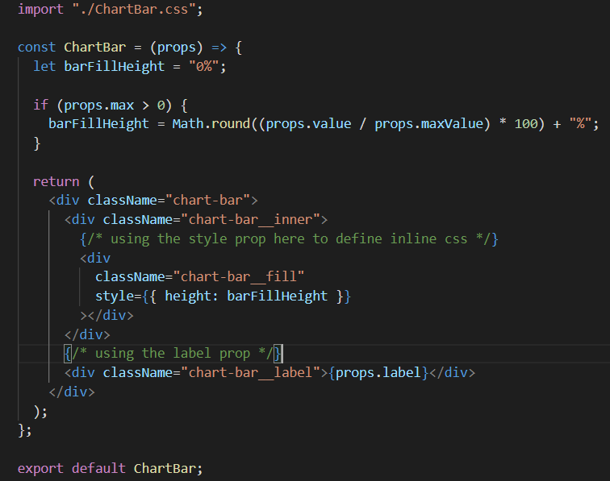

And initially I'll set **barFillHeight** to 0% as a text because this will be assigned as a CSS style in a second.

We're going to set the style of an element dynamically and that can be done by adding the style prop here which is of course a default HTML attribute as well but actually that style prop, that style attribute works a little bit differently when building a react application. The value is set here should be dynamic because it should be our derived fill height here and indeed you then don't generate a dynamic string where you set something like height 10% but instead style and that's the special thing once an object. So, here we don't have a special double curly brace syntax but instead we have to single a curly braces for outputting something dynamically but then the dynamic value is a JavaScript object which has also created with curly braces. That's why we overall have the double curly braces but it's no special style syntax. The only special thing here is that style wants a JavaScript object as a value. And then this object you should then use the CSS property names as key names as properties and the values as well values.

**NOTE: Regarding using inline CSS. If we wanna include background-color property, we do it as ‘background-color’ : ‘red’. However, if our key doesn’t include the character ‘-‘, we can write it as backgroundColor: ‘red’. ***Notice the missing single quotes around the backgroundColor property***.**

We expect every datapoint to be an object as we use properties such as datapoint.label.

Hence, we create an array of objects.

**Npm install is run when we install a zip file from github because it does not come with a node module folder as it will bloat the zip file. Hence, npm install will install all the dependencies.**

**Section 6: Styling React Components**

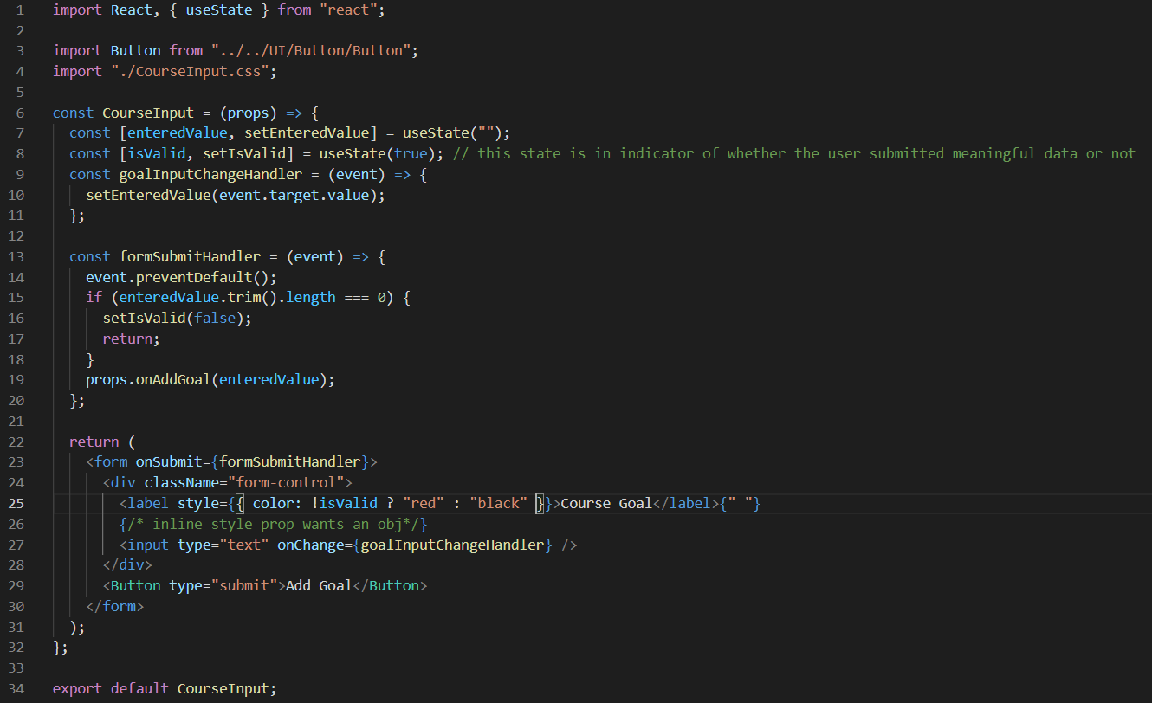

Line 8 is to create another state which can store an indication to whether the user entered a valid goal or not.

Line 15 is to check the enteredValue length. If it is 0, we set isValid to false and also return so that props.onAddGoal() is not executed.

Line 25 is passing an object to a style prop and we dynamically change the value that is fed to the color property in that style object. Hence, if we enter anything without writing anything, the label is changed to red colour.



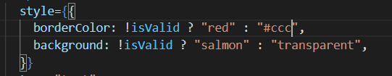

The only tricky thing is borderColor written like this because we're in JavaScript here, not in a CSS file. And therefore we need to use the JavaScript property name (borderColor) for that CSS property (border-color). And that happens to be the camel case version of the CSS property name.

However, there are 2 things.

First we are not resetting the properties which we do as follows.

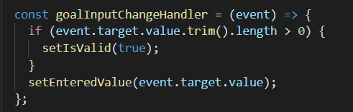

Secondly we are applying inline CSS which has the highest priority and hence overwriting the already defined CSS in another file. This can have a bad impact as let us say we want our border color to be **#ccc** which we defined in the CSS file. However, when we write this code, our default borderColor changes to **black** as we are using inline CSS. We can however, change black to **#ccc** in the inline css aswell, however this leads to code duplication.

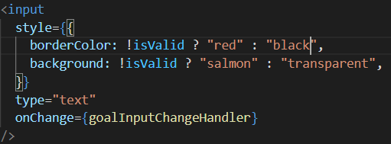

We got a base color scheme here in the CSS file. And then we override this with inline styles just because we want to conditionally set some specific style iIf the input is invalid.

**Setting CSS classes dynamically**

What if we write 2 classes within the **.css** file and then add these classes dynamically to our **div** if the input is invalid.

Hence, in **div** we write **className = {} // we used curly braces to set dynamic value of the class depending on whether the input is valid/invalid instead of className = “hi” as a string is always hard-coder.**

We can use backtick as we can not only enter string, but also inject dynamic value into the string using **${}.** **We can pass any js expression within the ${}.**

**Hence, we dynamically add this invalid class to the className inside div.** Hence, our className can be form-control or form-control invalid depending upon whether the input entered by the user is valid or invalid.

Hence, we dynamically add/remove classes.

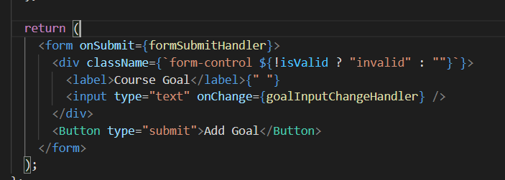

Also, for the CSS file note the following:

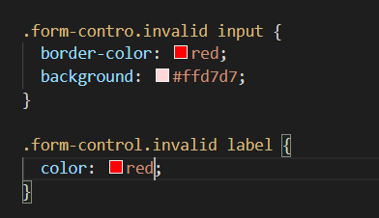

For example, here, we could say if the form control also has the invalid class, and therefore make sure there is no space between form control and this dot, which means they both have to be on the same element, then we could target our input and set the border color to red.

**Introducing Styled Components**

Currently we're using just CSS for that regular CSS files with regular selectors, mostly class selectors but also sometimes combined with tag selectors for example. We're importing these files into our component files, but as I emphasized multiple times, this does not result in those styles being scoped to this component only. So that means that if we had any other element anywhere else in a form that has a form controlled CSS class on it, this style for example, would target it and would affect it. So it's not like we only care about foreign control elements in this component, no, every element on the entire page is affected because by default, those styles are not scoped. Now that is not necessarily a problem. You can of course be careful about your selectors. You can use class selectors or ID selectors here, it is regular CSS after all, you can use any selector and you can ensure that the IDs and the classes you are selecting are only used in the places where you want to apply the styling. But of course, especially in larger projects, potentially with a lot of developers working on the code, it could happen that a name is used twice. That form control, for example, is used in different parts of the application and therefore unfortunately styles spill over to our components and you might want to avoid this.

**Method to avoid this:**

For the moment we just need to know that what we pass between these two back ticks will kind of end up in that button method. And this button method, and that's the interesting part, will return a new button component. Actually, that styled package has methods for all HTML elements. It has p method for a paragraph h1, h2 and so on for the h1, h2 tags, div to create a div and so on.

So this overall expression will return a button but a button with the styles we provide between these two back ticks.

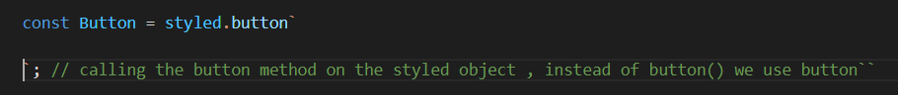

Now, what do we need to do to make this work in the end? This will return a button and this button won't have a class of button because we have no place where we would set up this class name. So instead, the styles will pass between the opening and closing back tick will directly effect this button. You therefore get rid of any selectors like this and instead just paste in your styles, just like that. And they will be added to the button element which is returned by this method call which extends toward into this Button constant. Now for a pseudo selectors, you can use the ampersand symbol that's supported by that styled component package. This tells the package that you wanna have a special case special pseudo selector in this case here for this component, which is created here. So in this case, we're saying, "Hey, when this button here has focus, please apply to style."

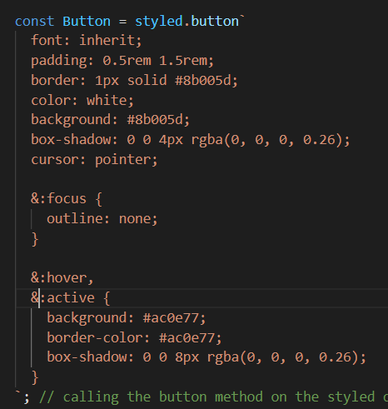

And this should now give us a button which has these styles. Now the button which is returned all to by **default applies all the props** you might be passing to your own button component which we're exporting here in the end. So we can still add on click prop, we can still set the type that will all be forwarded by the style components package, to that core built in button, which we previously wrapped or used ourselves (**commented code shown below)** which is now used internally by this button method (**styled.button)**.

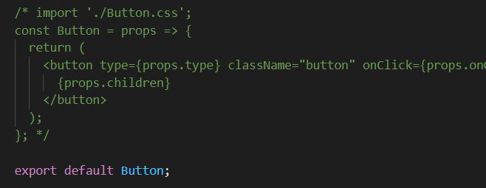

But you see on that, there is a very strange class two strange classes to be precise. And these are class names we certainly didn't set up. These are class names dynamically generated by the styled components package. Because what this package does in the end is it looks at the styles we set up here and then it wraps these styles into generated class names where it guarantees that every class name is unique so that it cant spill over to other components of the app. And it will then add these classes as global CSS. But now since we have unique class names for every styled component, the style set up here will never be able to affect the number of component in the app because these unique class names are really well unique per style component. So that's how the styling is applied here and that's how styled components work.

**Lec 77: Styled Components and Dynamic Props**

We create another component in the **CourseInput.js** file for re-defining div and its css properties. Since, this is the only component we want with this div characteristics, we don’t need to export it. (and it is only being use by another component in the same file and hence we can define both together)

**Method 1:**

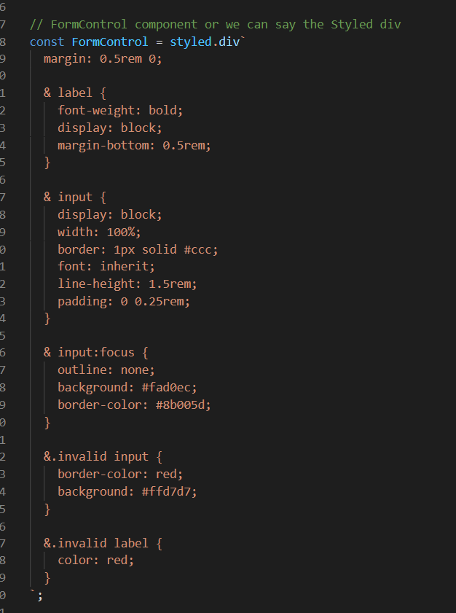

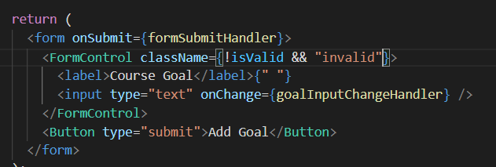

If !isValid, we add the invalid class to our FormControl component.

**Method 2:**

Adding props to our component and utilising it within the backticks.

Hence, we create a prop named **invalid** (name can be any)

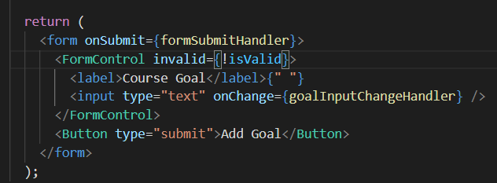

**Invalid is true if isValid is false and vice versa. (invalid prop is now used within the backticks).**

**Now, we go to the place where we set the background-color and use the syntax ${} since we are within backticks. Now, we pass in an arrow function which receives a prop as a parameter and then return the text that should be returned in this position. This function is called by the styledComponents package and for props it will feed in all the props our component gets (for our case invalid prop).**

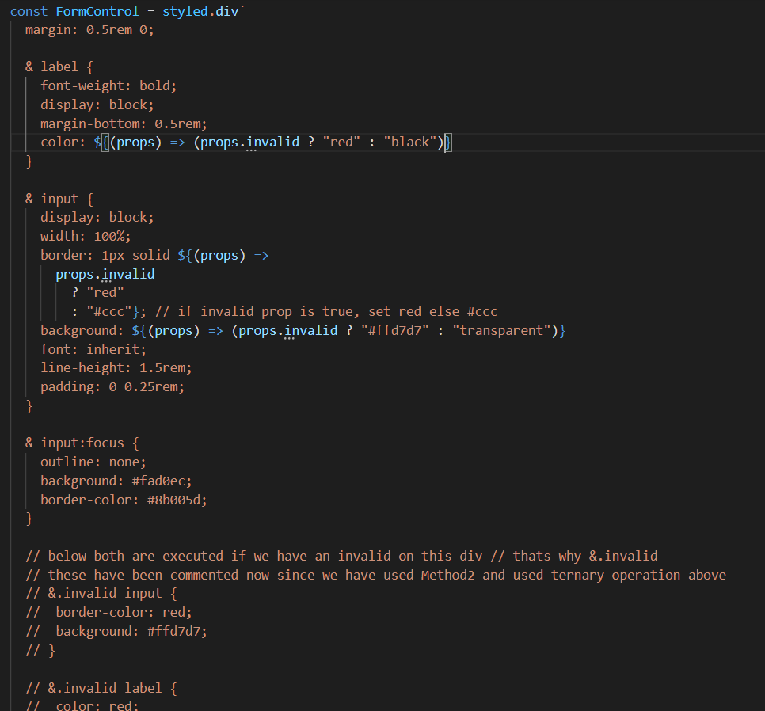

**Now, we are dynamically changing parts of the styles based on the props that are set on our styled components.**

**Using CSS modules**

1) The earlier method wherein we used css files (global non-scoped files) and we use classes within our components in such a way that we are not re-using classes and not affecting other components.

2) Use CSS modules:

**The css modules takes the className from our css file and changes it to unique names.**

**The css styles we set up in a css file are scoped to the component we import this file to.**

Some things to do this are:

* Rename .css file to .module.css.
* Import styles from ‘./Button.module.css’.
* This styles is now an object and all the classes we defined in our css behave as properties for this object (class.obj).

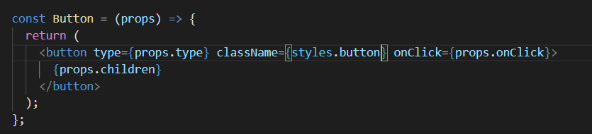

This is the best way as our CSS is separated from the JS file and it is also scoped properly.

**Dynamic Styling with CSS Modules**

To make sure the invalid style is applied, we need to make sure the invalid css class is added to the element.

Previous code: (in CourseInput.js, used when we use the special styled module with commented backticks code)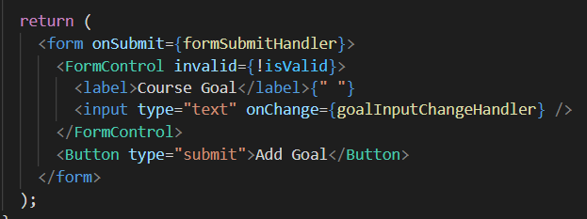

New Code: Adding dynamic classes with CSS

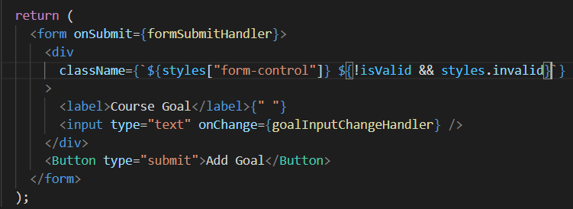

**NOTE: To use className with ‘-‘ in them, we use [‘ ‘] syntax.**

To add media query we use the following code // the only change is we add the .button selector which we didn’t when we used the styled component.

@media (min-width: 768px) {

  .button {

    width: auto;

  }

}

**Section 7: Debugging React Apps**

1) The return statement always need to have 1 root element <Div> </div> or anything because we saw that behind the scene is operates as React.createElement() and we cannot have 2 of these return statements within a single return statement.

Methods:

1) Use the vs code terminal to see any compile time errors.

2) Use the browser inspect window to see for warnings (logical error eg same key in a list).

3) Use the break point method to check which statement is causing an error.

4) Use the react dev tool.

**Section 8: Making project**

We use label so that when we click on the text within the label, it toggles the control, i.e., basically to improve usability for mouse usersAlso the id within the input and the htmlFor within the label should be same so that we can they can co-ordinate (htmlFor in jsx else for).

We pass props.children between the card component so that it outputs what passed between the opening and closing tags of the card component used within the AddUser component.

When we apply className to built in HTML components like div, react knows how to add the specified class to that HTML element. However, when we add classes to our custom component, eg Card here (used within AddUser component), we need to add this class in the Card component aswell (using props) since react doesn’t know what to do with our own personal defined **className prop**. Hence, we go to our component and accept the incoming className prop and do something with it. We want that the classes sent as prop are applied along with the **classes.card** class and then these classes combined are applied on the **div rendered by the card.**

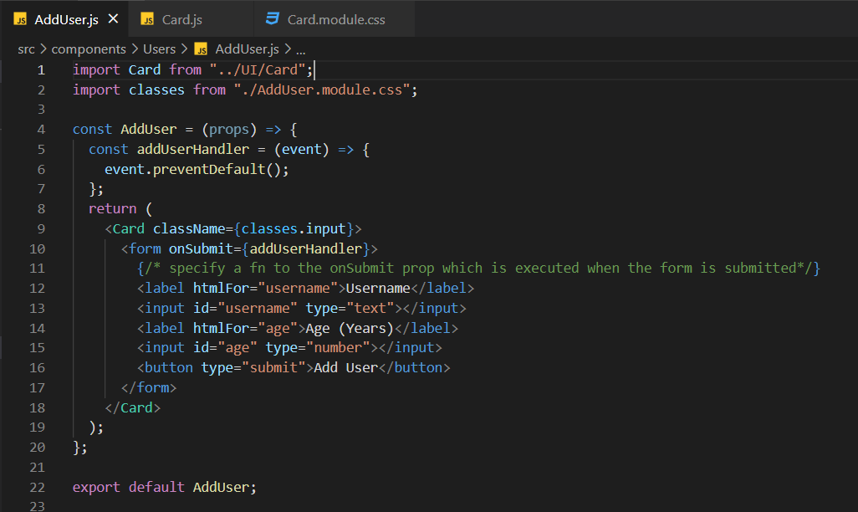

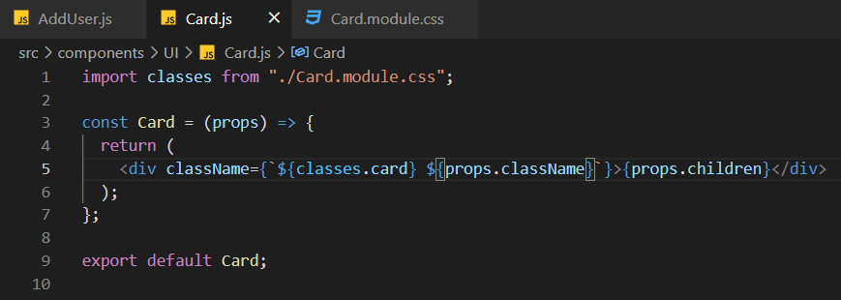

We can name the prop anything other than className aswell since its our component

**Button component –** we add className to add classes, add type and take input as props.type. However, if the user doesn’t enter any type or it is invalid, we use **“button”**.

Also we want to receive the onClick as we expect to get a handler function via props on our own button component. Props.children is used to output the content between the button tags whatever we receive between our **<Button />** tags in the AddUser component.

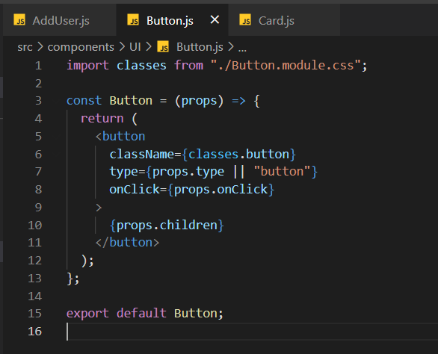

**Creating states to store user inputted data.**

This is (below) a JavaScript syntax, which is called array de-structuring and we use it, because useState always returns an array with exactly two elements. And with this syntax, we're pulling these elements out of that returned array. And we store them in separate constants, of the name enteredUsername and setEnteredUsername. And I chose those names for those constants, because the first element of that returned array, is the current state snapshot. And every time this Component re-renders, which it, for example, does when the state is updated, this concept (eneteredUsername) will hold the latest state snapshot and setEnteredUsername on the other hand, holds a function which we can call, to change that state and to then trigger such a re-render cycle.

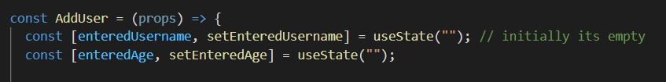

We created the states to store values entered by the user.

So now, we need a function which is triggered on every keystroke of that input here. And for that, I'll have my **usernameChangeHandler** function for example, where I get the event object, because we'll listen to a default DOM event and such events will dispatch objects with more information and we can bind this to input here (onChange) , for the **onChange** prop. Which then will tie this to the change event listener. So here I pass my **usernameChangeHandler** and therefore, this function will be triggered for every keystroke in the input element, down there.

We get the respected value using the **event** object.

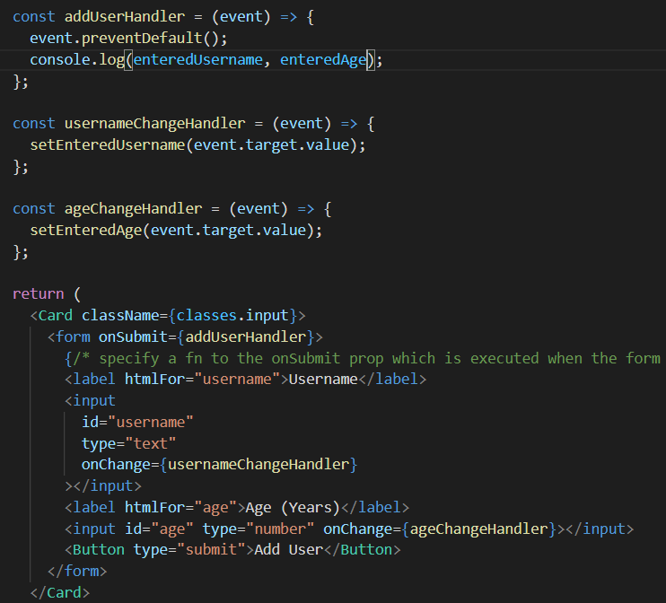

**Resetting and validation**

First we set the age and username to empty after the form is submitted.

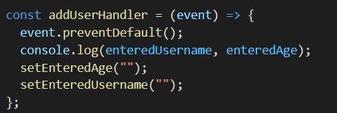

However, doing this alone will not clean the input boxes as we are not reflecting our current states back in the input. We can do this using the **input** prop so that we can reflect the current state snapshots even if it is not changed through a keystroke (**onChange)** but like above during a form submission.

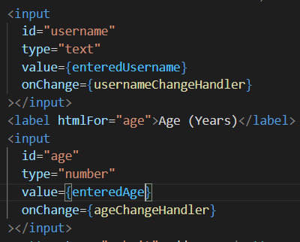

Note that enteredAge is a string and not a number as we initialised it to a string and also anything that is passed to the value is retrieved as a number in the DOM. Write **+** as it converts a string to a number.

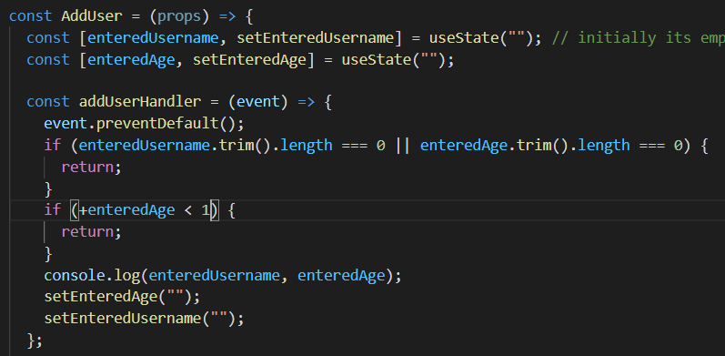

**Outputting the data**

Map our **users** array to an array of JSX elements which are then rendered on the DOM.

So, map executes a function on every item of the user’s array and will get that item as an input (**user)** and in this arrow function we return a JSX element for every **user** of the **users array** we get from the prop. The jsx element we want to render is a **li** here.

We expect **user** to be an **object** with a property such as **name**.

The **()** syntax is just to add text. // where we use age years old

We also add className is the **Card** component **<Card>** because we have used it as a prop within our **Card** component. This way our card component doesn’t only has the **.card** class but also the special **.users** class.

All this is shown in the below picture:

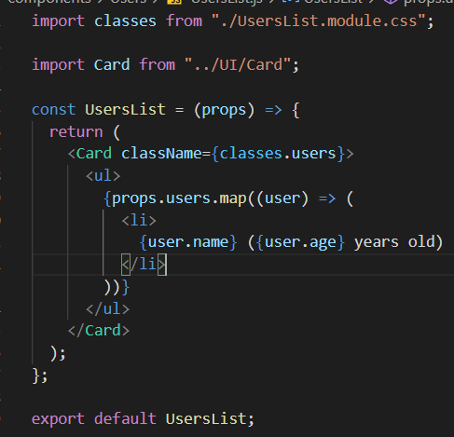

**NOTE: AddUser.js is taking the data input and adds it.**

**Hence, we don’t add our UsersList component inside the AddUser, rather inside the App component.**

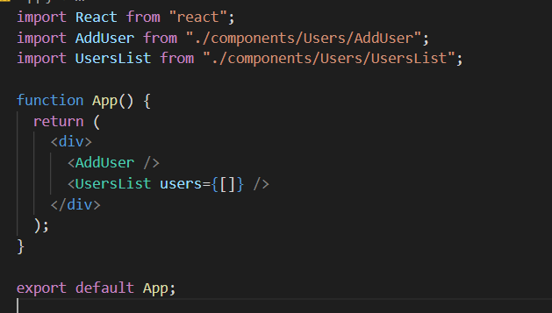

**NOTE: we are passing prop name as users since we used that in the UsersList component. Also note that we are currently passing an empty array since we expect an array.**

**Setting the array dynamically (**managing list of users via state)

We now want to not set it as an empty array, but rather an array of objects.

Now we want to access this data which we have in our **AddUser component** in the **UsersList component.** We do this by lifting the state up and the closest component which is above both these components and has access to them is **App.js.** Hence, we want to manage the state here. (when the state data changes, the app re-renders and that’s what we want)

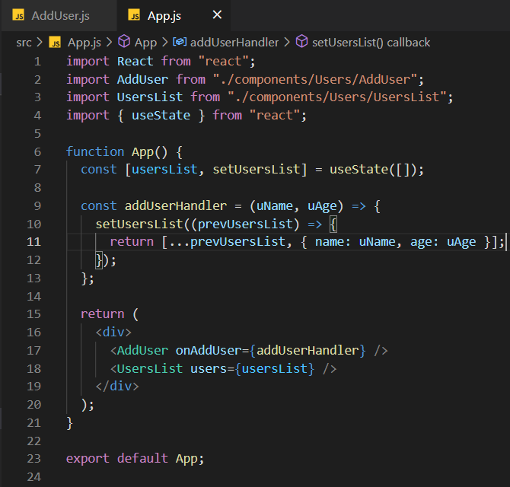

I will call props dot **onAddUser**. And I'll execute it as a function here, because I know that what I get as a value on that prop will be a function. Because we're passing a pointer at **AddUserHandler** to **onAddUser (inside App.js component)** and **AddUserHandler** is a function. So we can execute it as a function inside of the **AddUser.js** component. And now we just have to forward our two pieces of data, the enteredUsername and the enteredAge which we got stored in this **AddUser** component. And with that we're forwarding that entered data to the App component up on every click on the **AddUser** button here inside of the **AddUser** component.

The below is inside AddUser.js.

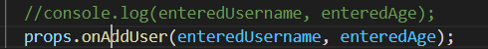

**Creating the Modal**

Note that we are using **{props.title}** and **{props.message}** since we don’t want to hardcode it and show various types of errors and messages.

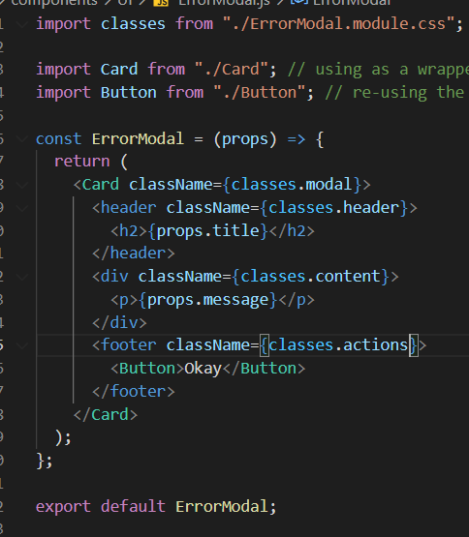

We are rendering this component in the **AddUser.js component** because it is this component which will ultimately trigger the modal. (as if we enter something which has error will trigger the **ErrorModal** component)

Below is **AddUser.js.**

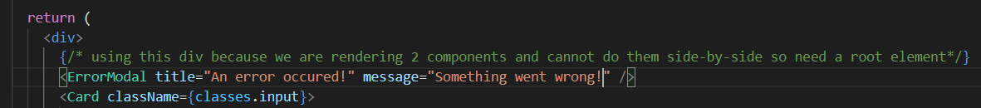

However, we can still interact with the backpage as you can see:

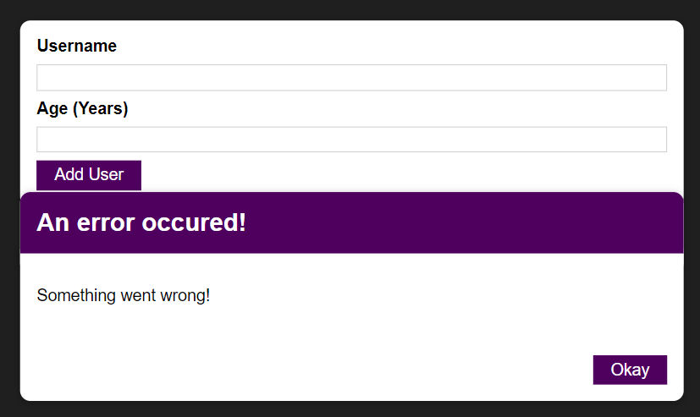

Hence, we make the following change in the **ErrorModal component.**

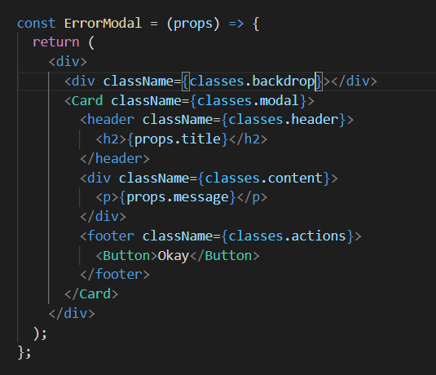

**The div itself is empty but the backdrop class makes it sure that the background is gray.**

**Next goal is to show the errormodal only when there is an error and also to dismiss it by pressing the button.**

**Managing the error state**

We create a state for an error which tells if it is true we render the **ErrorModal** component (used inside **AddUser)** else we do not.

NOTE the lines 10, 15-17, 22-24 and the second ss.

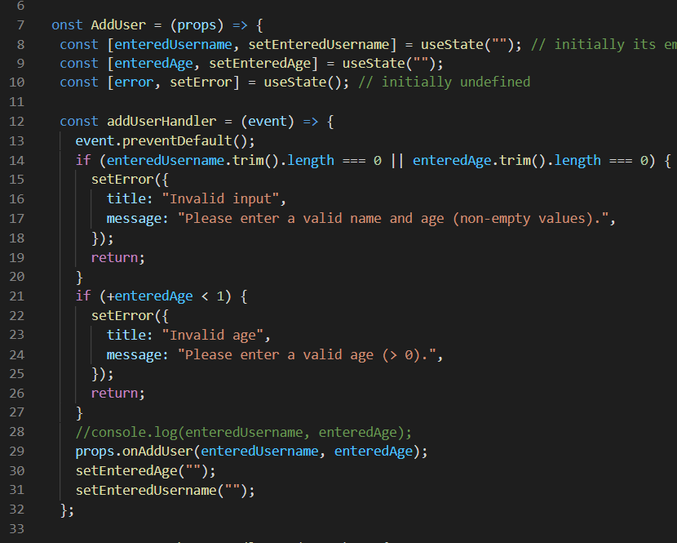

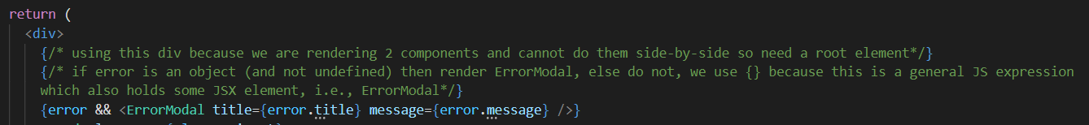

Now to dismiss the ErrorModal, we need to reset our error state to undefined so that ErrorModal is not rendered (since error state will change its value, useState will cause re-rendering and hence during the re-render, ErrorModal will now not be rendered since error state is undefined).

Now, to dismiss the ErrorModal we first create **errorHandler** function in **AddUser,** and pass it as a prop **onConfirm**.

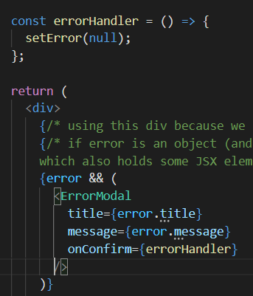

Now within the **ErrorModal (line 9 and 18)** we create an onClick prop and pass this onConfirm function. (basically passing a function from parent to child, wherein when someone clicks the button in the child component then, the function within the parent component is triggered and the **error** state is set to undefined). (So that this function is triggered when we either click **the background = div, or the button = button).**

Also note that for div onClick is managed by react. However, for our **Button** custom component we also did pass an **onClick** prop (**in the button class). Hence, it manages.**

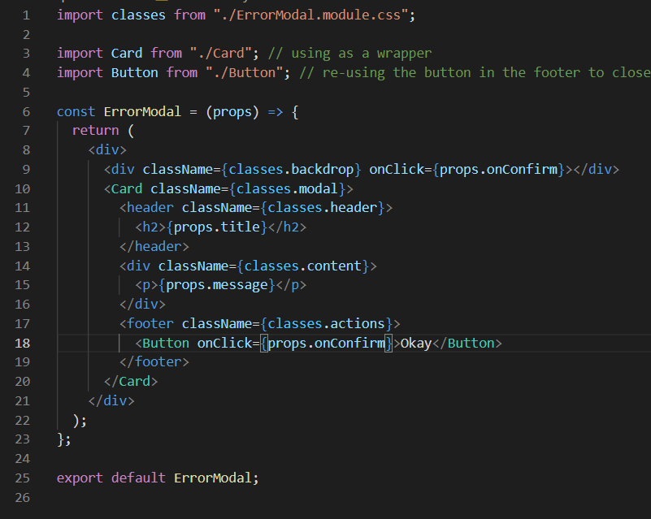

**Section 9: JSX**

**Limitations of JSX**

Whatever we return in the return statement is JSX code. However, there is a limitation that we cannot return 2 JSX elements side by side. They should be wrapped in a root JSX element.

This is because our JSX code transforms to Javascript code ie;

Return {

React.createElement(‘h2’, {}, ‘Hi’);

}

And we cannot have 2 of these Reacte.createElement.

The root jsx can have multiple children as they will act like the 3rd, 4th and so on arguments in javascript.

**SIDE NOTE: we used {error && ErrorModal…} in AddUser.js. We use {} because now we have a dynamic expression instead of JSX again and hence we need curly braces to evaluate this.**

One approach is to use <div> to wrap it however, we can end up with a div soup as all our components are wrapped in <div> and we get a whole lot of <div> which we need to render.

Second approach and the better one is to use **Wrapper.**

Remember the children prop holds all the content you're passing between the opening and closing tag off your custom component.

Now of course all that content is taken and just returned here (in props.children in wrapper) , but that's also okay because in this return statement, I technically still only returned one thing, i.e., props.children.

This is basically an empty component which return the children. **It doesn’t render any real HTML element to the DOM, but it fulfils react’s/JSX requirements.**

Within wrapper we can also use **{React.fragment /> or < />.**

**React Portals**

The first approach isn’t good for semantic purposes and a clean HTML view. Because you have to keep in mind, that a modal basically is an overlay on your page. It is an overlay to the entire page. So logically, it's above everything else. And if it's then nested in some other HTML code, it might technically work because of styling, but it's not good code. It's not a good structure. And it can even lead to real problems again, with styling, or with accessibility, if you have such nested overlay content, because if, for example, a screen reader has to interpret your HTML code, which is being rendered, it might not see this as a general overlay, because you are CSS styling won't matter too much there. And from a semantical perspective, from the structure it has, it's deeply structured in our HTML code. So it's not obvious that this modal should be an overlay to all the other content.

Using portals we can keep writing our code similarly however But to still render this differently in the real DOM and to, for example, render the modal HTML content somewhere else, than it would normally go to.

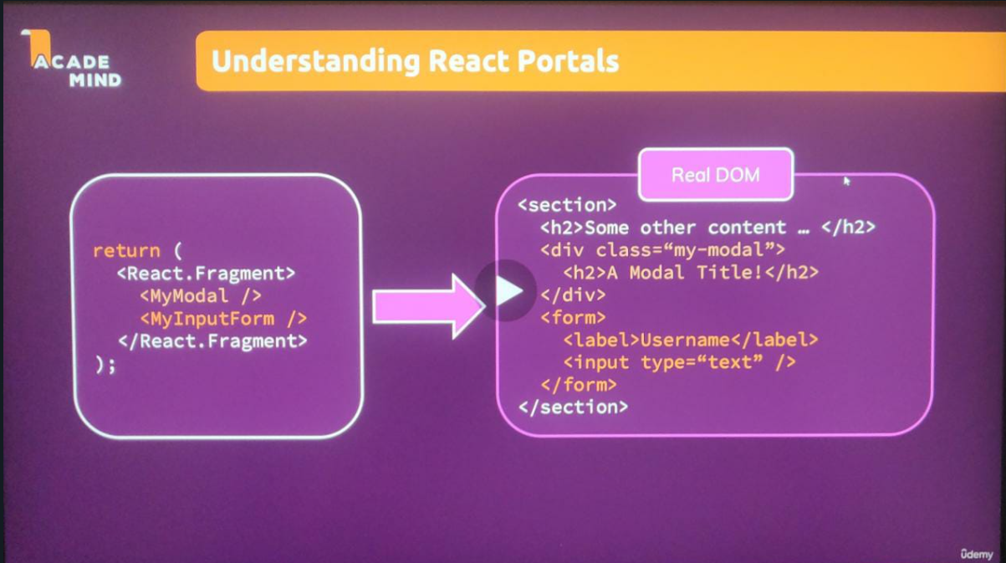

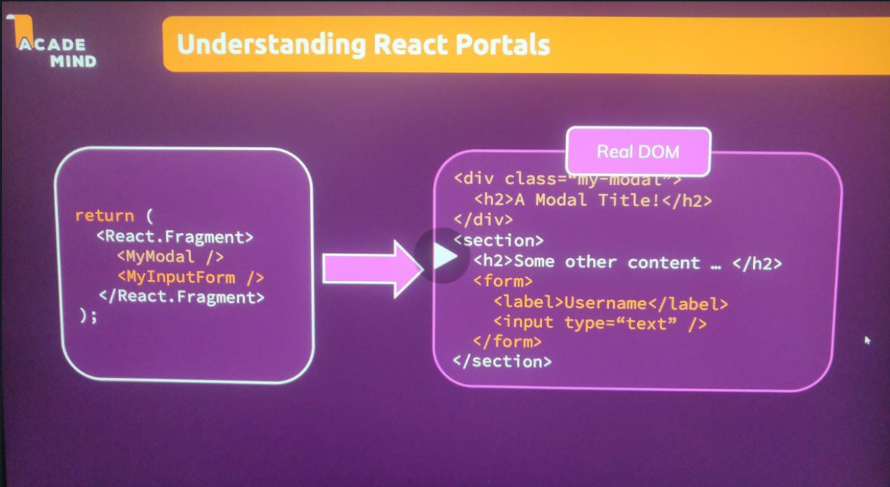

**SIDE NODE: React dom is like an adaptor to react for the browser. You can imagine React being the library that has all the React features, state management, add on, baked-in. And React DOM uses React to bring that logic and these features into the web browser.**

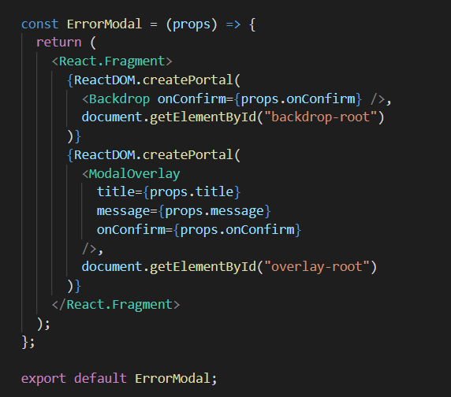

Now the createPortal method takes two arguments. The first one is your React node that should be rendered. And here I can render my Backdrop, let's say, like this. Important here it wants JSX, so you don't parse just Backdrop like this (**Backdrop)**, instead, you really render it like this **(<Backdrop>)**.

Now the second argument of createPortal is a pointer to that container in the real DOM where this elements should be rendered in. And in my case, I of course want to render my backdrop here in that backdrop-root Component **(defined in index.html)**. We use document.getElementById (which is an API) to get access to the DOM element.

Note that In **App.js** we also rendered the root Component with the render method, into a place selected with getElementbyId. We're using the same logic now but now we're not rendering an element there but instead inside of an existing application, which is already being rendered by React, we portal. We move the HTML content that is about to be rendered into a different place.

We did all this just so that the components which we want closer to the body, don’t end up being rendered too deeply inside the other components. So wherever you would normally just use the Component, you can use createPortal to portal, to move that Component's HTML content somewhere else, only in the actual DOM that is being rendered. In JSX, in your Components, you continue working with those Components as you did before.

**Refs**

They allow us to get access to other DOM elements and work with them.

**Prev code of AddUser.js using UseState.**

import Card from "../UI/Card";

import classes from "./AddUser.module.css";

import Button from "../UI/Button";

import React, { useState } from "react";

import ErrorModal from "../UI/ErrorModal";

import Wrapper from "../Helpers/Wrapper";

const AddUser = (props) => {

  const [enteredUsername, setEnteredUsername] = useState(""); // initially its empty

  const [enteredAge, setEnteredAge] = useState("");

  const [error, setError] = useState(); // initially undefined

  const addUserHandler = (event) => {

    event.preventDefault();

    if (enteredUsername.trim().length === 0 || enteredAge.trim().length === 0) {

      setError({

        title: "Invalid input",

        message: "Please enter a valid name and age (non-empty values).",

      });

      return;

    }

    if (+enteredAge < 1) {

      setError({

        title: "Invalid age",

        message: "Please enter a valid age (> 0).",

      });

      return;

    }

    //console.log(enteredUsername, enteredAge);

    props.onAddUser(enteredUsername, enteredAge);

    setEnteredAge("");

    setEnteredUsername("");

  };

  const usernameChangeHandler = (event) => {

    setEnteredUsername(event.target.value);

  };

  const ageChangeHandler = (event) => {

    setEnteredAge(event.target.value);

  };

  const errorHandler = () => {

    setError(null);

  };

  return (

    <React.Fragment>

      {/* using this div because we are rendering 2 components and cannot do them side-by-side so need a root element*/}

      {/* if error is an object (and not undefined) then render ErrorModal, else do not, we use {} because this is a general JS expression

      which also holds some JSX element, i.e., ErrorModal*/}

      {error && (

        <ErrorModal

          title={error.title}

          message={error.message}

          onConfirm={errorHandler}

        />

      )}

      <Card className={classes.input}>

        <form onSubmit={addUserHandler}>

          {/* specify a fn to the onSubmit prop which is executed when the form is submitted*/}

          <label htmlFor="username">Username</label>

          <input

            id="username"

            type="text"

            value={enteredUsername}

            onChange={usernameChangeHandler}

          ></input>

          <label htmlFor="age">Age (Years)</label>

          <input

            id="age"

            type="number"

            value={enteredAge}

            onChange={ageChangeHandler}

          ></input>

          <Button type="submit">Add User</Button>

        </form>

      </Card>

    </React.Fragment>

  );

};

export default AddUser;

// We use label so that when we click on the text within the label, it toggles the control, i.e., basically to improve usability for mouse users

// Also the id within the input and the htmlFor within the label should be same so that we can they can co-ordinate (htmlFor in jsx else for)

Here we have our inputs and we manage what the user enters by simply keeping track of it. We simply have our state and with every keystroke, we update our state. So with every keystroke, we update the value we get by the user and we store it in our state and we feed that state back into the input

and we then use that state later on to reset the inputs

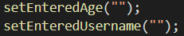

but also to send it to the place where we need the data.



This approach is fine. However, updating the state with every keystroke even though when we need it when we submit the form is redundant. Hence, we use refs.

With refs, we can set up a connection between a HTML element which is being rendered in the end and our other JavaScript code.

Like other hooks, useRef is only usable inside functional components.

It takes in any default values and returns a value which allows us to work with that ref later, so which allows us to work with that element to which we're going to connect it. And therefore, here I'll name this nameInputRef because I plan on connecting this ref with that first input, which allows us to enter a username.

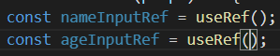

**We can connect any HTML element to one of your references.**

Now, we can let React know that we wanna connect a ref to a HTML element by going to that element to which we wanna connect the ref and adding a special prop there, the **ref** prop.

Also, we can add the ref prop to any built in HTML components like **input** here, since its built in.

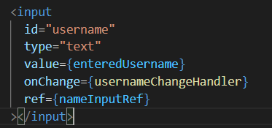

And nameInputRef is just that constant, which stores this first ref. So with that, I'm connecting this ref, which I created in this component **(useRef())** with that JSX code that is rendered by that same component **(here input)**. And now a connection will be established.

The first time React reaches this code (React.fragment) and renders this code, it will actually set the values stored in nameInputRef to the native DOM element that is rendered based on this input. And that's important. What will end up inside of nameInputRef in the end will really be a real DOM element later.

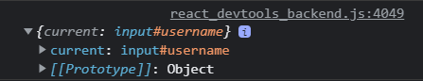

This ref value, which is being generated here always is an object, which always has a current prop and the current prop holds the actual value that ref is connected with. Now, by default, it's undefined but as soon as this code ran, because of this ref prop, the nameInputRef is connected to that input and hence, it's actually the input which is being stored as a value in the current prop. And what's being stored here really is the actual DOM node. So not some theoretical value or anything like that but the real DOM node, which you could now manipulate and do all kinds of things with.

Now, it is recommended that you don't manipulate it. Your DOM should really only be manipulated by React. You're using React to let it do all the heavy lifting but reading data from the input doesn't sound too bad because you're not changing anything with that. You're just reading data.

So if I now save this and I log this value, if I enter Max here, you see MAX being logged here. And that's pretty cool because that means we can get access to the values stored in the element without having to log every keystroke.

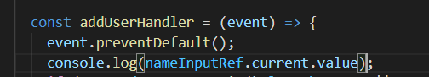

Hence, we create 2 variables, **enteredName and enteredUserAge** and check their conditions and pass them aswell like this.

Also, we remove the bottom 2 lines as we should no longer reset these inputs by resetting the state here though because we're not using the state to get our values anymore. (as we are using ref to get values and not states)

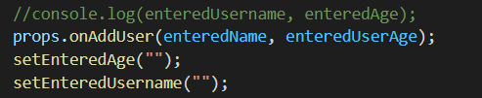

Hence, get rid of all states and state updating functions. Also, get rid of the value and onChange property inside input.

However, we lost our resetting logic. Now, to bring it back we can either use state like we did or manipulate the DOM (which we shouldn’t and let react do it) to reset the values entered by the user

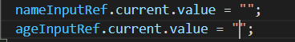.

**Final code using refs**

import Card from "../UI/Card";

import classes from "./AddUser.module.css";

import Button from "../UI/Button";

import React, { useState, useRef } from "react";

import ErrorModal from "../UI/ErrorModal";

import Wrapper from "../Helpers/Wrapper";

const AddUser = (props) => {

  const nameInputRef = useRef();

  const ageInputRef = useRef();

  const [error, setError] = useState(); // initially undefined

  const addUserHandler = (event) => {

    event.preventDefault();

    const enteredName = nameInputRef.current.value;

    const enteredUserAge = ageInputRef.current.value;

    if (enteredName.trim().length === 0 || enteredUserAge.trim().length === 0) {

      setError({

        title: "Invalid input",

        message: "Please enter a valid name and age (non-empty values).",

      });

      return;

    }

    if (+enteredUserAge < 1) {

      setError({

        title: "Invalid age",

        message: "Please enter a valid age (> 0).",

      });

      return;

    }

    //console.log(enteredUsername, enteredAge);

    props.onAddUser(enteredName, enteredUserAge);

    nameInputRef.current.value = "";

    ageInputRef.current.value = "";

  };

  const errorHandler = () => {

    setError(null);

  };

  return (

    <Wrapper>

      {/* using this div because we are rendering 2 components and cannot do them side-by-side so need a root element*/}

      {/* if error is an object (and not undefined) then render ErrorModal, else do not, we use {} because this is a general JS expression

      which also holds some JSX element, i.e., ErrorModal*/}

      {error && (

        <ErrorModal

          title={error.title}

          message={error.message}

          onConfirm={errorHandler}

        />

      )}

      <Card className={classes.input}>

        <form onSubmit={addUserHandler}>

          {/* specify a fn to the onSubmit prop which is executed when the form is submitted*/}

          <label htmlFor="username">Username</label>

          <input id="username" type="text" ref={nameInputRef}></input>

          <label htmlFor="age">Age (Years)</label>

          <input id="age" type="number" ref={ageInputRef}></input>

          <Button type="submit">Add User</Button>

        </form>

      </Card>

    </Wrapper>

  );

};

export default AddUser;

// We use label so that when we click on the text within the label, it toggles the control, i.e., basically to improve usability for mouse users

// Also the id within the input and the htmlFor within the label should be same so that we can they can co-ordinate (htmlFor in jsx else for)

If you only want to read a value and you never plan on changing anything, well, then you don't really need state because just to use state as a keylogger is not that great. It's a lot of unnecessary code and work. So if you just want to read a value, refs are probably better. In scenarios like this, it's up to you what you prefer. Refs, which are a little bit less code but you have this edge case of manipulating the DOM, or a state, which is definitely cleaner but is a bit more code.

**Watch video 106 (3mins)**

**Section 10: Advanced Handling States**

If we would send a Http requestfor example, directly here (in a component). Then we would send this request whenever this function re-runs. So for example, whenever this state changes and that might sometimes be what you want but definitely not always. And if in response to your Http request you for example eventually change some state, you would even create an infinite loop. Because you would send the request whenever the function re-runs. And in response to the request you change some state which triggers this function again. So therefore such side effects should not go directly into this component function because that would most likely create bugs, infinite loops or simply send too many Http requests to stick with that example.

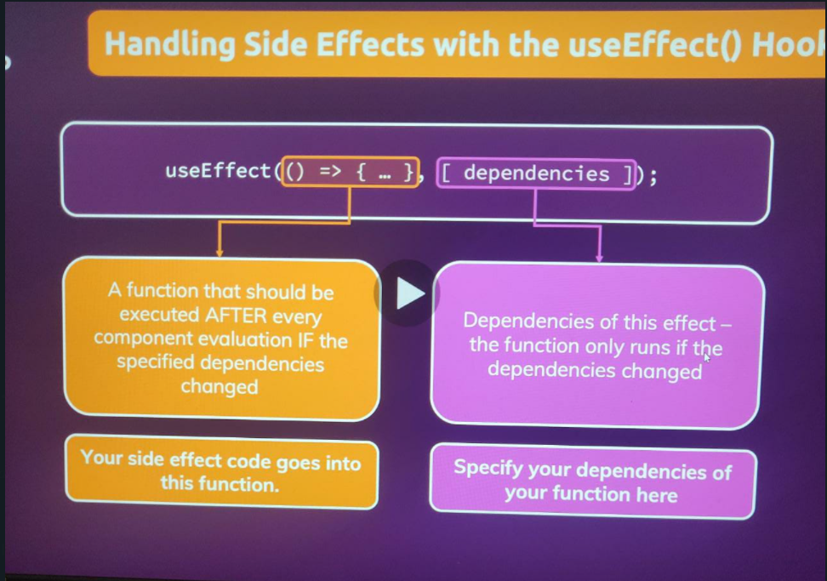

Second argument is an array full of dependencies. Whenever such a dependency changes, the function re-runs.

And therefore in that first function you can put any side effect code and that code will then only execute when the dependencies specified by you changed and not when the component re-renders. So only when your dependencies changed.

In our current project:

At the moment we lose the login credentials on refreshing the page (after logging in) because in the app.js file where I manage this simple **isLoggedIn** state, it's just managed as some react state. And therefore it's just in the end, managed in some JavaScript, the variable behind the scenes by react. Now the nature of that is that when you reload your application, your entire react script restarts and all variables from the last execution are lost. That's how the web and scripts and the browser works. This is nothing react specific.

Now, since we lose all the data, when this restarts it would be nice to store it somewhere where it persists the reload. And even better than that, we also want to make sure that whenever this app does start, we check if the data was persisted. And if it is we log the user in automatically so that the user doesn't need to re-enter the details.

**localStorage** is a global object available in the browser where we can store something.

**Approach 1:**

We can use the localStorage which takes 2 arguments, a key-value (both string) to keep track about whether the user is logged in or not. (change value of key for login and logout). And when the page is refreshed, before asking login credentials from the user, we can check if the storage value shows **logged in** and if it does, we update the state (which we earlier did when the user entered credentials).

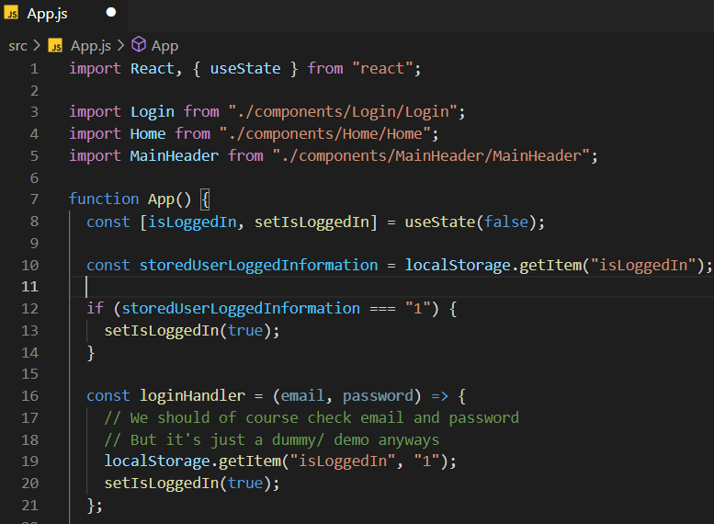

However, this approach fails as we are running an infinite loop because when we check the if condition, if it returns true then we update the state and as we know updating the state causes the component to re-render, therefore our component re-renders and we are stuck in an infinite loop.

Hence, we need to use useEffect here as it allows us to control when this if condition should run. So, make a useState with first thing as a function and the second as an array of dependencies.

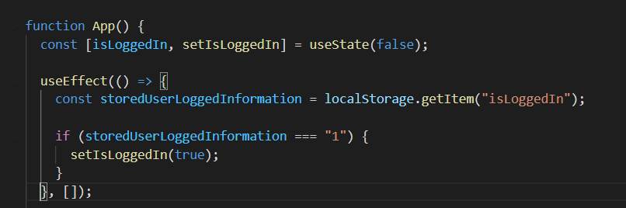

Because now this function here is executed by react and it is executed after important, after every component re-evaluation. So whenever this component function ran (**App component**) thereafter, this will run (**useState**).

And if you then update the state in here (**useState**) the component will run again. But it (**useEffect function**) will not just run after every component evaluation but only if the dependencies here changed. Now when the app starts for the first time that will be the case. If this component function runs (**App**) for the very first time because your app just started, then the dependencies are considered to have changed because you had no dependencies before you could say.

But once it ran for the first time for example, with this setup here, we have no dependencies but therefore of course they also didn't change compared to the first execution cycle. So therefore this anonymous function here would indeed only run once when the app starts because thereafter the dependencies never change because this here specifically has no dependencies. And in this scenario, that's exactly what we want. We want to run this code (**useState function code**) once and that's when our app starts up. So therefore here we should have exactly the behavior we want. Once the app started, this code (**useState function code**) runs. Here we update the state and as you learned this triggers this component function (**App)** to run again.

Now therefore this all runs again, this JSX code is evaluated (**inside return)** and the dom is updated accordingly but thereafter the effect would run again but only if our dependencies also changed. And that's not the case here as I explained. So therefore digit only run once. And hence if we saved that and I reload here you see I am logged in. I don't end up on the authentication screen but in the logged in state.

In short, reload => useState renders -> App renders -> (useState function doesn’t run) -> return statement of app renders.

With empty dependency list our useState only ran when we rendered the component for the first time. However, it is common to use useState and run it whenever a particular prop, or any value or anything changes.

Hence, we use **useState** within **Login.js** to demonstrate this.

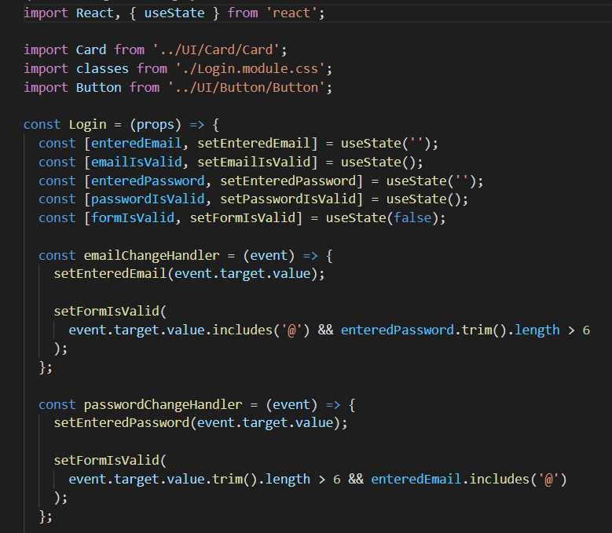

Rather than use the above approach wherein (for every keystroke the emailChangeHandler function runs and it sets the form as valid/invalid and we got the same for passwordChangeHandler) we use the same logic (if condition) in email and password, we could use useEffect to have one place where we could mark the form as valid/invalid with 1 logic that should trigger whenever the email or password changed. Hence, we need a dependency.

--------------------------------------------------------------------------------------------------------------------------

Hence, we use the following approach. Here we want to reevaluate this and rerun this form validation state setting function for every keystroke in email and password change handler. (we use useEffect else this function would run everytime the component is rendered, which would setState and then again call re-render of this component and set an infinite loop)

Since we are using dependencies now useEffect function reruns whenever enteredEmail or enteredPassword changed. It helps us make sure that we have one code, in one place, instead of as before in multiple places which reruns, whenever one of the dependencies changed. So it's not just for when a component was created for the first time, but it's equally common to use it to rerun logic when certain data, typically some state or some props changed

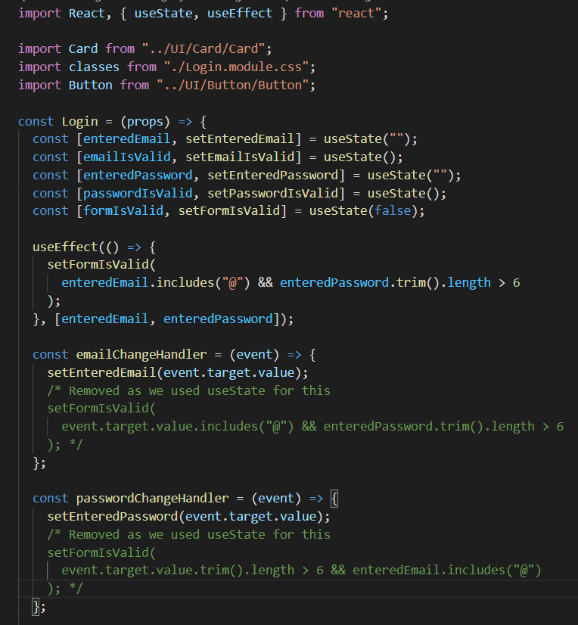

And this tells React, that after every login component function execution, it will rerun this useEffect function but only if either setFormIsValid, or enteredEmail or enteredPassword, changed in the last component rerender cycle. If neither of the three changed, this effect function will not rerun.

**// if we added setFormIsValid as a dependency. Note that we do not add setFormIsValid() as it would add the result of this function execution, rather pass the pointer to fn.**

**Now actually, you can also omit setFormIsValid because those state updating functions by default are insured by React to never change. So these functions will always be the same across rerender cycles, so you can omit them. enteredEmail and enteredPassword could have changed of course. To be precise, with every keystroke, one of them will change.**

Here we might be confused as to why we are using useEffect and not useState to update the state of the form. Remember that useEffect has one main job, it's there to handle side effects and often side effects are http requests and so on, but it's also a side effect, if we listen to every keystroke and save that entered data as we're doing it in the emailChangeHandler for example and we then wanna trigger another action in response to that. So checking and updating that form validity, in response to a keystroke in the email or a password field, that is also something you could call a side effect. It's a side effect of the user entering data. It could be anything, whenever you have an action that should be executed in response to some other action, that is a side effect and that is where a useEffect is able to help you.

**Read this :** [**https://www.udemy.com/course/react-the-complete-guide-incl-redux/learn/lecture/25871518#search.**](https://www.udemy.com/course/react-the-complete-guide-incl-redux/learn/lecture/25871518#search)

**UseEffect Cleanup Function**

Currently we are updating the state inside of our useEffect function after every keystroke. However, let us say we are sending the data to the server data to check if the username entered by the username is valid or not. We do not want to be doing this for every keystroke as it would generate unnecessary traffic.

Hence, we make use of the concept called **DeBouncing, i.e.,** not update the state after every keystroke but rather let us say, 500ms after the user stopped typing.

However, if we just add a timer it does nothing but delay the console.log by 500ms, as for every keystroke we are delaying it by that much of amount. Hence, what we do is we keep resetting the timer for every keystroke. (so that only 1 timer is running at a time, i.e., save the timer and clear it for the next keystroke)

In the first argument we pass the function. However, we can even return something. (an arrow function) So here you can also return a function, for example, an anonymous arrow function. But it could also be a named function just as for all the places where I'm using anonymous functions. So we are returning this anonymous arrow function here. That's a so-called cleanup function. This will run as a cleanup process before useEffect executes this function **(function in the first argument)** the next time.

So to make it clear when this runs, whenever this useEffect function runs (function defined in the first argument), before it runs, except for the very first time when it runs, this cleanup function will run. And in addition, the cleanup function will run whenever the component you're specifying the effect in unmounts from the DOM, so whenever the component is reused.

So basically like earlier our function (first argument console.log) was running after every keystroke. Now after adding the cleanup function, initially the console.log function runs, however after that on every keystroke, first the cleanup function runs and then the console.log (function defined in the first argument).

So with all this knowledge we can use the fact that SetTimeout actually returns a handler, let's say, or actually, an **identifier** for the timer that was set. And we can use this identifier to clear this timer (by passing in cleanup). This clears the timer that was set up before this cleanup function ran, i.e., in the previous execution of the first argument function of useState.

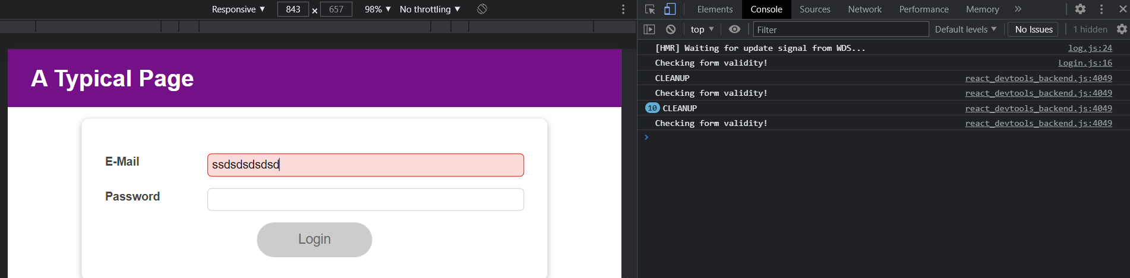

Hence, we see that first the **Checking form validity** code runs. Then before the next time it runs, the **Cleanup** function runs first and then the first argument function. Also, from now the first argument function doesn’t run for every keystroke (ran once for 10 keystrokes) but rather when there is a time delay of 500ms.

And that means that this code in here (first argument function) only ran once for all those keystrokes. And that's what I mentioned earlier. If we want to be sending an HTTP request here, we would have now only sent once instead of a dozen HTTP requests. And that's an improvement.

**UseReducer**

2 use cases are as follows:

1) When we have states that belong together, like here, with the entered value and the validity of the value.

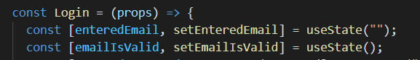

2) Let us assume we go back to the original code and are not using useEffect. Hence, there is a very serious problem here which we might ignore. Here, when we use **setFormIsValid** we are dependent on the previous state snapshots (we are updating the form validity state based on 2 other states). However, we learnt that in some cases it might happen that the setIsFormValid is executed first before fetching the latest snapshot of any one of the two we need (entered password might not contain the latest snapshot because of how the react schedules state updates). Hence, we should use the prevState function. However, we cannot use it here because for using that function, the setFormIsValid should be dependent on the latest snapshot of its own state (on the latest snapshot of the **formIsValid** state, i.e., the state for which this function sets the value) and not of any other two useStates Hence, here is a good place to use the useReducer (**when we have state updates that depend on other states)**.

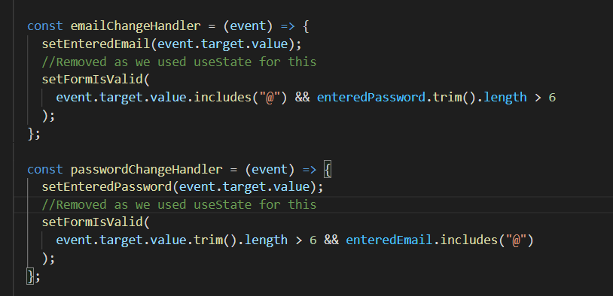

We are doing the same thing here (violating the rule of using the function form if a state update depends on an older state). Here we are calling setEmailIsValid and passwordIsValid to set the states for emailIsValid and passwordIsValid states. However, we are setting these states by having a look at the enteredEmail state which is a different state. It might happen that the state update for enteredEmail wasn’t processed in time and then we would try to update emailIsValid on some outdated enteredEmail state.

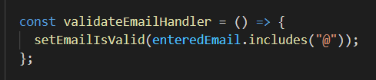

Hence, we might wanna use useReducer to combine these states. We can also create a useState object and manage those together, however this is also an approach.

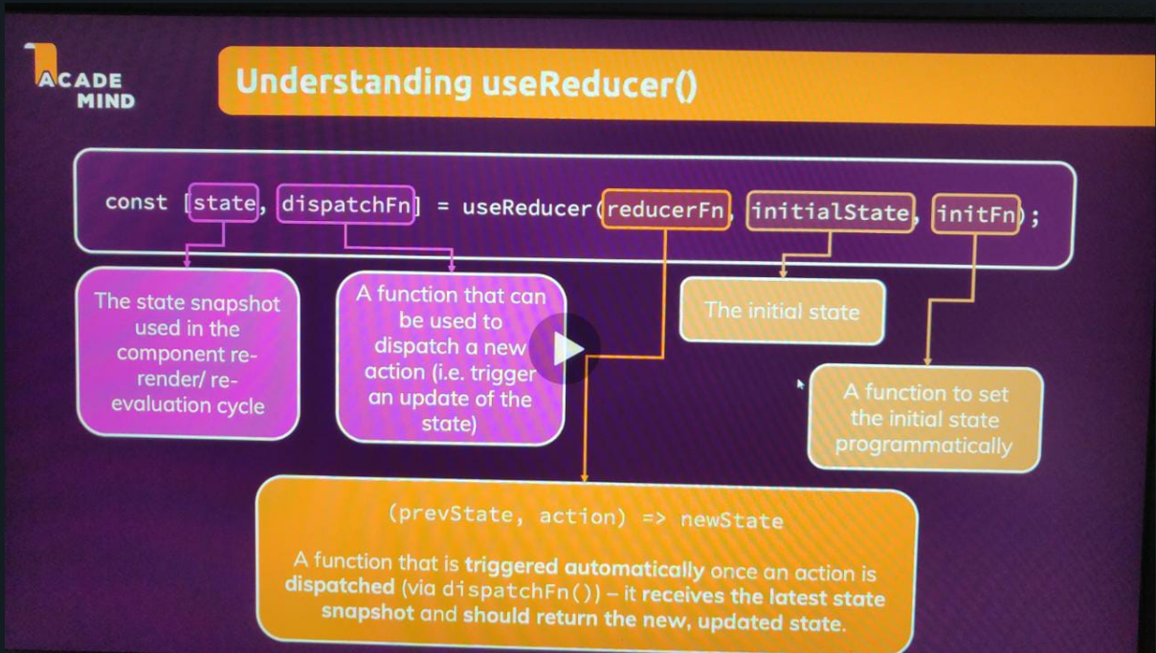

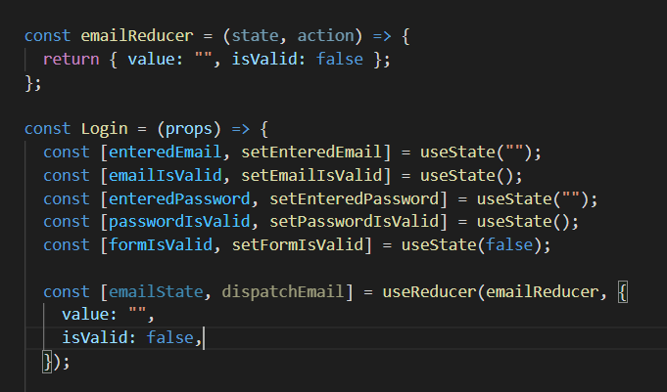

Now, please note that I created this reducer function (emailReducer) outside of the component function. And I did so because inside of this reducer function, we won't need any data that's generated inside of the component function. So this reducer function can be created outside of the scope of this component function because it doesn't need to interact with anything defined inside of the component function. All the data which will be required and used inside of the reducer function will be passed into this function when it's executed by React, automatically. So that's why we can define it outside of the component function here.

Also this reducer function (**emailReducer)** receives two arguments, two parameters. Our last state snapshot and the action that was dispatched.

We are returning a new state which is an object where we have **value** and **isValid** field.

We have also set their initial state in const[] definition.

Now we use this emailState in place of our enteredEmail and emailIsValid state and change the following to

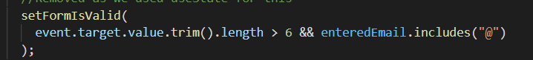

This (and repeat the same everywhere, even in props).

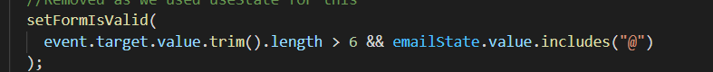

This code is changed by the isValid property. (field of the object) (instead of re-evaluating here, we just check)

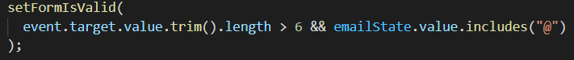

To



Now we want to dispatch an action **dispatchEmail**

1) when we want to change the value

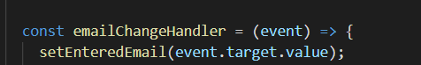

2) update the validity

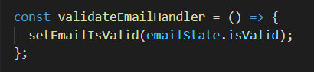

The type field describes what happened and val is the extra payload (value entered by the user). This causes the **emailReducer** function to execute.

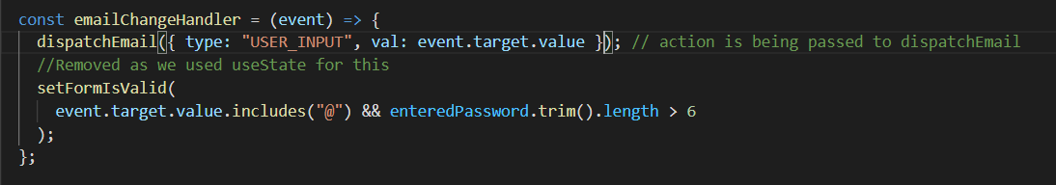

We are checking action.type because **what we dispatch as an action is an object because that’s what we set in the last SS.** Also what we return is an object and **val** here in **action.val** is the extra payload. Hence, im updating the value whenever I receive the USER_INPUT action and for any other action we return the default thing.

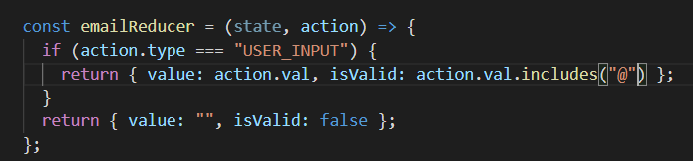

**NOTE: Action structure should be similar everywhere like in the first SS when we dispatched an action in emailChangeHandler and now when we dispatch action on the validateEmailHandler. Hence, we pass an object as the action. However, we don’t use the val field because we don’t need to pass any data.**

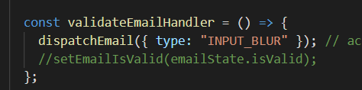

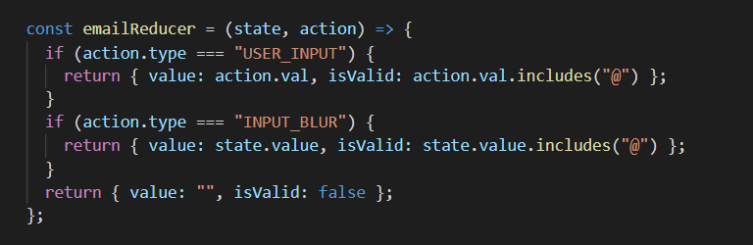

**Note that since input can go blur (mouse can click somewhere else) even after entering a valid input. Hence, I use the latest snapshot which is present in state given to us by react.**

Now instead of using setFormIsValid like this, we use useEffect because here the formIsValid state depends on the latest snapshot of other 2 states and hence not a good approach

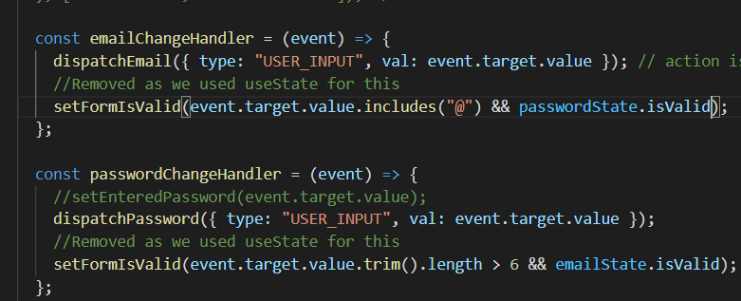

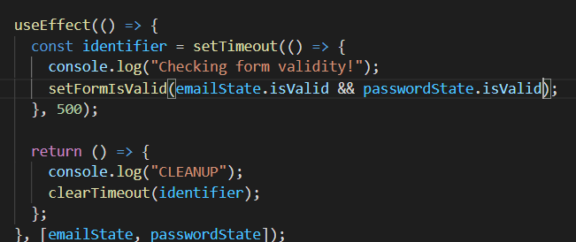

And this what now be a fine way of calling setFormIsValid, because since it's now inside of an effect, we still refer to our state snapshots, but this effect is guaranteed to rerun whenever these states change, and therefore ultimately, it will run with the latest state values.

Since useEffect runs only after the states have been updated with the latest snapshots and never earlier which could have been possible before due to react scheduling state updates (since it depends on 2 other states, we cannot use prevState function).

However, our use state is changing every time we change the inputs even though it should change when the validity changes. Hence we use object destructuring. Here on the left hand side we first write the property we want to grab and then define an alias for it.

**isValid : emailIsValid // here emailIsValid is an alias for the isValid property we have got from the emailState object. This is an alias assignment and not a value assignment as we are doing object destructuring.**

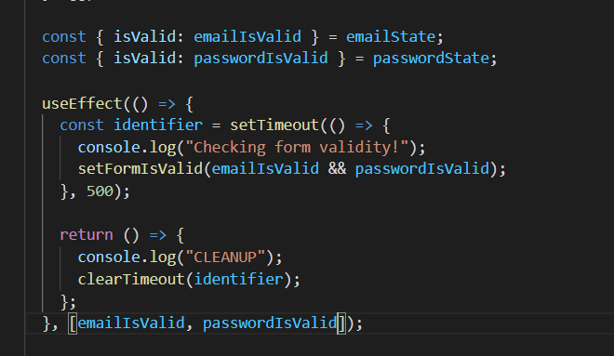

Hence, the useEffect will only run whenever the validity changes and not the input value changes. Hence, we avoid unnecessary running of the effect.

Instead of object destructuring I can also directly write **obj.property,** however this looks better.

I just want to point out, that they **key thing is NOT that we use destructuring** but that we **pass specific properties instead of the entire object** as a dependency. Because now the **effect function would re-run whenever ANY property** of someObject changes - not just the one property (someProperty in the above example) our effect might depend on.

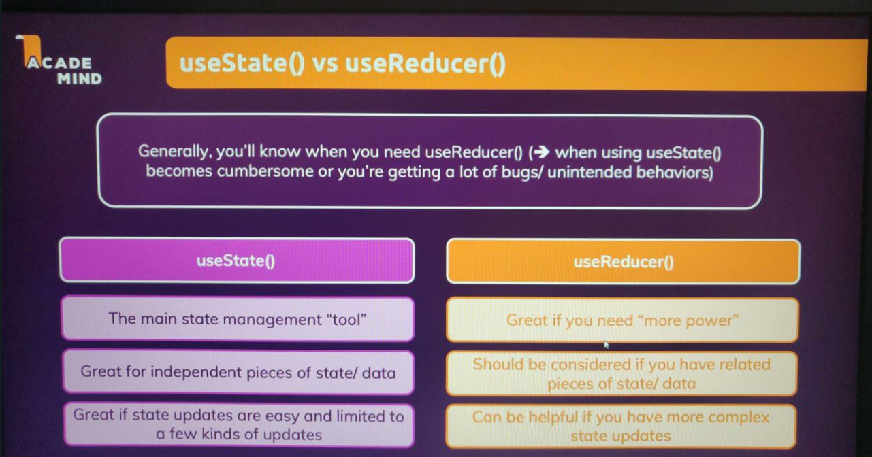

**React context API**

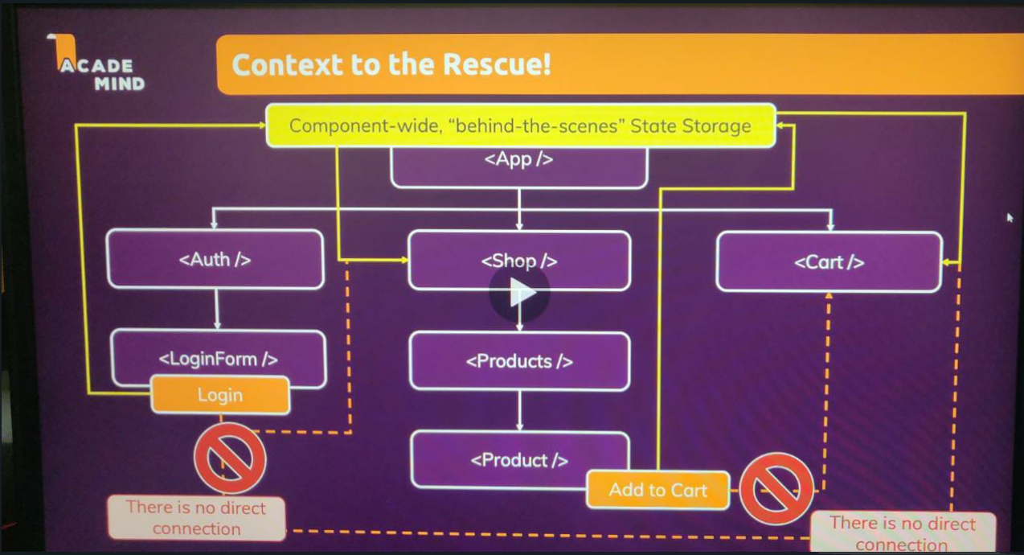

Here we need to send the function pointer from the App component to the shop, then products then finally to the product component which uses it. Hence, this causes a lot of transfer of data via props wherein some components don’t even need that data, however need to receive it so that they can pass it to their child/parent.

So therefore, in bigger apps, you could easily build such prop chains, which are used to forward data through components to other components. That's something you can do, and that's not necessarily bad but the bigger your app gets, the more inconvenient it is to do that. Instead, it would be nicer if we could use props in a component to only receive the data this component really needs from its parent, and not to forward our data through the parent which the parent doesn't ever manage nor need itself.

And for that we got a component-wide, "behind the scenes", State Storage, built into React. We have a concept called React Context, and this then allows us to, for example, trigger an action in that component-wide State Storage, and then directly pass that to the component that is interested without building such a long prop chain. And that allows us to solve our problem in a more elegant way here.

This React Context Concept, allows us to manage State kind of behind the scenes in React, such that we actually are able to directly change it from any component in our App and directly pass it to any component in our App without building such a prop chain.

createContext creates an object which takes in your state to be managed.

What this returns (left side) is an object which contains a component.

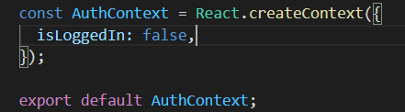

The two things we need to do with this object are:

1) Providing it: "Hey, here's my Context." All components that are wrapped by it should have access to it.

2) Consuming it

1) Providing: Providing means that you wrap in JSX code all the components that should be able to tap into that Context, so that should be able to listen to that Context. Any component that's not wrapped will not be able to listen. (below SS)

So here, if we know that we need this Context everywhere in the entire application, so in all components possibly, we wanna wrap everything in app component with it. If we knew that we only needed, let's say, in the log in component and its child components, we could only wrap to login component.

We import the AuthContext object and then access its properties (to wrap out JSX) which contain components.

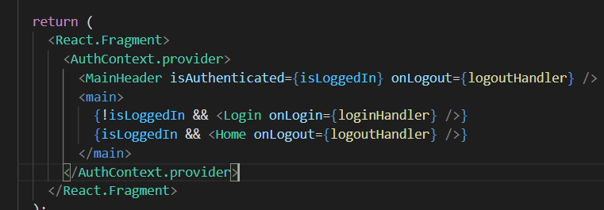

Now all the included components between this wrapper, their children and so on will have access to this context.

We can remove React.Fragment because we are using this wrapping component as a root level component. Now everyone has access to AuthContext.

2) Listening: a) use the consumer approach which isn’t that good syntactically.

b) use the useContext hook.

We pass in the pointer to the Context we wanna use. What it returns is ctx (context data, in our case it is the object we pass which contains isLoggedIn currently). All these children which are wrapped inside the provider have access to this ctx.

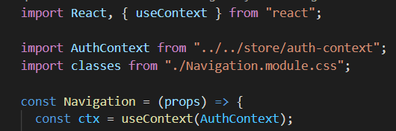

The following is app.js code where we pass value prop with the loggedIn value which is dynamically changed. This value object is changed whenever loggedIn is changed. Whenever it changes, the new value is passed down to the consuming components.

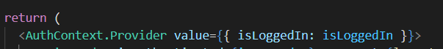

Prior code of navigation New code of navigation

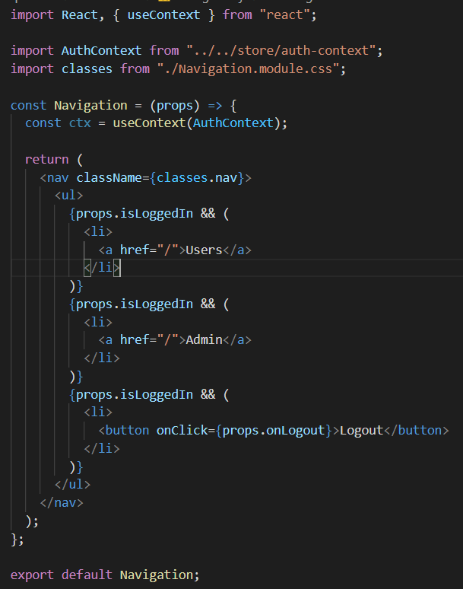 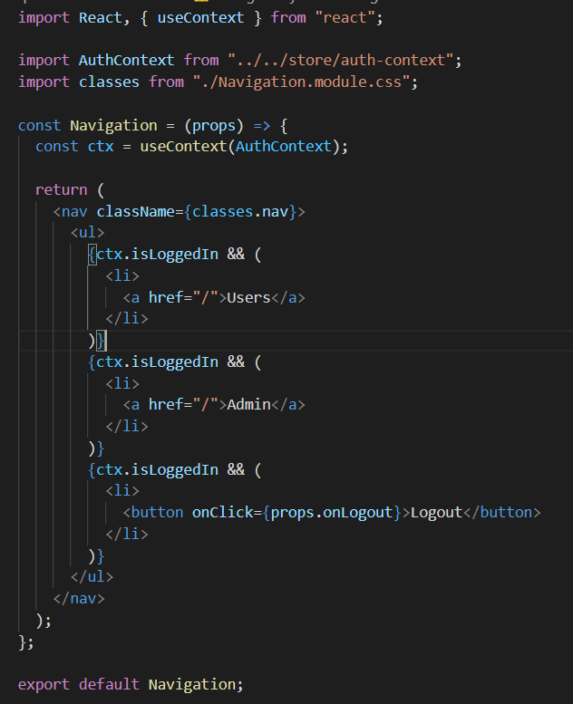

Note that instead of props we are using ctx.

Hence, we have successfully used the useContext to pass the inLoggedIn state to the other components.

Following is code in App.js.

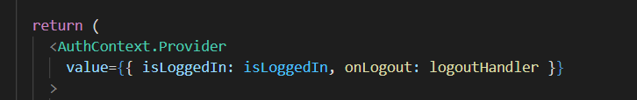

Every component which listens to AuthContext will be able to utilise the logoutHandler through the onlogout context value.

Therefore now, we're using this app-wide or component-wide context object to manage our state and to manage the function that changes the state.

Also just add a dummy function in the auth-context.js file so that ide suggests this. (because it looks on this default context object to find out what we are able to access on our context)

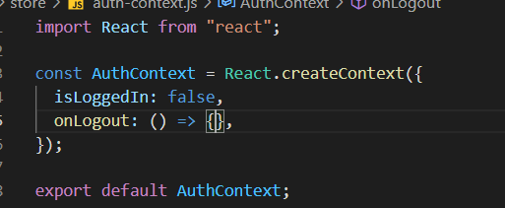

Following is the current code of App and auth-context. However, it would be great if we wont need to do all this authorization in the App component but rather do it completely in the auth-context file. Hence, the following code will be changed to something else.

**auth-context.js**

import React from "react";

const AuthContext = React.createContext({

  isLoggedIn: false,

  onLogout: () => {},

});

export default AuthContext;

**App.js**

import React, { useState, useEffect } from "react";

import Login from "./components/Login/Login";

import Home from "./components/Home/Home";

import MainHeader from "./components/MainHeader/MainHeader";

import AuthContext from "../src/store/auth-context";

function App() {

  const [isLoggedIn, setIsLoggedIn] = useState(false);

  useEffect(() => {

    const storedUserLoggedInformation = localStorage.getItem("isLoggedIn");

    if (storedUserLoggedInformation === "1") {

      setIsLoggedIn(true);

    }

  }, []);

  const loginHandler = (email, password) => {

    // We should of course check email and password

    // But it's just a dummy/ demo anyways

    localStorage.setItem("isLoggedIn", "1");

    setIsLoggedIn(true);

  };

  const logoutHandler = () => {

    localStorage.removeItem("isLoggedIn");

    setIsLoggedIn(false);

  };

  return (

    <AuthContext.Provider

      value={{ isLoggedIn: isLoggedIn, onLogout: logoutHandler }}

    >

      <MainHeader />

      <main>

        {!isLoggedIn && <Login onLogin={loginHandler} />}

        {isLoggedIn && <Home onLogout={logoutHandler} />}

      </main>

    </AuthContext.Provider>

  );

}

export default App;

**AuthContextProvider is a component which we created and exported using a named export.**

**auth-context.js**

import React, { useContext, useState, useEffect } from "react";

const AuthContext = React.createContext({

  isLoggedIn: false,

  onLogout: () => {},

  onLogin: (email, password) => {},

});

export const AuthContextProvider = (props) => {

  const [isLoggedIn, setIsLoggedIn] = useState(false);

  useEffect(() => {

    const storedUserLoggedInformation = localStorage.getItem("isLoggedIn");

    if (storedUserLoggedInformation === "1") {

      setIsLoggedIn(true);

    }

  }, []);

  const logoutHandler = () => {

    localStorage.removeItem("isLoggedIn");

    setIsLoggedIn(false);

  };

  const loginHandler = () => {

    localStorage.setItem("isLoggedIn", "1");

    setIsLoggedIn(true);

  };

  return (

    <AuthContext.Provider

      value={{

        isLoggedIn: isLoggedIn,

        onLogout: logoutHandler,

        onLogin: loginHandler,

      }}

    >

      {props.children}

    </AuthContext.Provider>

  );

};

export default AuthContext;

**App.js**

import React, { useContext } from "react";

import Login from "./components/Login/Login";

import Home from "./components/Home/Home";

import MainHeader from "./components/MainHeader/MainHeader";

import AuthContext from "../src/store/auth-context";

function App() {

  const ctx = useContext(AuthContext); // AuthContext object which is our default export in the auth-context file

  return (

    <React.Fragment>

      <MainHeader />

      <main>

        {!ctx.isLoggedIn && <Login />}

        {ctx.isLoggedIn && <Home />}

      </main>

    </React.Fragment>

  );

}

export default App;

The advantage here could just be that you have a leaner app component which again is now just focused on returning JSX (inside return) and bringing something onto the screen. And you have to actual off state management and auth-context management all in one file.

**Hence, this is good for states which effect multiple components.**

**Hook rules**

We cannot call useState or hooks in the following function as it returns an object and is therefore not a component (a component is one that returns JSX).

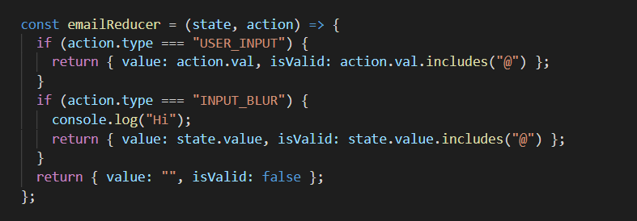

We cannot call hook statements between any block statements (eg if condition or calling a useState inside a useEffect function). It must be at the top level of the component.

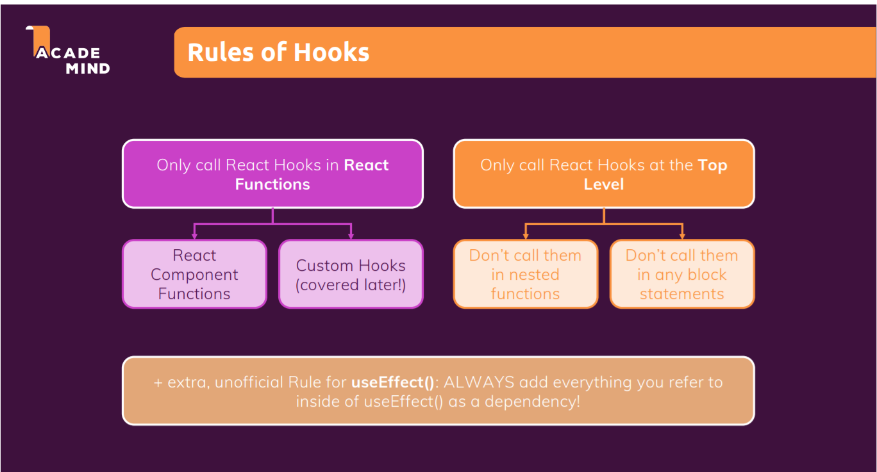

**Looking into forward refs**

Instead of using div to create multiple input, we have created the **Input** component and passed props to-it.

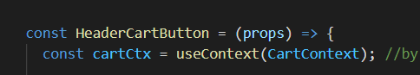

Now by using use context here, the header cart button component will be a re-evaluated by react whenever the context changes. And it of course changes when we do update it in the cart provider component. So now we established this connection

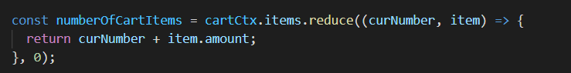

We can now use this to output our number of cart items. For this we can add another constant here. Number of cart items sounds like a descriptive name and here we want to get access to cartCtx.items. And you could no think that you simply use the length of that array to get the number of cart items. This could work depending on how you write your cart logic but I don't want to add every item as a new entry in that list. Instead if we add, let's say three pieces of sushi I want to add one item to the cart items array but set the amount for that item to three. So then the length would be wrong because it's just one item and the cart items array but there are actually three meals inside of it simply because inside of our cart items array will have objects where for every kind of meal we stored the amount of meals of that type is part of the cart. So therefore the proper way to derive that number of items is to access cart items. So cart contexts on items, but then use the reduced method on that reduces a built in method in the end that is a method which allows us to transform an array of data into a single value into a single number in this case. For data takes two arguments. The first argument is a function which will be called for you. The second argument is a starting value and you'll see why it's a starting value in a second. Here we use 0, this function which has passed and as a first argument then receives two arguments itself automatically by JavaScript which is calling that function for every item in that array on what you're calling reduce. That's the current number. However you want to name it. And then the item at which it's currently having a look and current number will be different for every item it's calling it. Item will also be different, but this (**current number)** is basically a number of value which has carried on across executions. Initially it's (**current number**) 0, but then after the first time this function has been executed it will be the result which you returned in that previous execution. And here I want to return current number plus item dot amount because my cart items objects will have an amount field which stores the number of items per item type. And this will now reduce this array to a single number. And it's this number of cart items which will be output down there.

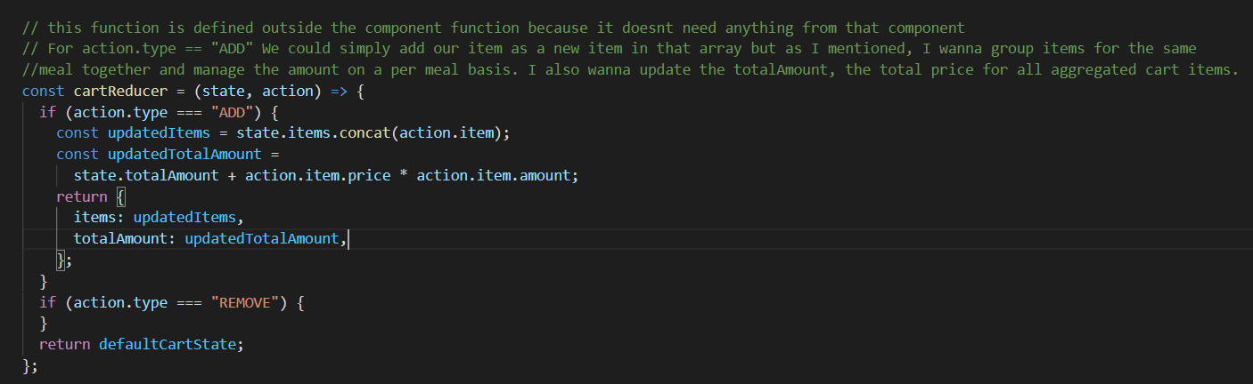

Concat is a built-in method in JavaScript, which adds a new item to an array but unlike push, it doesn't edit the existing array but return a new array. And that's kind of important. You wanna update your state in an immutable way, which simply means you don't wanna edit your old state snapshot because of the reference value thing in JavaScript. That would mean that existing data in memory gets edited without React knowing about it, but instead, you wanna generate a brand new state object, which you return. And concat gives us a brand new array instead of editing the old array in memory, which is better. And we wanna concat this item. This action.item to be precise, which we're getting.

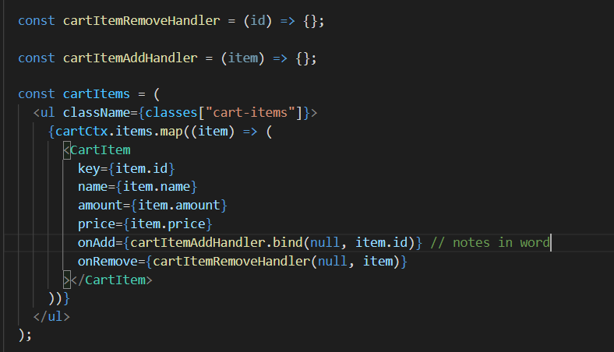

Now on both these functions you should call bind and bind no item ID. This ensures that the ID of the to be added or removed item is passed here to remove handler and on end you should also call bind and bind null and pass the overall item. You'll learn that bind pre-configure as a function for future execution and basically allows you to pre-configure the argument that function will receive when it's being executed. And that's something we need here to ensure that both these functions do receive the ID or the item respectively.

**Section 12: How react works behind the scenes**

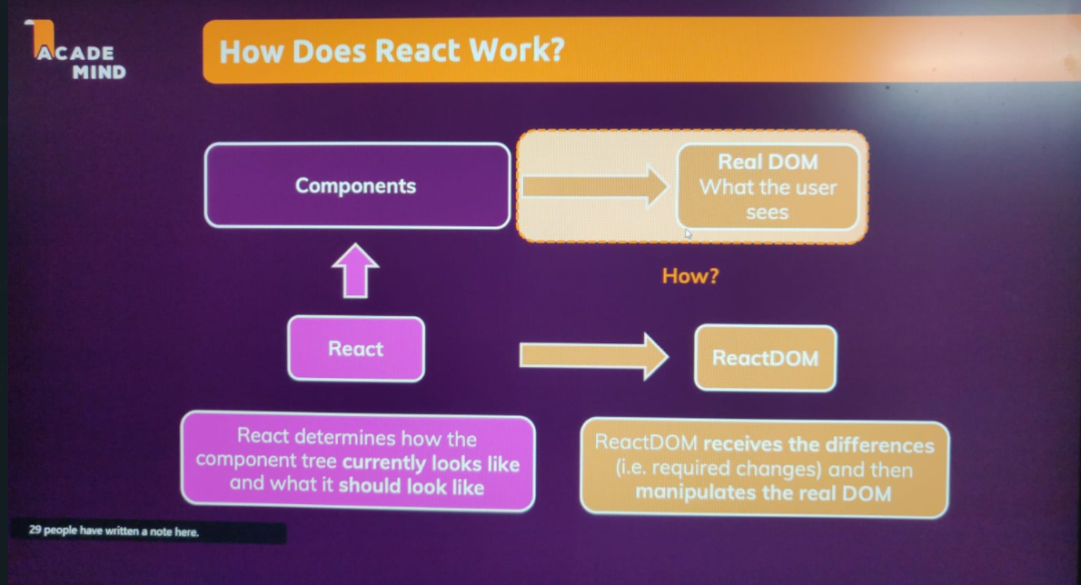

React only cares about **components**. It cares about **props,** which is basically data you pass to components to make components configurable and to enable parent-child component communication. React cares about **state** which is internal data inside of a component. And React cares about **context** which is component-wide data. Now of course, React has a couple of other features built in as well. But these are the core features. And whenever props, state or context changes, components that use these concepts are updated by React and React checks whether this component now wants to draw something new onto the screen. And if that should be the case, React will let ReactDOM know about that so that ReactDOM is able to bring that new screen, that new component, that new output to the screen. It all comes down to state changes as context also manages some state and props are also changed when some state changes in the parent component.

React doesn’t care whether the components contain html or anything, it matters to react-dom. React only handles information about changes between previous and current states.

And what React in the end does is, it uses a concept called the virtual DOM. It determines how the component tree, which your app is building in the end, and every component itself, of course, has a sub tree, that JSX code returned by that component. It determines how that component tree currently looks like and what it should look like, for example, after a state update. And that information is then handed off to ReactDOM which now knows about the differences and which then knows how it should manipulate the real DOM to match that virtual DOM, that virtual snapshot React derived for your component trees.

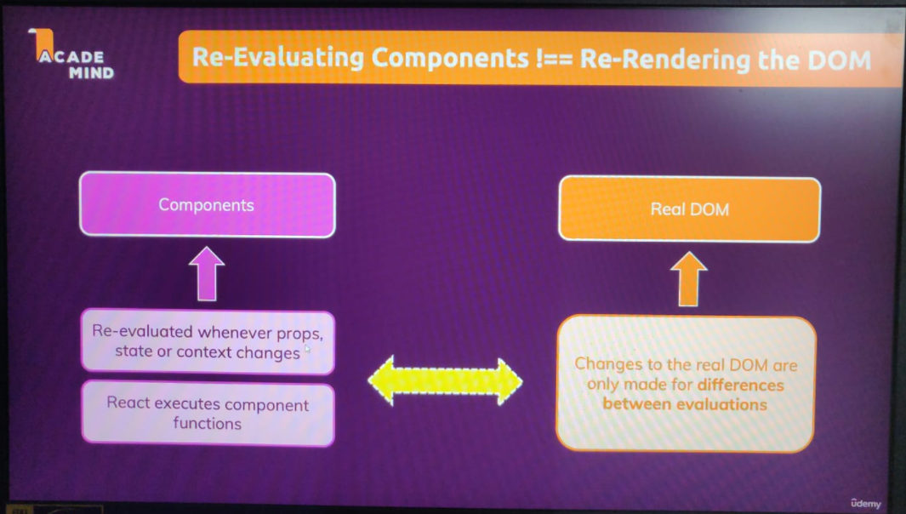

Re-evaluating a component is not the same as re rendering the DOM. So just because a component function is re-executed by React does not mean that the respective part of the actual real DOM is re-rendered or re-evaluated. Instead we have to differentiate between our component part, our React part and the real DOM. Our components, as I just said, are re-evaluated whenever props, state or context changes. So React then executes that component function again.

Now the real DOM on the other hand is only updated in the places where it needs to be changed based on that difference React derived between the previous state of a component and its tree and the current state after the state prop or context change. So the real DOM is not changed all the time. It's changed rarely and only when needed. And that's important for performance, because making a virtual comparison between the previous state and the current state, that's fairly cheap and easy to do. That happens only in memory. Reaching out to the real DOM, that's rendered in the browser is pretty expensive from a performance perspective, because working with the real DOM just turns out to be a performance intensive task. Of course not a tiny change in one place, but if you do that tiny change in a lot of places all the time, then your page might become slow because you're working with the real DOM too much. And that's why React has this structure of doing virtual comparisons with that virtual DOM and then only passing the changes between your last snapshot and the current snapshot to the real DOM.

For example, if the result of previous evaluation is H2 tag and the new evaluation is H2 tag and a <p> tag, then react will report this change to ReactDOM so that react dom can update the real dom and insert this paragraph. ReactDOM will not render the complete page, but only insert the paragraph within the <p> tag.

Example:

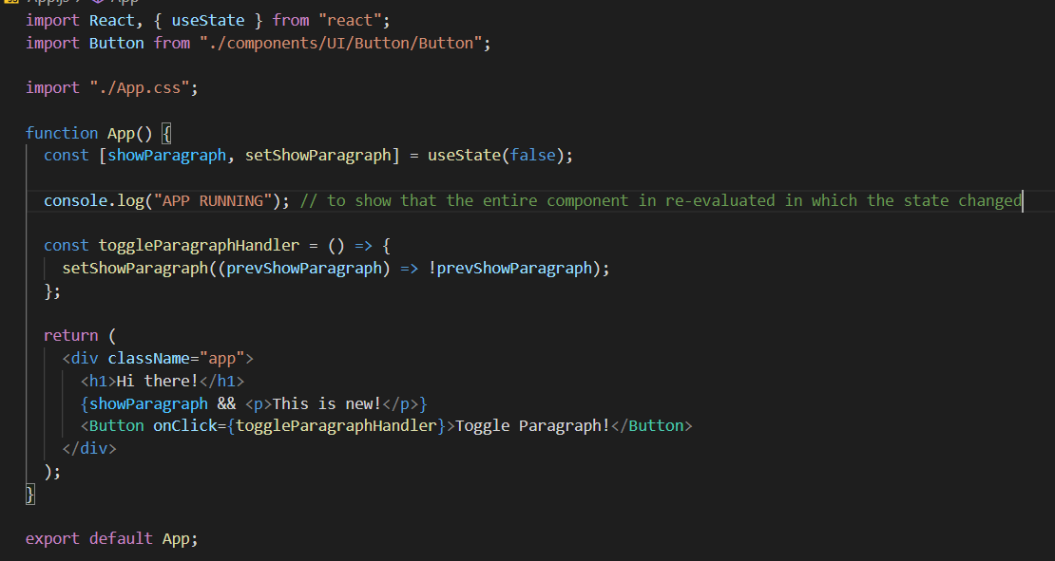

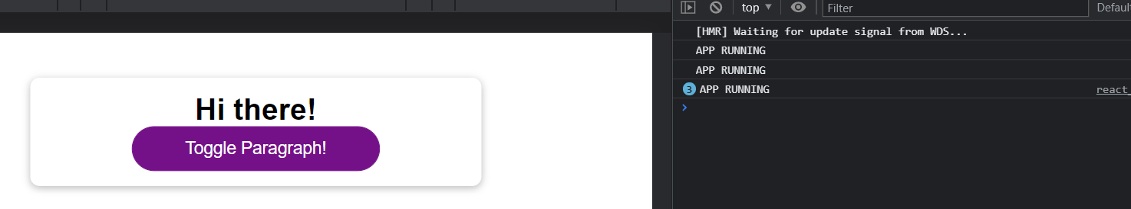

We can see above that for every state change, the entire component is re-evaluated in which the state is changed.

However, in the following we see that the dom only renders for the thing which was changed.

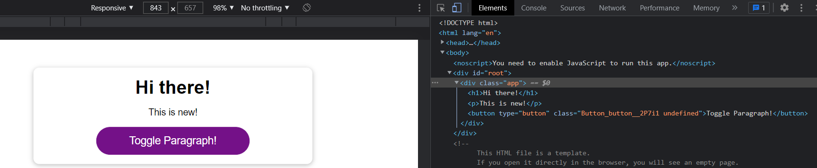

Only <p> was flashed, and it means it was changed (to see where the real dom was re-rendered).

Now we are changing the state in the app component, however <p> which is a part of another component flashes (only). Hence, this shows the diffing property. However, even though clicking on this button performs a change to the <p> in DemoOutput, we have changed the state in App component and hence it is re-evaluated and re-executed and ‘APP RUNNING’ is executed always. Hence, even props always come down to state changes.

Code in App.js.

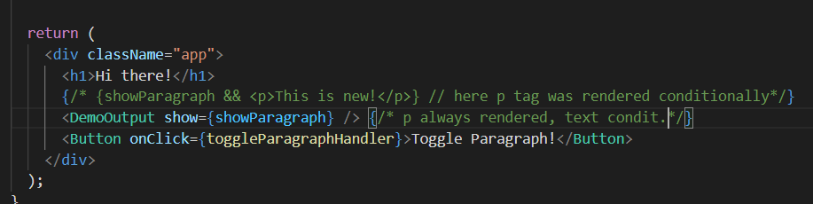

Code in DemoOutput.js.

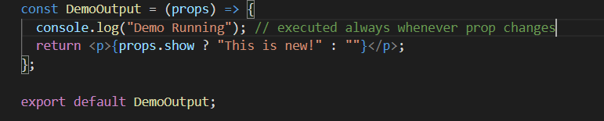

**Very important point to be noted. Even if I hardcode the show prop here as follows,**

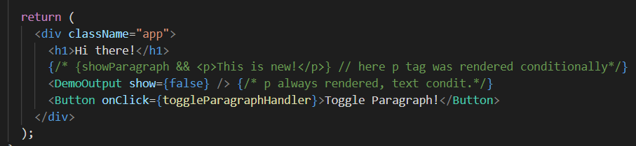

**The console.log statement within the DemoOutput component will execute whenever I click on the button in App component where its state is changed. Why is this happening (because the prop is hardcoded and even if im changing the showParagraph state im not using it as a prop for the child, so why is the child function being re-executed)?**

We have the show prop and the value I pass in there is still false. It never changes, it's always false. So why was DemoOutput re-executed? Well, let's take it step by step. The app function is re-executed because state changed here. Now, what is part of that app function? Of course, this return statement and there we return some js code. Now, all those js elements here in the end are like function calls to the respect of component functions. So we call the function for the DemoOutput component. We call the function for the button component. That's why those child components are also re-executed and re-evaluated just because the parent component changed because they are part of the parent components, function body. And if the parent component function runs again of course the child component functions also run again. So in the end, the prop value doesn't even matter here for this component to be executed again, it's just a fact that the parent changed. Changes in props might lead to actual changes on the real Dom but for the function to be re-evaluated it's enough that the parent component was re-evaluated. Of course, the fact that DemoOutput runs again does not mean that the real Dom is touched. We can verify this with elements there you'll see that nothing flashes. I can hammer that button and nothing changes there because react just re-evaluates the components. And as you learned, re-evaluating a component and re-running its component function is not the same as re-rendering the real Dom or manipulating the real Dom. But it is really important to understand that if a component is re-executed all its child components will also be re-executed and re-evaluated.

So this continuous down the component tree and this poses or this brings up one important question, isn't this bad? Because if all those component functions are re-executed that's a lot of ongoing function executions and virtual comparisons that certainly costs some performance, right? So isn't this bad if there actually is no reason for that because we know for example, that we never need to re-evaluate DemoOutput because it can't change. The only prop, which it has is hard coded. If it had no props at all we also would know the output in there will never change because of the state that's managed in app component. So re-executing DemoOutput and all its children is a total waste.

**To solve this we use the MEMO approach.**

Now, what does memo do? It tells React that for this component, which it gets as a argument, React should look at the props this component gets and check the new value for all those props and compare it to the previous value those props got. And only if the value of a prop changed, the component should be re-executed and re-evaluated. And if the parent component changed but the prop values for that component here did not change, component execution will be skipped.

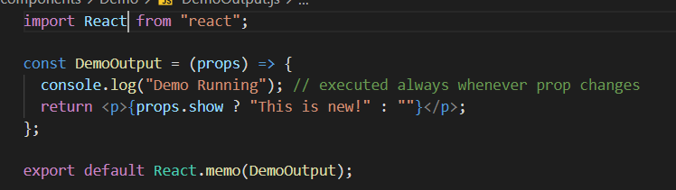

Now, that might bring up a new question, though: Why aren't we using that on all components if it allows us to optimize them? Because this optimization comes at a cost. The memo method here tells React that whenever the App component changed, it should go to this component here and compare the new prop values to the previous prop values, so therefore React needs to do two things. It needs to store the previous prop values, and it needs to make that comparison. And that, of course, also has its own performance cost. And it, therefore, greatly depends on the component you're applying this to whether it's worth it or not because you're trading the performance cost of re-evaluating the component for the performance cost of comparing props.

Of course, React.memo can be a great tool if you have a huge component tree with a lot of child components. And on a high level in the component tree, you can avoid unnecessary re-render cycles for the entire branch of the component tree. Like in this case, by avoiding the re-evaluation of DemoOutput, we're also automatically avoiding the re-evaluation of MyParagraph even though we're not using React Demo in there just because we cut off this entire branch, so this entire branch of the component tree. That is something where React.memo can definitely be worth it. If you, on the other hand, have a component where you know it's going to change or its props values are going to change with pretty much every re-evaluation of the parent component anyways, then React.memo doesn't make a lot of sense because if the result is that the component should re-render anyways, well, then you can also save that extra comparison of the prop values. That's then just some overhead cost, which is not worth it. For small apps, for small component trees, and so on, for all of that, it might simply not worth it to add this. But for larger apps where you can cut off entire branches of unnecessary re-evaluations, it might very well be worth it. You just don't wanna wrap every component with React.memo. Instead, you wanna pick some key parts in your component tree which allows you to cut off an entire branch of child components. That's way more effective than doing this on every child component.

**NOTE: If we apply memo on a component, then all its child components are also not executed until the parent on which we applied memo is executed (which is executed when any prop changes). So, basically we cut the entire branch of unnecessary execution.**

**One super important catch here is that even if we apply the memo to the button component and its props aren’t changing, it is always re-executed. It receives 2 props, onClick and children and none of them changes.**

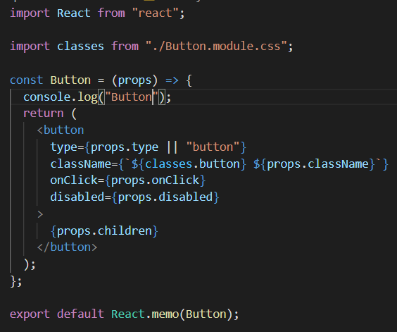

Now the main reason is that: Keep in mind that this App component is just a function in the end, and it re-executes like a normal JavaScript function because it is a normal JavaScript function if your state changes. The only magic thing here is that the function's going to be called by React and not by you. But then, it still executes like a normal function, which means all that code (within App) executes again, and that has one important implication. Of course, this function which you pass to the Button (toggleParagraphHandler) is re-created. This is now a brand new function for every render or every execution cycle of the App function because in the end it's just a normal constant which we recreate.

Since all this code

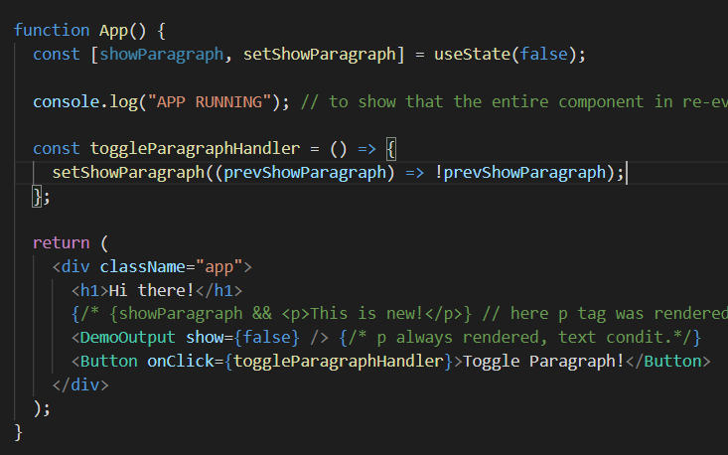

All that code in here is executed again, so, of course, a new function is created. This is not the same function all the time. It's a function that does the same thing. But technically to JavaScript, it's a brand new function for every time the App function is being executed. That's, by the way, also true for false being passed to DemoOutput. Previously, I said that this never changes, even that technically was not correct. This App function is re-executed, therefore a new false value is created. So even if we had false in the last render cycle too, now we have a new false. But if that's the case, why does React.memo then work on the DemoOutput but not on the button? What's the difference between false and the function here? If a new false is created and a new function is created, shouldn't then both components be re-evaluated? Well, for that, you have to keep in mind that false is a boolean, and booleans like strings and numbers are primitive values in JavaScript.

Now, what React.memo does in the end is it has a look at all the prop values, and in the end it compares: **props.show === props.previous.show.**

**Now, even if we have two different Booleans with the same value, i.e., false, this operation will evaluate to true since they are primitive. However, the function toggleParagraphHandler is basically a javascript function object which like arrays will return false when compared with a different javascript function object even with the same values. Two objects in js with the same contents are evaluated to false.**

**Now we need to look at an approach which allows us to do something wherein objects/arrays/functions are received as props and memo fails.**

**Recreation with useCallback**

We can make React Memo work for prop values that are objects as well. We just need to tweak the way we create and store those objects a little bit. There is an extra hook provided by React that helps us with that. And that is the Use Callback Hook. Use Callback is a hook that allows us to basically store a function across component executions. So it allows us to tell React that we wanna save a function and that this function should not be recreated with every execution. With that one in the same function object is stored so one in the same place in memory and therefore the comparison does work (eg if we define obj2 = ob1, then compare them so they will be equal as they point at the same memory)

And that's in the end what Use Callback does for us, it will save a function of our choice basically somewhere in React's internal storage and we'll always reuse that same function object then when this component function executes.

Hence, we just use the following code.

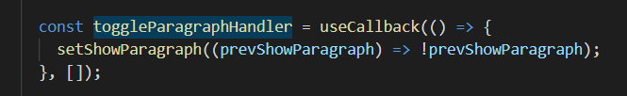

So here we use the Use Callback Hook and pass our function as a first argument to use callback and Use Callback then returns that stored function and when the app function reruns UseCallback will look for that stored function which React stored for us and reuse that same function object.

Here we have an empty array of dependencies which basically tells React that this callback function this function here which we wanna store it in toggle paragraph handler ultimately will never change that it has no dependencies and the data for always the same function object should be reused when the app component rerenders.

Hence, the memo works perfectly as we tell react that this function object is always the same object in memory using useCallback.

**UseCallback and its dependencies**

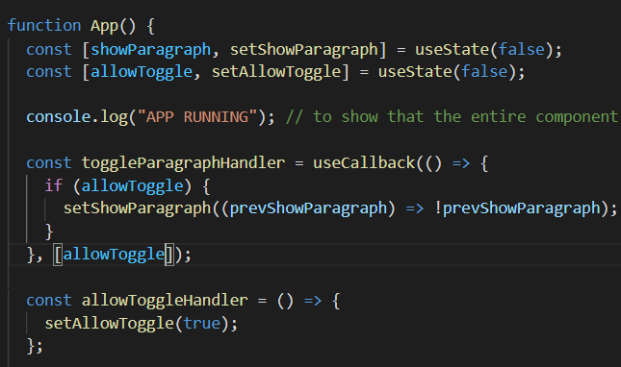

Functions in JavaScript are closures. That means when a function is defined, which happens when the app function runs in this functions case, when that function here is defined, JavaScript basically locks in all the variables that we're using in there. All the variables that are defined outside of the function that we are using, I should say. In this case, the allowed toggle variable, that is a variable or a constant coming from the app function and I'm using it inside of this function. Therefore JavaScript closes over that constant and basically stores that constant for that function definition. That means the next time this function here, the toggle paragraph handler, is executed, this stored variable will be used.

The problem with that, and with useCallback however is, that with useCallback we're telling React to store that function, and exactly that function somewhere in memory. Now, when the app function is re-evaluated and reexecuted because the toggle state changed, then React will not recreate this function because we're using useCallback where we told React that we don't want to recreate it under all circumstances. So therefore the allow toggle value React stored for our function, is still the old allow toggle value from the first time the app component was executed, not the most recent one because JavaScript, as I just explained, stored allow toggle this constant when it created that function here.

So here we would want to add allow toggle as a dependency in our dependency array. And that tells React that we generally want to store that function. But, whenever allow toggle changes and it has a new value, we want to recreate that function and store that new recreated function. And this ensures that we always use the latest allow toggle value inside of that stored function. If allowed toggle does not change however, then we don't recreate the function.

**useState information**

It's strange that even though we call useState every time the app function runs again, we don't seem to lose or reinitialize our state all the time. The reason for that is simple. UseState is coming from React, and I just said that React is managing the state and the connection to the component for you. And as part of that management process, React makes sure that useState and the value you pass as a default value to useState essentially is only considered once. The first time ever a component is rendered, so the very first time the app component runs, useState, when executed, creates a new state variable which is handed off to React and which is managed by React. React then basically memorizes to which component that belongs. The app component, in our case. And it uses the default value to initialize the state with that value. For subsequent app function calls, so for reevaluations of the app component, when useState is being called, no new state is being created. Instead, React recognizes that it already has a state for this component, and it instead simply updates that state as needed because the app function reran because some state changed most likely, and therefore React will only do that state management and updating. It will never reinitialize the state unless the component was totally removed from the DOM in the meantime. Which in case of the app component, will never happen since it's our root component. For child components, if it's rendered conditionally, for example, a component might be removed, and in that case, if it's then later reattached, a new state would be initialized. But as long as a component stays attached to the DOM, state is only updated after that first initialization.

React useState works by scheduling the states updates and sometimes it might not be immediate. Hence, it schedules the update so that when the page is re-rendered, which it will be because we have called the useState updating function, then the values are updated.

That’s the reason we use form function for fetching the latest snapshot when our updating function depends upon the output of the previous state and use useEffect because the function within it is only triggered upon fetching the changed value of the dependency.

**useMemo hook**

Unlike the useCallback hook which is used to store functions, useMemo is used to store any data (for eg if sorting is a performance intensive task and we want to store the sorted list until the array changes, because it might happen that our component re-renders due to something else but a new array with the same value is generated which as we know will lead to calling of the child component) then we use useMemo.

**Section 13: Class Based Components**

Besides building components as functions, which is what we did up to this point, we can also define components with classes.

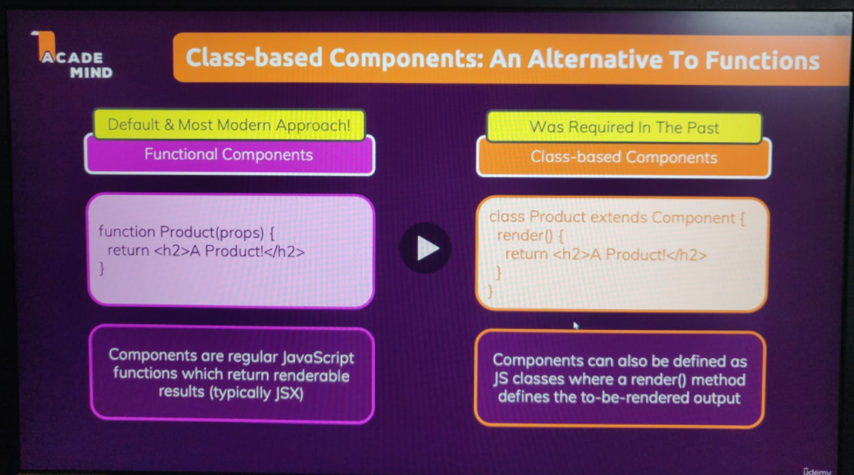

Traditionally, prior to React 16.8, you could not change State in Functional Components and you couldn't really handle side effects there either. That changed with React 16.8 because that React version introduced a concept called React Hooks, which are all these Hooks, these functions starting with use. UseState and useEffect and so on. These are functions for Functional Components, which bring features to Functional Components, which previously were reserved for Class-Based Components. And indeed, Class-Based Components can't use React Hooks.

**Render** is a method managed by react file **component** which is called automatically by react.

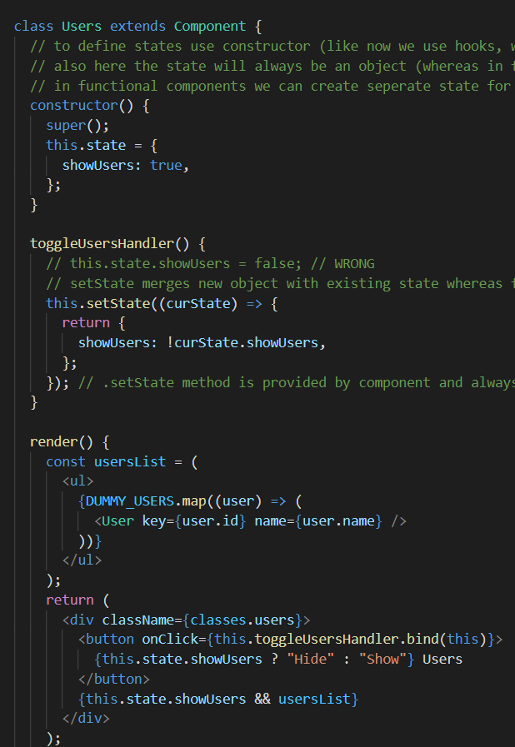

In **this.toggleUserHandler.bind(this)**, the first this is used because we are calling the method which is part of **this class (same class).** However, we now need to make sure that the **this** keyword within the **toggleUserHandler** method refers to the surrounding class (because it wouldn’t by default when we are calling our method within the **return statement** like **this.toggleUserHandler**). Hence, this ensures that the **this** keyword refers to the same class.

It is not required in the functional components because there we define a function just before we use it and we are not working inside a class.



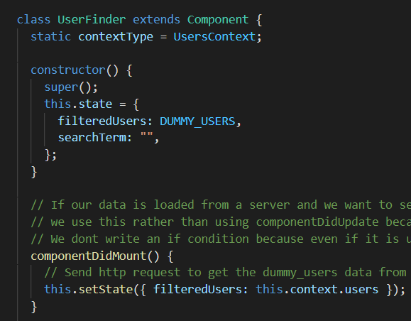

With use context, you can listen to multiple context in one of the same component by calling use context multiple times and pointing at different contexts. This will not be possible with class based components, because there you can only connect a class based component to one context. And you do that by adding a static property, by adding the static keyword here and then adding the property named context type written like this. And then you assign a value of users context here. With that you're telling React hey this component should have access to the user's context context, but you can only set the static context type property once so if there are two contexts which should be connected to one at the same component, this would simply not be an option, you would have to find some other work around like wrapping it in a number component or anything like that.

**componentDidUpdate, componentDidMount, componentWillAmount are all lifecycle methods.**

**Section 14: Sending HTTP Requests**

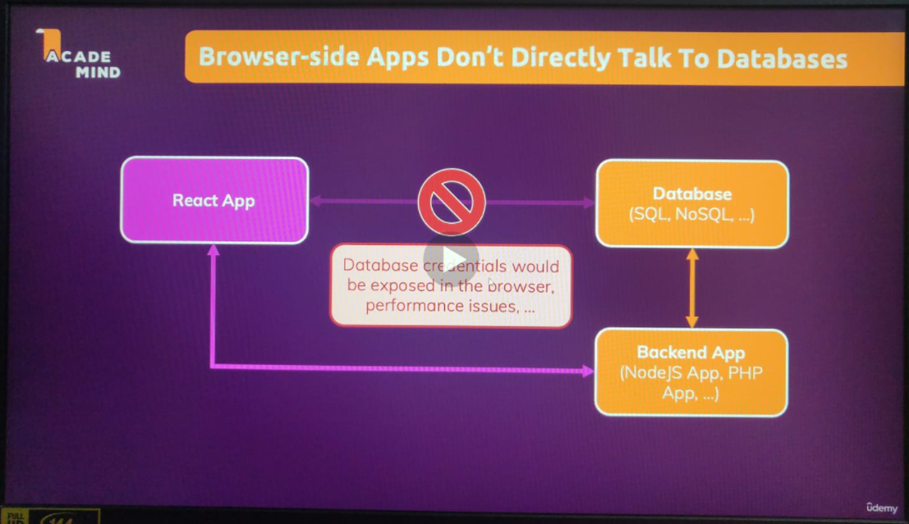

We use fetchAPI for sending requests (in-built browser).

The first argument takes in the website url. We could provide a second argument here, which allows us to pass in a JavaScript object where we configure various options, for example, where we add extra headers or an extra body or change the HTTP request method, but here we don't need that because the default method will be GET, so by default, a GET request will be sent and that's all we need here for the moment.

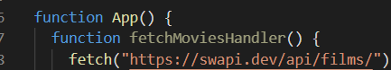

So that will now send such a HTTP request whenever this function is called.

But, of course, we also wanna handle the response. And fetch returns a promise, which allows us to then react to the response or any potential errors we might be getting. Now, we're getting a promise here, which is an object which will eventually yield some data instead of immediately doing that because, of course, sending an HTTP request is an asynchronous task. It doesn't finish immediately. It can take a couple of seconds or milliseconds. It can even fail, of course. And therefore, we can't just continue in the next line of code and use the result immediately. Instead, the result will be there at some point in the future and that's exactly what promises exist for in JavaScript.

So we can add **then** here to the final function which will be called whenever we got a response.

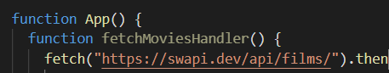

Here we get a **response** and then write an arrow function to use this response. (this response argument is an object with a lot of data about the response) **.json** is a built in method on the **response** object which translates the json code (JSON is a data format in which data is sent back by the API) to a javascript object.

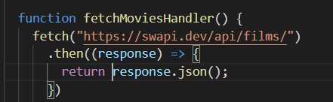

Now, this itself them again returns a promise and therefore, what we should do here is return that promise and then add another then block here, which will then be fired once this data transformation is done and we get the transformed data.

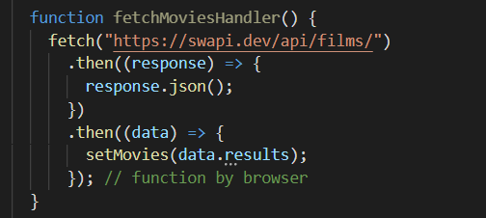

But in our **App.js** we expect the components to be of a certain name which are different in the fetched API data. Hence, we can either change our prop names to match that of the API fetched data, or transform the incoming data to the format we expect in our app.

So here I'll have my transformedMovies let's say and that in the end will be data.results, which is this array we're getting back, .map to convert every object in the results array into a new object. And it's then the new objects, the array full of new objects, which will be stored in transformedMovies.

Note that I am returning an object here because im transforming the received array of objects to a different array of modified objects.

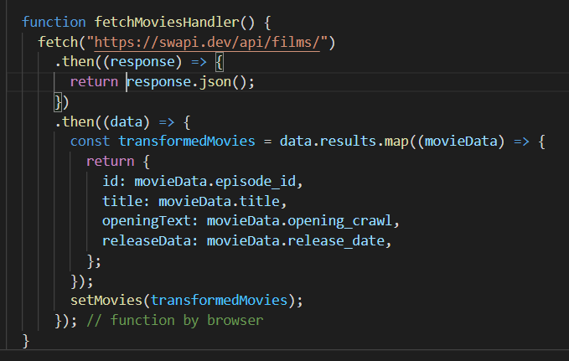

Hence, this is how we managed to send HTTP request from our javascript to the backend which then fetches the data from the server.

**Async**

We can also use asynchronous approach here wherein we use wait feature and behind the scene it does the same what we did earlier. (this approach might look synchronous, but it is actually unsynchronous)

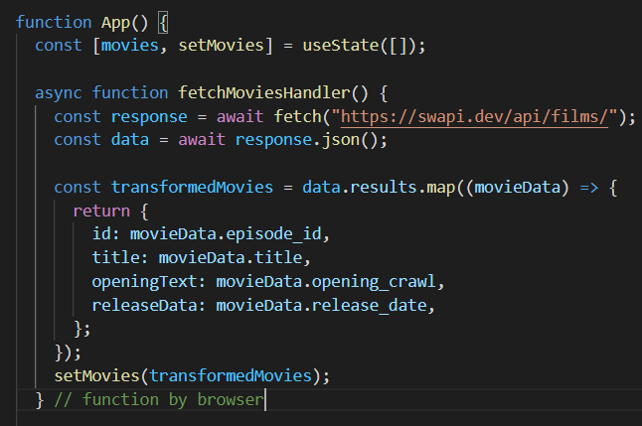

This is same as using **.then** but it just looks cleaner.

**Setting states**

**Catching Errors (status code and all)**

Now, one problem we'll face here is that the Fetch API doesn't treat error status codes as real errors. It will not throw a technical error if we get back an error status code. So the problem we have here would not result in an error. We would only get an error in a second step if we then try to operate on data, which we haven't gotten. But that's not how we wanna handle this. Instead, it would be better if we would throw a real error if we got back a response with an unsuccessful status code. And again, by default, the Fetch API here doesn't do that.

To do this on our own, use the **response** object which we get back using its **ok** field.

Now when we throw the error, the next bit of code involving transformedMovies is not executed and we directly catch the error.

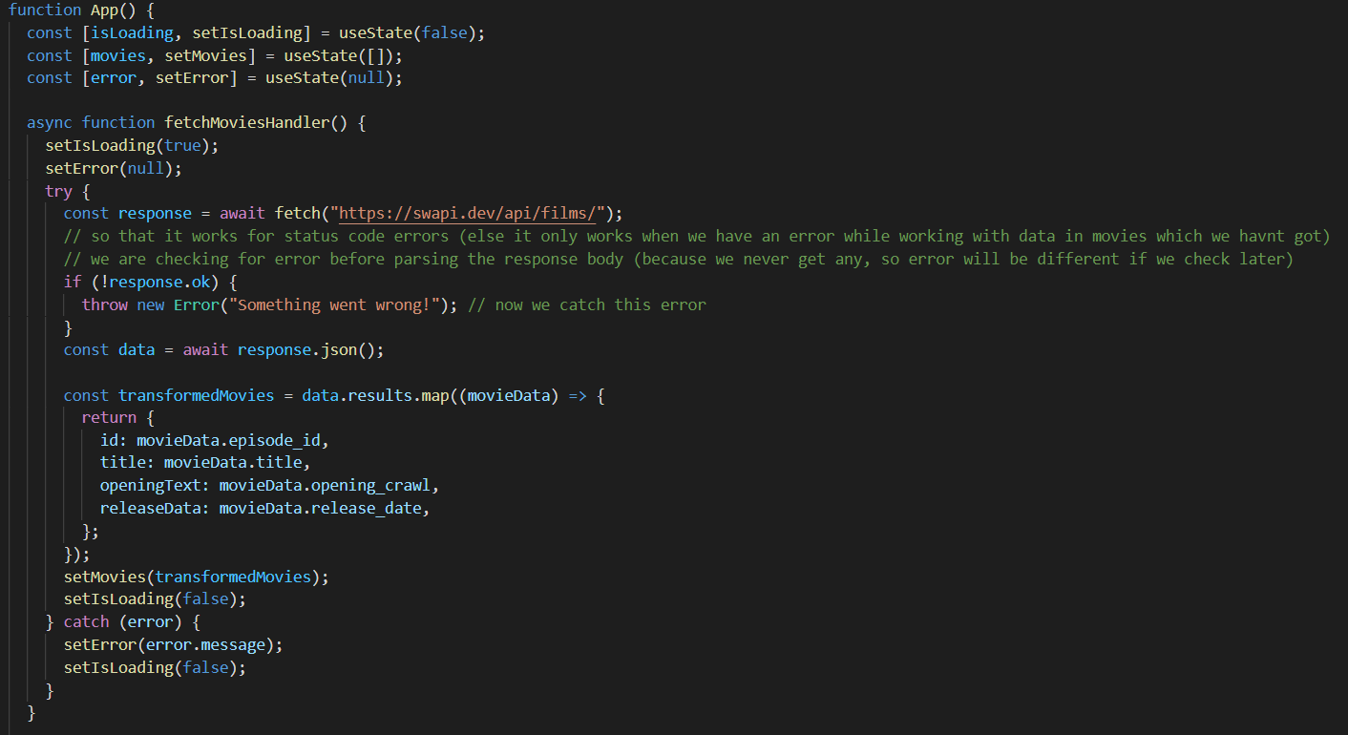

**useEffect and useCallback hooks**

Now we are currently fetching data whenever the button is clicked. However, in most cases, we want the data to be fetched as soon as the page is loaded and thereafter we can do anything with the button as we want.

So its time to use the useEffect hook. (because sending http request is a side effect which changes our state) Having them into a functions (like we did earlier) of course also fine as long as you don't just call this function as part of your main component function because then you could create an infinite loop where you call this function, it updates the state the component function re-renders or is re-evaluated and therefore the function is called again it updates the state to component function is called again and so on. We wanna avoid that and that's how we use useEffect for that.

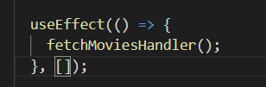

If we call like this then it is only executed when the page is loaded for the first time.

However, it’s a good practice to list all the dependencies we use. We can add the **fetchMoviesHandler** which will make this effect run whenever the function changes (due to change of some external state used within it), it will cause useEffect to run. However, functions are objects and it always changes whenever this component is re-rendered. Hence, we need to use useCallback.

**// We do not add state updating functions as dependencies within useEffect and useCallback because react ensures that these do not change**

import React, { useState, useEffect, useCallback } from "react";

import MoviesList from "./components/MoviesList";

import "./App.css";

function App() {

  const [isLoading, setIsLoading] = useState(false);

  const [movies, setMovies] = useState([]);

  const [error, setError] = useState(null);

  // useEffect(() => { // doesn’t work before

  //   fetchMoviesHandler();

  // }, [fetchMoviesHandler]);

  const fetchMoviesHandler = useCallback(async () => {

    setIsLoading(true);

    setError(null);

    try {

      const response = await fetch("https://swapi.dev/api/films/");

      // so that it works for status code errors (else it only works when we have an error while working with data in movies which we havnt got)

      // we are checking for error before parsing the response body (because we never get any, so error will be different if we check later)

      if (!response.ok) {

        throw new Error("Something went wrong!"); // now we catch this error

      }

      const data = await response.json();

      const transformedMovies = data.results.map((movieData) => {

        return {

          id: movieData.episode_id,

          title: movieData.title,

          openingText: movieData.opening_crawl,

          releaseData: movieData.release_date,

        };

      });

      setMovies(transformedMovies);

      setIsLoading(false);

    } catch (error) {

      setError(error.message);

      setIsLoading(false);

    }

  }, []);

  // written after function definition (Above) because it works when it is parsed

  useEffect(() => {

    fetchMoviesHandler();

  }, [fetchMoviesHandler]);

  let content = <p>Found no movies.</p>;

  if (movies.length > 0) {

    content = <MoviesList movies={movies}></MoviesList>;

  }

  if (error) {

    content = <p>{error}</p>;

  }

  if (isLoading) {

    content = <p>Loading...</p>;

  }

  return (

    <React.Fragment>

      <section>

        <button onClick={fetchMoviesHandler}>Fetch Movies</button>

      </section>

      <section>

        {/* {!isLoading && <MoviesList movies={movies} />}

        {!isLoading && movies.length === 0 && !error && <p>Found no movies.</p>}

        {isLoading && <p>Loading...</p>}

        {!isLoading && error && <p>{error}</p>} */}

        {content}

      </section>

    </React.Fragment>

  );

}

export default App;

**Post request**

By default fetch is used to GET, but we can add the second argument and set it to POST.

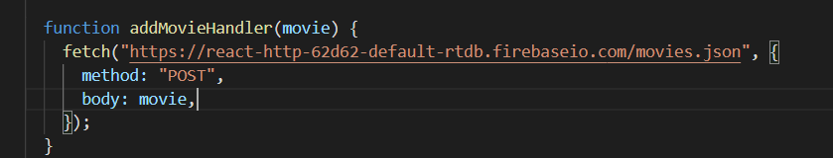

Here I wanna pass on my movie, though body doesn't want a JavaScript object like this, instead it wants JSON data. I mentioned before that JSON is this data format which is typically used for exchanging data between front-end and backend.

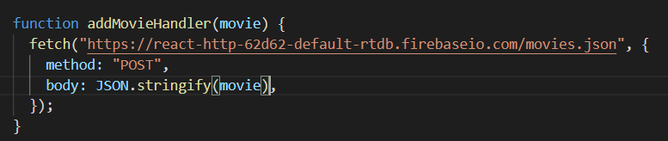

This takes in a javascript array or object and converts it into a JSON format.

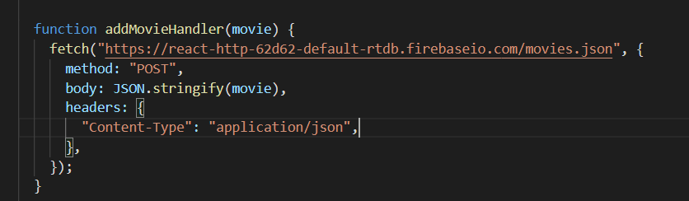

Headers is passed as an object to define the type of data we are sending.

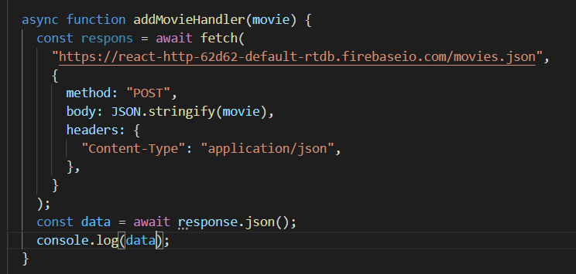

And then we can also get our response data (data = response.json()) by awaiting response dot JSON, because Firebase also sends back data in JSON format. And for the moment we can console log that data.

React talks to backend and not a database.

We send request to an API (url used) using fetch API.

**Section 15: Building custom hooks**

With custom hooks, you can outsource logic, which you might be using in different components, into a custom hook, which you can then call from all these various components. So, it is simply a mechanism of reusing logic, just as regular functions are with the special thing that in these custom hook functions, you can use React hooks and other hooks.

Here both the forward and backward counter are 99% same except 1 minute detail which we choose to re-factor so that we can avoid code duplication. However, we need custom hooks (function) for this because this is using react hooks and also managing state and using state updating functions which cannot be used inside a regular function (as these react hooks can be used within component functions or custom react hooks which we use now).

**Important note just because we use a custom hook does not mean that we share state or effects across components. Instead for every component the custom hook is executed again. And every component instance then receives its own state. So, it's just a logic which has shared not the concrete state. (this means that the various states created in the use-counter js get associated with different states in each component they are tied to, i.e., forward and backward counter, useState state is set up and useEffect fires for the forward counter component)**

But of course now inside of the forward counter I need access to the counter state, which is managed by the custom hook, because I wanna output it here. And how can we do that? How can we make that happen? Well, just as we do it with the built in hooks. For use state this built in react hook this also does something behind the scenes and it also creates and manage this state. And then it does one important thing. It returns an array, which we are de-structuring, i.e., const[counter,setCounter] = useState(0).

Custom hooks are just functions and they afford they can return things. So to make the useCounter (from use-counter.js) state available in forwardCounter.js, we can simply return it. We can return anything from our custom hooks, object, array or anything.

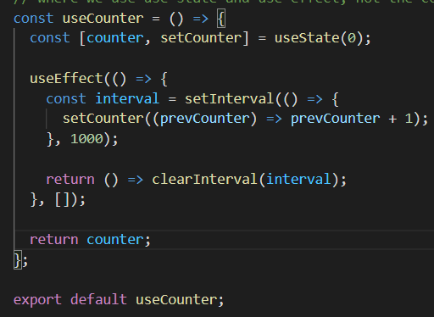

Previous **forwardCounter** code

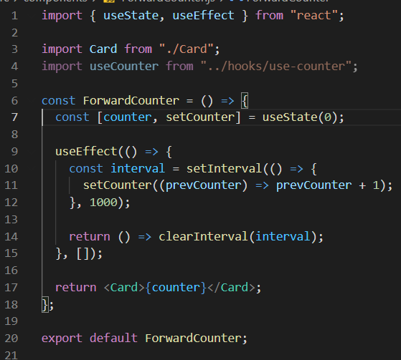

New **forwardCounter** code after re-using this.

import { useState, useEffect } from "react";

import Card from "./Card";

import useCounter from "../hooks/use-counter";

const ForwardCounter = () => {

  const counter = useCounter();

  return <Card>{counter}</Card>;

};

export default ForwardCounter;

**Now, we want to make our use-counter.js hook reusable. So, we need to make it accept parameters.**

**Earlier code of use-counter:**

/* That is a hard rule which you have to follow. It will be a normal function in the end but the use at their beginning

signals to react that it will be a custom hook and it gives the reacts to guarantee that you will use that function by respecting

these rules of hooks so that you will use this custom hook function just as you use to build in hooks.*/

import { useState, useEffect } from "react";

// Inside this we write the logic which we want to re-use

// And in our case, if we started with the forward counter, in the end we can just copy that code here from the forward counter that code,

// where we use use state and use effect, not the code where we return JSX, just the other code.

const useCounter = () => {

  const [counter, setCounter] = useState(0);

  useEffect(() => {

    const interval = setInterval(() => {

      setCounter((prevCounter) => prevCounter + 1);

    }, 1000);

    return () => clearInterval(interval);

  }, []);

  return counter;

};

export default useCounter;

**Newer code of use-counter:**

/* That is a hard rule which you have to follow. It will be a normal function in the end but the use at their beginning

signals to react that it will be a custom hook and it gives the reacts to guarantee that you will use that function by respecting

these rules of hooks so that you will use this custom hook function just as you use to build in hooks.*/

import { useState, useEffect } from "react";

// Inside this we write the logic which we want to re-use

// And in our case, if we started with the forward counter, in the end we can just copy that code here from the forward counter that code,

// where we use use state and use effect, not the code where we return JSX, just the other code.

const useCounter = (forwards = true) => {

  const [counter, setCounter] = useState(0);

  useEffect(() => {

    const interval = setInterval(() => {

      if (forwards) {

        setCounter((prevCounter) => prevCounter + 1);

      } else {

        setCounter((prevCounter) => prevCounter - 1);

      }

    }, 1000);

    return () => clearInterval(interval);

  }, [forwards]);

  return counter;

};

export default useCounter;

**Note that forwards is not a dependency and is passed in the dependency array so that this re-reruns whenever the value of forward is changed. (it’s a dependency It's not defined inside of the EFFECT function, it's not defined outside of our custom hook instead, it is a value that we get as a parameter, here, and we have to add it as a dependency, therefore.)**

To ensure that if we would have a component where useCounter is used with different values for the argument, this EFFECT would rerun if the argument changes.

**Section 16: Forms**

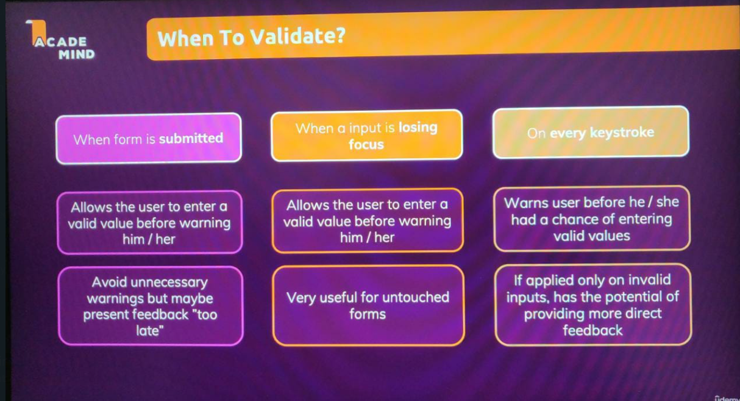

useState is better when we want to check input for every keystroke and when we want to clear fields after the form is submitted (not ideal with useRef as we don’t want to be manipulating the DOM directly).

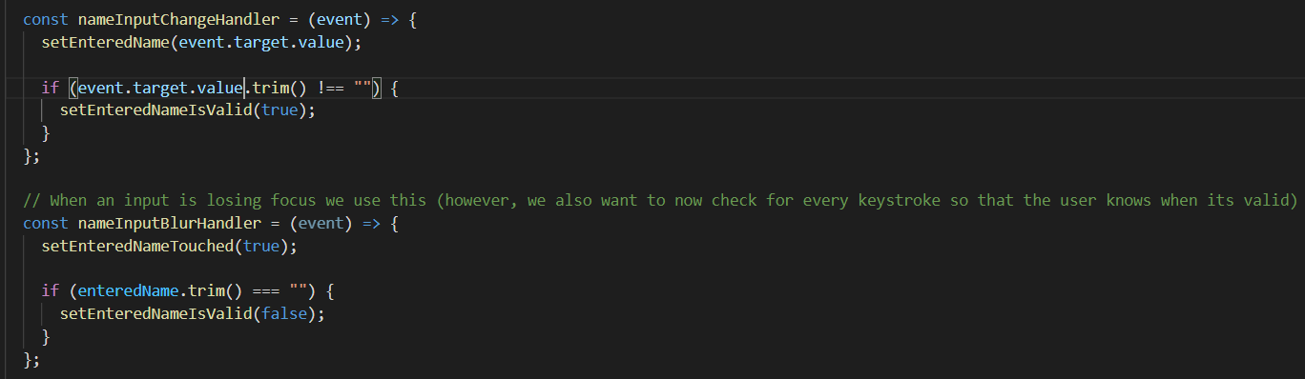

In the nameInputChangeHandler im checking for every keystroke so that the user knows when his input becomes valid. Also **NOTE: I used event.target.value.trim() and not enteredName.trim() because I updated the state in just the previous line and hence might not get the latest snapshot.**

**Current code of SimpleInput without adding custom hook:**

import { useState } from "react";

const SimpleInput = (props) => {

  // const nameInputRef = useRef(); // set a ref on input and read the value when we need it

  const [enteredName, setEnteredName] = useState("");

  const [enteredNameTouched, setEnteredNameTouched] = useState(false);

  const [enteredEmail, setEnteredEmail] = useState("");

  const [enteredEmailTouched, setEnteredEmailTouched] = useState(false);

  const enteredNameIsValid = enteredName.trim() !== "";

  const nameInputIsInvalid = !enteredNameIsValid && enteredNameTouched;

  const enteredEmailIsValid = enteredEmail.includes("@");

  const enteredEmailIsInvalid = !enteredEmailIsValid && enteredEmailTouched;

  let formIsValid = false;

  if (enteredNameIsValid && enteredEmailIsValid) {

    formIsValid = true;

  }

  const nameInputChangeHandler = (event) => {

    setEnteredName(event.target.value);

  };

  // When an input is losing focus we use this (however, we also want to now check for every keystroke so that the user knows when its valid)

  const nameInputBlurHandler = (event) => {

    setEnteredNameTouched(true);

  };

  const emailInputChangeHandler = (event) => {

    setEnteredEmail(event.target.value);

  };

  // When an input is losing focus we use this (however, we also want to now check for every keystroke so that the user knows when its valid)

  const emailInputBlurHandler = (event) => {

    setEnteredEmailTouched(true);

  };

  const formSubmissionHandler = (event) => {

    event.preventDefault();

    setEnteredNameTouched(true);

    if (!enteredNameIsValid && !enteredEmailIsValid) {

      return;

    }

    console.log(enteredName, enteredEmail);

    // const enteredValue = nameInputRef.current.value; // refs are objects with a current property

    // console.log(enteredValue);

    // nameInputRef.current.value = ""; NOT GOOD as we are directly manipulating the DOM

    setEnteredName("");

    setEnteredNameTouched(false);

    setEnteredEmail("");

    setEnteredEmailTouched(false);

  };

  const nameInputClasses = !nameInputIsInvalid

    ? "form-control"

    : "form-control invalid";

  const emailInputClasses = !enteredEmailIsInvalid

    ? "form-control"

    : "form-control invalid";

  return (

    <form onSubmit={formSubmissionHandler}>

      <div className={nameInputClasses}>

        <label htmlFor="name">Your Name</label>

        <input

          //ref={nameInputRef}

          type="text"

          id="name"

          value={enteredName}

          onChange={nameInputChangeHandler}

          onBlur={nameInputBlurHandler}

        />

        {nameInputIsInvalid && (

          <p className="error-text">Name must not be empty.</p>

        )}

      </div>

      <div className={emailInputClasses}>

        <label htmlFor="email">Your Email</label>

        <input

          //ref={nameInputRef}

          type="email"

          id="email"

          value={enteredEmail}

          onChange={emailInputChangeHandler}

          onBlur={emailInputBlurHandler}

        />

        {enteredEmailIsInvalid && (

          <p className="error-text">Please enter a valid email.</p>

        )}

      </div>

      <div className="form-actions">

        <button disabled={!formIsValid}>Submit</button>

      </div>

    </form>

  );

};

export default SimpleInput;

**After using custom hook Name state**

import { useState } from "react";

import useInput from "../hooks/use-input";

const SimpleInput = (props) => {

  // const nameInputRef = useRef(); // set a ref on input and read the value when we need it

  const {

    value: enteredName,

    isValid: enteredNameIsValid,

    hasError: nameInputHasError,

    valueChangeHandler: nameChangeHandler,

    inputBlurHandler: nameBlurHandler,

    reset: resetNameInput,

  } = useInput((value) => value.trim() !== ""); // With this function, we can customize the validation logic in the Component where we need

  // this hook and still execute it inside of the hook. (this function is called within the use-input hook for validation)

  const [enteredEmail, setEnteredEmail] = useState("");

  const [enteredEmailTouched, setEnteredEmailTouched] = useState(false);

  const enteredEmailIsValid = enteredEmail.includes("@");

  const enteredEmailIsInvalid = !enteredEmailIsValid && enteredEmailTouched;

  let formIsValid = false;

  if (enteredNameIsValid && enteredEmailIsValid) {

    formIsValid = true;

  }

  // When an input is losing focus we use this (however, we also want to now check for every keystroke so that the user knows when its valid)

  const emailInputChangeHandler = (event) => {

    setEnteredEmail(event.target.value);

  };

  // When an input is losing focus we use this (however, we also want to now check for every keystroke so that the user knows when its valid)

  const emailInputBlurHandler = (event) => {

    setEnteredEmailTouched(true);

  };

  const formSubmissionHandler = (event) => {

    event.preventDefault();

    if (!enteredNameIsValid && !enteredEmailIsValid) {

      return;

    }

    console.log(enteredName, enteredEmail);

    // const enteredValue = nameInputRef.current.value; // refs are objects with a current property

    // console.log(enteredValue);

    // nameInputRef.current.value = ""; NOT GOOD as we are directly manipulating the DOM

    resetNameInput();

    setEnteredEmail("");

    setEnteredEmailTouched(false);

  };

  const nameInputClasses = nameInputHasError

    ? "form-control invalid"

    : "form-control";

  const emailInputClasses = enteredEmailIsInvalid

    ? "form-control invalid"

    : "form-control";

  return (

    <form onSubmit={formSubmissionHandler}>

      <div className={nameInputClasses}>

        <label htmlFor="name">Your Name</label>

        <input

          //ref={nameInputRef}

          type="text"

          id="name"

          value={enteredName}

          onChange={nameChangeHandler}

          onBlur={nameBlurHandler}

        />

        {nameInputHasError && (

          <p className="error-text">Name must not be empty.</p>

        )}

      </div>

      <div className={emailInputClasses}>

        <label htmlFor="email">Your Email</label>

        <input

          //ref={nameInputRef}

          type="email"

          id="email"

          value={enteredEmail}

          onChange={emailInputChangeHandler}

          onBlur={emailInputBlurHandler}

        />

        {enteredEmailIsInvalid && (

          <p className="error-text">Please enter a valid email.</p>

        )}

      </div>

      <div className="form-actions">

        <button disabled={!formIsValid}>Submit</button>

      </div>

    </form>

  );

};

export default SimpleInput;

**After using custom hook for name and email state**

import useInput from "../hooks/use-input";

const SimpleInput = (props) => {

  // const nameInputRef = useRef(); // set a ref on input and read the value when we need it

  const {

    value: enteredName,

    isValid: enteredNameIsValid,

    hasError: nameInputHasError,

    valueChangeHandler: nameChangeHandler,

    inputBlurHandler: nameBlurHandler,

    reset: resetNameInput,

  } = useInput((value) => value.trim() !== ""); // With this function, we can customize the validation logic in the Component where we need

  // this hook and still execute it inside of the hook. (this function is called within the use-input hook for validation)

  const {

    value: enteredEmail,

    isValid: enteredEmailIsValid,

    hasError: emailInputHasError,

    valueChangeHandler: emailChangeHandler,

    inputBlurHandler: emailBlurHandler,

    reset: resetEmailInput,

  } = useInput((value) => value.includes("@"));

  let formIsValid = false;

  if (enteredNameIsValid && enteredEmailIsValid) {

    formIsValid = true;

  }

  const formSubmissionHandler = (event) => {

    event.preventDefault();

    if (!enteredNameIsValid && !enteredEmailIsValid) {

      return;

    }

    console.log(enteredName, enteredEmail);

    // const enteredValue = nameInputRef.current.value; // refs are objects with a current property

    // console.log(enteredValue);

    // nameInputRef.current.value = ""; NOT GOOD as we are directly manipulating the DOM

    resetNameInput();

    resetEmailInput();

  };

  const nameInputClasses = nameInputHasError

    ? "form-control invalid"

    : "form-control";

  const emailInputClasses = emailInputHasError

    ? "form-control invalid"

    : "form-control";

  return (

    <form onSubmit={formSubmissionHandler}>

      <div className={nameInputClasses}>

        <label htmlFor="name">Your Name</label>

        <input

          //ref={nameInputRef}

          type="text"

          id="name"

          value={enteredName}

          onChange={nameChangeHandler}

          onBlur={nameBlurHandler}

        />

        {nameInputHasError && (

          <p className="error-text">Name must not be empty.</p>

        )}

      </div>

      <div className={emailInputClasses}>

        <label htmlFor="email">Your Email</label>

        <input

          //ref={nameInputRef}

          type="email"

          id="email"

          value={enteredEmail}

          onChange={emailChangeHandler}

          onBlur={emailBlurHandler}

        />

        {emailInputHasError && (

          <p className="error-text">Please enter a valid email.</p>

        )}

      </div>

      <div className="form-actions">

        <button disabled={!formIsValid}>Submit</button>

      </div>

    </form>

  );

};

export default SimpleInput;

**Section 18: Redux**

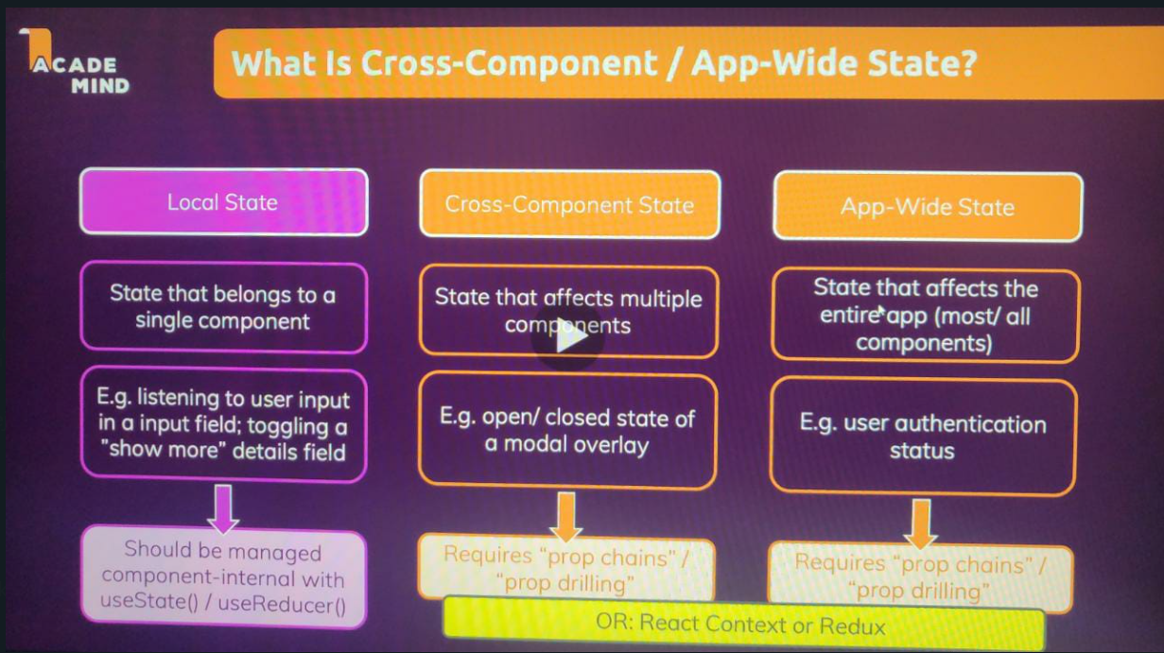

Redux is a state management system for cross-component or app wide state (like react context).

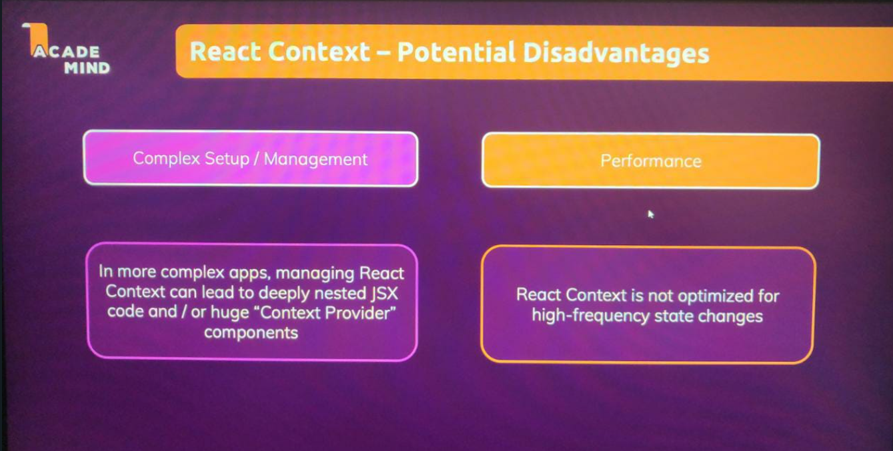

**How redux works?**

**We have 1 data store in our application where we store all the managed states.**

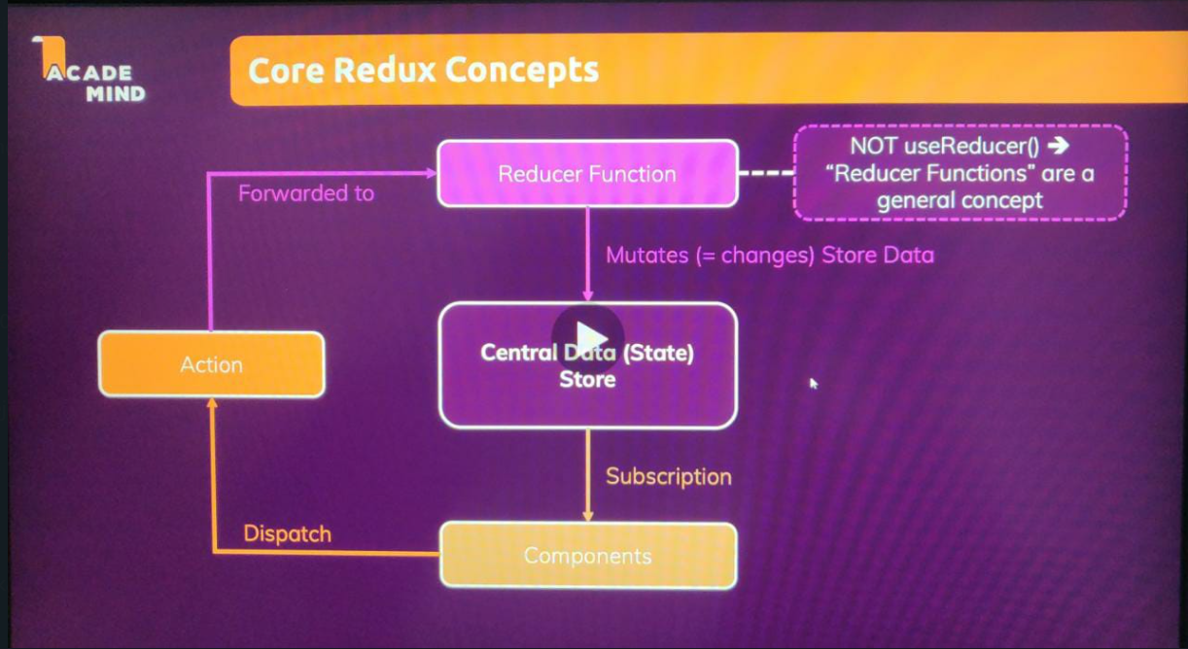

**Reducer functions are general functions which take in an input and give out a corresponding output (eg take a list of numbers and return their sum).**

**Now an action is really just a simple JavaScript object, which describes the kind of operation, the reducers should perform.**

**Therefore, Redux then forwards actions to the reducer, reads that description of the desired operation, if you want to call it like this, and then this operation is performed by the reducer.**

**So components dispatch actions, which describe what should be done, but don't do it directly, then these actions are forwarded to the reducer, the reducer then does what the action wants, the reducer to do. And then the reducer, spits out a new state, which effectively will replace the existing state in that Central Data Store. And when that happens, when that state in that data store is updated, subscribing components are notified, so that they can update their UI. That's how Redux works.**

A reducer function is a standard JavaScript function, but it will it be called by the Redux library and it will then always receive two pieces of input, two parameters, the old or existing state and the action that was dispatched. And then this reducer function must return a certain output. It must always return a new state object.

const redux = require("redux"); // node js syntax for importing 3rd party packages, imported redux object from package

// reducer function (state is initialised with an object with a counter property so that first time it runs, it is initialised)

// the goal is to do different things for different action type

const countReducer = (state = { counter: 0 }, action) => {

  // if we use this if we get output as 1 because for the initialisation its not incrementing (if we dont use action.type, it shows 2)

  if (action.type === "increment") {

    return {

      counter: state.counter + 1, // accessing old counter state + 1

    };

  }

  return state;

};

// creating a store and passing the reducer function to it (because store wants to know which reducer is responsible for changing the data)

const store = redux.createStore(countReducer);

// this subscription function is triggered whenever the state is changed and then it gets the latest state using the inbuilt methods

const counterSubscriber = () => {

  const latestState = store.getState(); // inbuilt method on store created with create store (gives latest snapshot)

  console.log(latestState);

};

// making redux aware of the subscriber function that should be executed whenever the state changes (not passing () as redux calls it on its own)

store.subscribe(counterSubscriber);

// disp. an action on store object(an action is a js object with a type property which acts as an identifier, so that we can do different things)

store.dispatch({ type: "increment" });

// We get this output because it is onen// after the initialization, as we saw a couple of seconds ago, and now we dispatched a new action, which

// caused this reducer function to run again and therefore the counter was again, incremented by one,  which is why we now see counter two here.

**If I don’t use the if in reducer function, then when it is executed for the first time, it will increment by 1 and then when the action is called it will again increment by 1. Hence, I used if for incrementing.**

**Using redux in react**

Now, first we create our store.

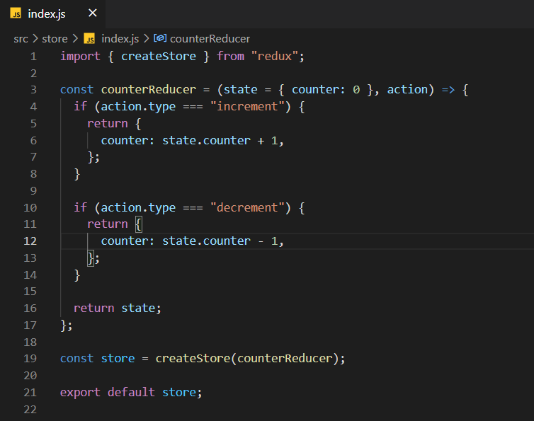

However, now we don’t dispatch it right here. We provide this redux store to the react app so that the components of that app can dispatch and listen.

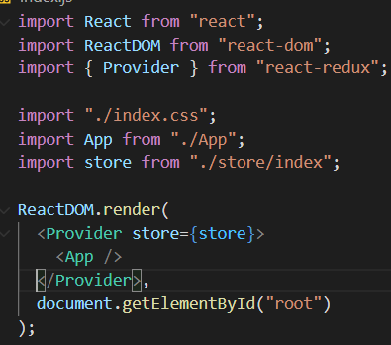

We import the Provider component and it comes with an in-built prop name **store** and we provide our redux store to it.

**Utilizing the store**

To utilize the provided store in the **Counter component** we do the **Following**.

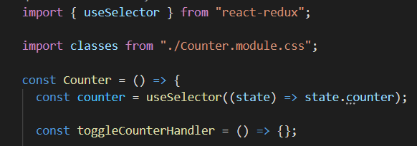

We get access to data managed in our store using the useSelector hook.

**useSelector hooks** receives a function which is executed by react-redux to determine which piece of data we want to extract from our store. It receives **state** managed by redux and then we return part of the state which we wanna extract.

Now the great thing is that when you use use selector, React Redux will automatically set up a subscription to the Redux store for this component. So your component will be updated and will receive the latest counter automatically whenever that data changes in the Redux store. So it's an automatically reactive and changes to the Redux store will cause this component function to be re executed. So you always have the latest counter.

**Dispatching actions**

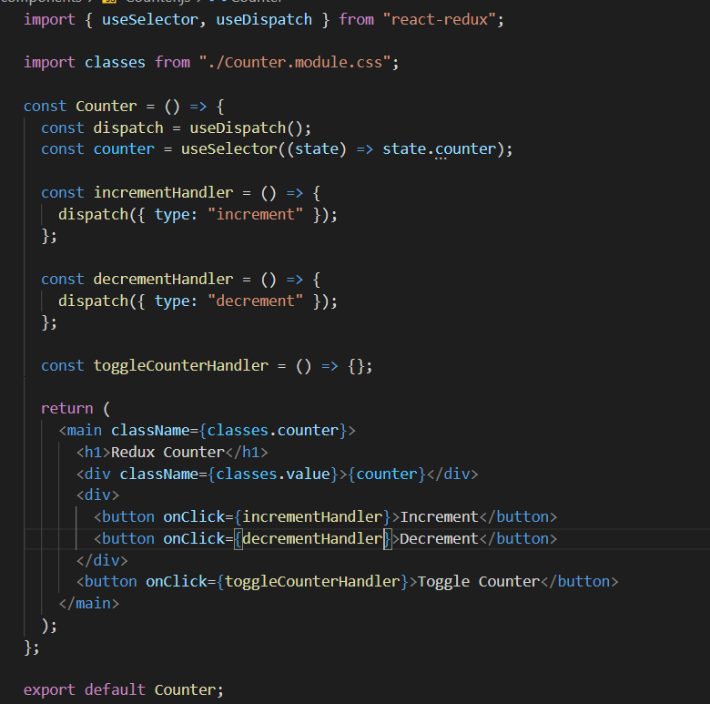

**useDispatch()** will give us a function which we can then call to **dispatch an action** against our redux store.

**dispatch** is a function and we provide an action to it (an action is an object with a type property).

**Adding a payload to action object**

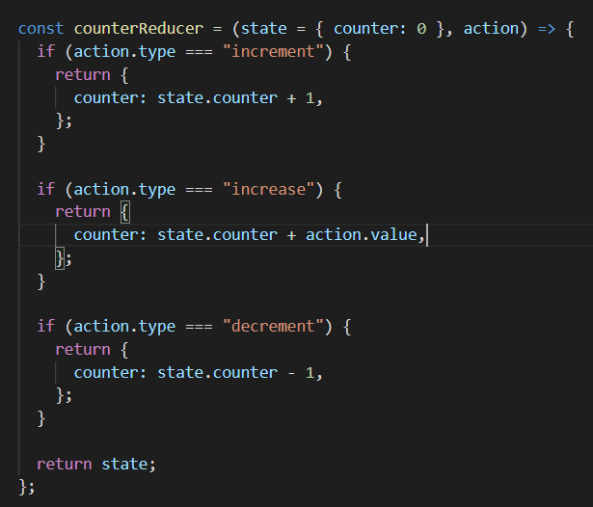

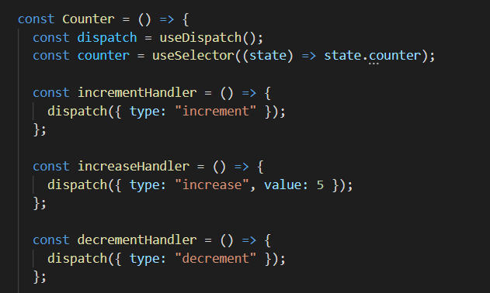

Adding a payload to our action object. (adding a property)

**Sidenote: Even if we are not changing a state/piece of data, we need to return it because redux need to return the overall state object and replaces the existing states with it (doesn’t merge it).**

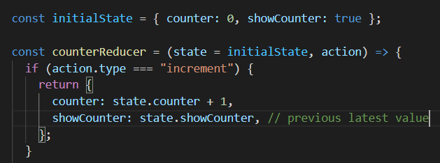

**If (action.type === ‘increment’) {**

**state.counter++;**

**return {**

**counter: state.counter,**

**showCounter: state.showCounter,**

**}**

**}**

**If I use the above code to mutate the state directly then:**

This can lead to bugs, unpredictable behavior and it can make debugging your application harder as well. it can have unwanted and unexpected side effects in bigger applications where your state gets out of sync. And suddenly the UI is not reflecting your state correctly anymore.

And hence the simple rule is never mutate your state (existing) like this. Always return a brand new object where you copy any nested objects or erase. If you have any and create brand new values as we're doing it here. By updating our state like this we create a brand new object where we don't change anything.

**If I don’t return states (eg showCounter in increment action) which im not changing then since redux creates a new object, the showCounter will assume a null value which is treated as false and hence the program will not work properly. So we must always set all the other states when we update a piece of state because we overwrite the old state. Always return a brand new snapshot of the state (counter: state.counter+1) rather than changing the current state yourself (state.counter++).**

**What we return here is a state object with multiple pieces of state.**

**Why use redux toolkit?**

There are three issues we currently face:

1) If the name of the identifiers are similar, it is quite easy to mess correctly using them in the other components and making typo errors.

2) We always have to return the complete state object even if certain pieces of data / states are not changed. This causes are redux file to become very large (because the reducer function becomes very large).

3) We have to respect the mutability and cannot just change the current values directly as it might lead to bugs (we might change it by mistake).

**Using redux toolkit**

**createSlice function expects an object as a argument**. Now, what we do with create slice is we are preparing a slice of our global state. And when we have different pieces of state which are not directly related, let's say an authentication status and the counter status, we could create different slices potentially also in different files to make our code maintainable. Here counter and showCounter state belong together and hence I create 1 slice.

**name is given to each slice to act as an identifier for that piece of state.**

**reducer is an object or map. Add all your methods here. They receive the current latest state and action. We don’t need action because these methods will be called for us depending upon which action was triggered. So we don’t need to write the if checks anymore and this reduces the code.**

**We are allowed to mutate the state within the methods of our reducers map** We still must not manipulate the existing state but the good thing is when using Redux toolkitand its functions like create slice,we can't accidentally manipulate the existing state.Because Redux toolkit internally uses another package,called imgur, which will detect code like thisand which will automatically clone the existing state,create a new state object, keep all the statewhich we're not editing, and override the statewhich we are editing in an immutable way.So we still have immutable code hereeven though it doesn't look like itbecause of this internally used packageand therefore we as a developerhave a much easier time working with Reduxbecause we don't have to create a copy manuallyand keep all the code we're not changing,instead, we just change the code we wanna changeand internally it's translated into immutable code.

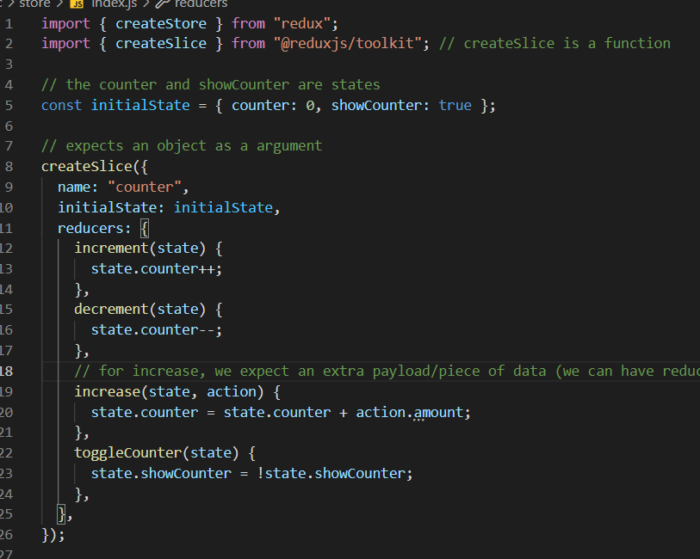

**These (all except increase) reducer functions do get a state aswell as the action.** We just didn’t accept and write it for the first 2 reducer functions because we didn’t want to do anything with it. However, now we want to accept an extra parameter and hence we use it (we accept action as a parameter and use it in the reducer function in the reducer method).

**Old code before slice**

import { createStore } from "redux";

// the counter and showCounter are states

const initialState = { counter: 0, showCounter: true };

const counterReducer = (state = initialState, action) => {

  if (action.type === "increment") {

    return {

      counter: state.counter + 1,

      showCounter: state.showCounter, // previous latest value

    };

  }

  if (action.type === "increase") {

    return {

      counter: state.counter + action.value,

      showCounter: state.showCounter,

    };

  }

  if (action.type === "decrement") {

    return {

      counter: state.counter - 1,

      showCounter: state.showCounter,

    };

  }

  if (action.type == "toggle") {

    return {

      counter: state.counter,

      showCounter: !state.showCounter,

    };

  }

  return state;

};

const store = createStore(counterReducer);

export default store;

import { useSelector, useDispatch } from "react-redux";

import classes from "./Counter.module.css";

const Counter = () => {

  const dispatch = useDispatch();

  const counter = useSelector((state) => state.counter);

  const show = useSelector((state) => state.showCounter); // whenever showCounter states changes in redux, THIS component will be re-evaluated

  const incrementHandler = () => {

    dispatch({ type: "increment" });

  };

  const increaseHandler = () => {

    dispatch({ type: "increase", value: 5 });

  };

  const decrementHandler = () => {

    dispatch({ type: "decrement" });

  };

  // to dispatch an action which controls a state in redux to determine whether the counter is shown or not (hence add a new state/piece of data)

  const toggleCounterHandler = () => {

    dispatch({ type: "toggle" });

  };

  return (

    <main className={classes.counter}>

      <h1>Redux Counter</h1>

      {show && <div className={classes.value}>{counter}</div>}

      <div>

        <button onClick={incrementHandler}>Increment</button>

        <button onClick={increaseHandler}>Increase by 5</button>

        <button onClick={decrementHandler}>Decrement</button>

      </div>

      <button onClick={toggleCounterHandler}>Toggle Counter</button>

    </main>

  );

};

export default Counter;

**Using the configureStore**

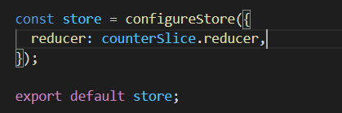

For exact theory refer to video [251](https://www.udemy.com/course/react-the-complete-guide-incl-redux/learn/lecture/25600202#overview), however, in short it is basically used when we have multiple state slices and we want to pass more reducers to the store (because createStore only takes in a single reducer, but configureStore will take in an object where we can use keys to set up various reducers). It makes merging multiple reducers easy. We pass a reducer function to createStore but a configuration object to configureStore wherein we then set a reducer property. **Reducer singular and not reducers plural because still, no matter if we use createStore or configureStore, Redux wants one main reducer function, which is responsible for the global state. With configureStore, the value of reducer can be a single reducer (like here, to use the reducer from the counterSlice which combines all those reducer methods defined in that slice).**

If we have multiple state slices, we can pass a map of reducers (key with values as different reducer functions) to the reducer.

**Dispatching Actions**

We can access **counerSlice.actions.toggleCounter** // here actions object has access to all method names for dispatching actions.

And with that we don't access the reducer methods definedup there but instead we get methods created automatically by Redux Toolkit which when called will create action objects for us. These methods on the actions object here which we can call will create action objects for us. Therefore these methods are called action creators and they will create action objects for us where these objects already have a type property with a unique identifier per action. Automatically created behind the scenes. So we don't have to worry about action identifiers. We don't have to create those action objects on our own. We can tap into this actions key into this **actions object** on our **createSlice** and execute these action creator methods, which with their **name match our reducer methods to dispatch actions**, which will then ultimately trigger those different reducer methods.

And that means that we, as a developer, don't have to worry about creating action objects on our own and about coming up with unique identifiers and about avoiding typos.

**Now,** we import the actions in our counter.js file and use it.

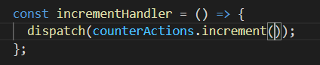

Here increment is actually executed as a method because increment is a method which when executed creates a full action object with the type set to this automatically created unique action identifier. So, we get a full action object automatically created for us here.

**Earlier we wrote dispatch({type:’increment’}).**

**To pass a payload we do the following:**

**Behind the scenes we get an action object (which it dispatches) with a payload property and a type.**

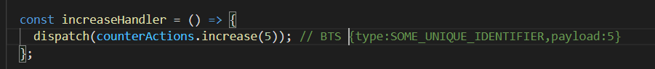

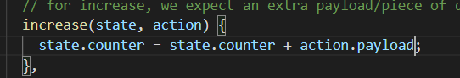

**Final Code**

import { createStore } from "redux";

import { createSlice, configureStore } from "@reduxjs/toolkit"; // createSlice is a function

// the counter and showCounter are states

const initialState = { counter: 0, showCounter: true };

// expects an object as a argument

const counterSlice = createSlice({

  name: "counter",

  initialState: initialState,

  reducers: {

    increment(state) {

      state.counter++;

    },

    decrement(state) {

      state.counter--;

    },

    // for increase, we expect an extra payload/piece of data (we can have reducer functions that listen to actions having extra payload)

    increase(state, action) {

      state.counter = state.counter + action.payload;

    },

    toggleCounter(state) {

      state.showCounter = !state.showCounter;

    },

  },

});

const store = configureStore({

  reducer: counterSlice.reducer,

});

export const counterActions = counterSlice.actions;

export default store;

import { useSelector, useDispatch } from "react-redux";

import { counterActions } from "../store/index"; // an object which has our reducer names as keys

import classes from "./Counter.module.css";

const Counter = () => {

  const dispatch = useDispatch();

  const counter = useSelector((state) => state.counter);

  const show = useSelector((state) => state.showCounter); // whenever showCounter states changes in redux, THIS component will be re-evaluated

  const incrementHandler = () => {

    dispatch(counterActions.increment());

  };

  const increaseHandler = () => {

    dispatch(counterActions.increase(5)); // BTS {type:SOME_UNIQUE_IDENTIFIER,payload:5}

  };

  const decrementHandler = () => {

    dispatch(counterActions.decrement());

  };

  // to dispatch an action which controls a state in redux to determine whether the counter is shown or not (hence add a new state/piece of data)

  const toggleCounterHandler = () => {

    dispatch(counterActions.toggleCounter());

  };

  return (

    <main className={classes.counter}>

      <h1>Redux Counter</h1>

      {show && <div className={classes.value}>{counter}</div>}

      <div>

        <button onClick={incrementHandler}>Increment</button>

        <button onClick={increaseHandler}>Increase by 5</button>

        <button onClick={decrementHandler}>Decrement</button>

      </div>

      <button onClick={toggleCounterHandler}>Toggle Counter</button>

    </main>

  );

};

export default Counter;

**Practicing Redux**

**isTheUserLoggedIn** state affects multiple components (app wide) as it matters to the header, user profile component. We create a brand new slice for this state and its actions.

Now to add the new slice to our redux store we first need to remember that we still only have a single redux store so we call configureStore only once. And also the store has only one main reducer here. However, this reducer doesn’t only take in a reducer function like

const store = configureStore({

  reducer: counterSlice.reducer,

});

but also an object which acts as a map of reducers where we can have any key names of our choice and then point at different reducers.

const store = configureStore({

  reducer: { counter: counterSlice.reducer, auth: authSlice.reducer },

});

And these individual reducers here will then automatically be merged together into one main reducer, which is exposed to this store. That's how we can combine multiple slices and their reducers.

Now our authSlice also exposes actions and hence we expose them aswell.

export const authActions = authSlice.actions;

**Important SideNote**

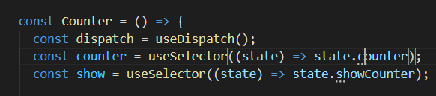

Since we merged our reducers (3rd above pic), the way we used to access data (above) changes.

Now we need to tell react that we want to dive in this particular slice (using the identifier we used in the reducer map in our store), into the state produced by this slicer’s reducer.

const Counter = () => {

  const dispatch = useDispatch();

  const counter = useSelector((state) => state.counter.counter);

  const show = useSelector((state) => state.counter.showCounter);

**Section 19: Advanced Redux**

Our reducer functions must be side-effect free and synchronous.

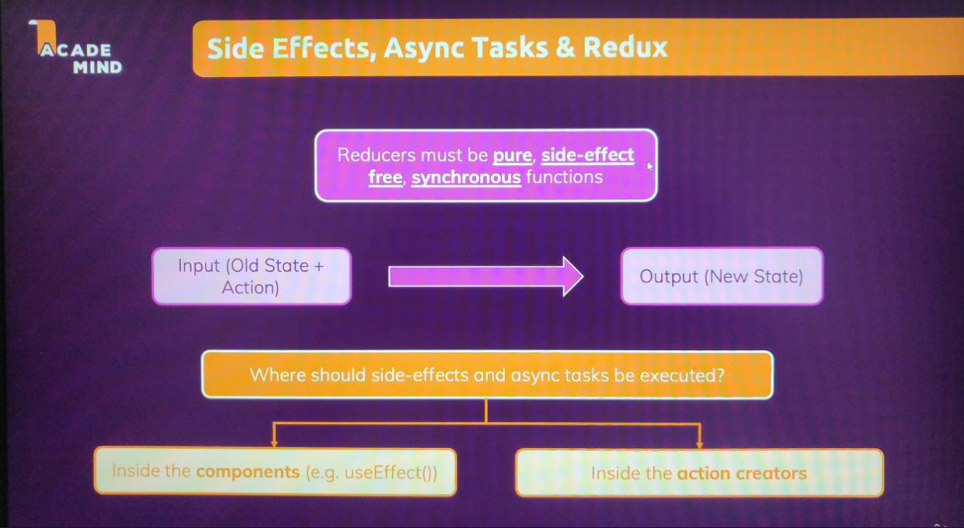

**Providing our redux store to the entire application.**

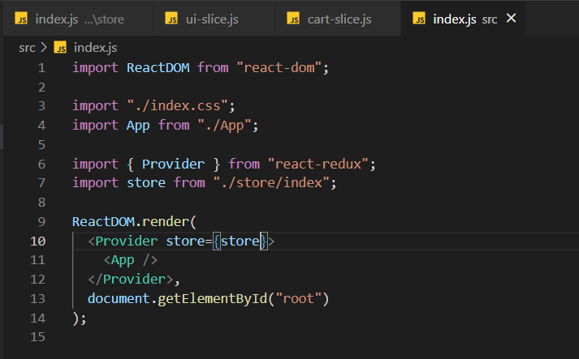

**Redux and Async Code**

We cannot perform asynchronous tasks like sending http requests or perform any side-effects within our reducer functions (e.g., reducer within cart-slice.js).

Hence, we can either write this in the component itself and ignore redux or we create an action creator which allows us to run asynchronous code / side effects.

**1) Using the component approach**

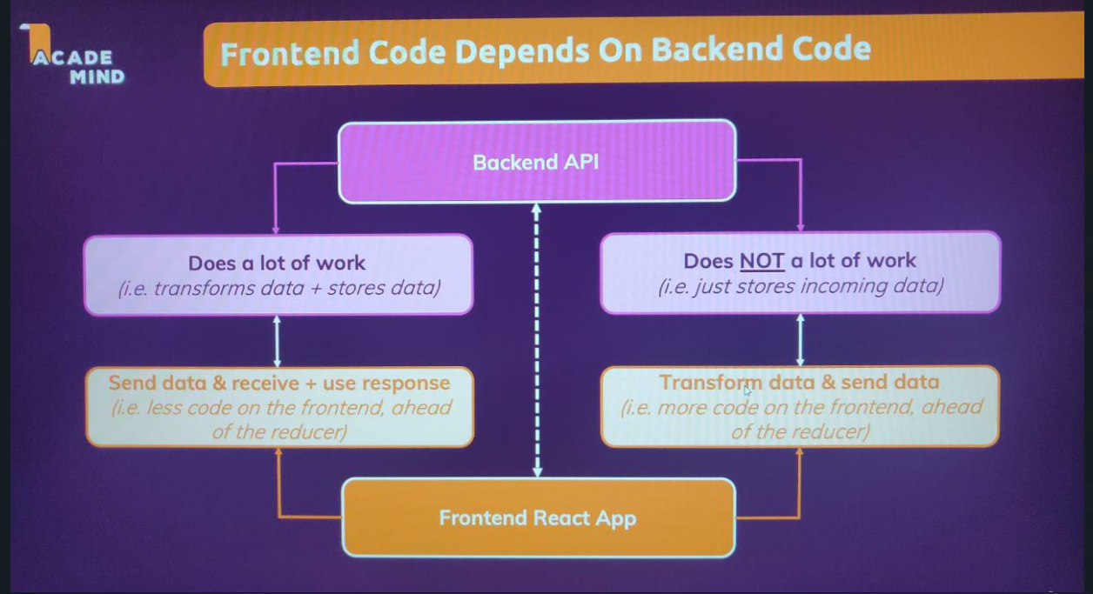

Since, we have a pretty dumb database which does not perform any transformations on the data it receives, we must perform this transformation in the frontend and outside the reducer function and send it to the backend.

import Cart from "./components/Cart/Cart";

import Layout from "./components/Layout/Layout";

import Products from "./components/Shop/Products";

import { useSelector, useDispatch } from "react-redux"; // to extract data from redux

import React, { useEffect } from "react";

import { uiActions } from "./store/ui-slice";

import Notification from "./components/UI/Notification";

let isInitial = true; // defined because our useEffect runs when the page is loaded for the first time and that overwrites the previous

// data with an empty cart. Also, we defined it outside the App component so that it is not re-initialised whenever the component

// is re-rendered, but rather when the file is parsed for the first time.

function App() {

  const dispatch = useDispatch();

  const notification = useSelector((state) => state.ui.notification); // null initially, however later set to an obj (in ui-slice)

  const showCart = useSelector((state) => state.ui.cartIsVisible); // we need to extract this data from redux, we pass a fn which receives

  // current redux state automatically because this fn we passed to useSelector is executed by react-redux, so it receives the current state

  // automatically and we should return the data which we want to use in this component. Hence, drill in that state slice and then the ppt name.

  /* Now, the great thing is that useSelector sets up a subscription to Redux. So whenever our Redux store does change

  this component function (App) will be re-executed and we will get the latest state. So in this case, the latest cart.

  So that means that effect will also be re-evaluated and it will re-execute if our carts did change and that is exactly what we need.

  So with this simple addition here we will send this Http request whenever our cart changes.

  Hence, we first update our Redux store (inside reduces fn) and we're done with that. And then we select the updated store to send the request

  And that's a very good way of having our side effect logic in a component and keeping all our data transformation logic inside of a Reducer. */

  const cart = useSelector((state) => state.cart);

  useEffect(() => {

    const sendCartData = async () => {

      dispatch(

        uiActions.showNotification({

          status: "pending",

          title: "Sending...",

          message: "Sending cart data!",

        })

      );

      const response = await fetch(

        "https://react-http-62d62-default-rtdb.firebaseio.com/cart.json",

        {

          method: "PUT",

          body: JSON.stringify(cart),

        }

      );

      if (!response.ok) {

        //throw new Error("Sending data cart failed.");

      }

      dispatch(

        uiActions.showNotification({

          status: "success",

          title: "Success...",

          message: "Sent cart data successfully!",

        })

      );

    };

    if (isInitial) {

      isInitial = false;

      return;

    }

    // using catch to catch any error thrown from inside this function, since its an async function it returns a promise and hence we catch errors

    sendCartData().catch((error) => {

      dispatch(

        uiActions.showNotification({

          status: "error",

          title: "Error...",

          message: "Sending cart data failed!",

        })

      );

    });

  }, [cart, dispatch]); // dispatch function will never change (reduc ensures this)

  return (

    <React.Fragment>

      {notification && (

        <Notification

          status={notification.status}

          title={notification.title}

          message={notification.message}

        />

      )}

      <Layout>

        {showCart && <Cart />}

        <Products />

      </Layout>

    </React.Fragment>

  );

}

export default App;

**2) Action Creator Approach**

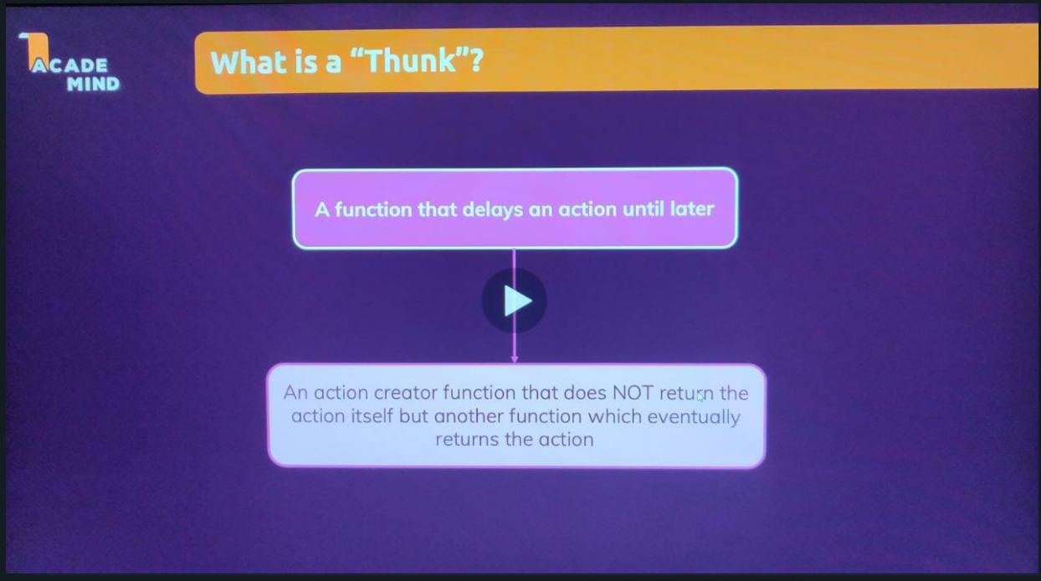

A thunk is simply a function, that delays an action until later, until something else finished. And we could write an action creator as a thunk, to write an action creator, which does not immediately return the action object, but which instead, returns another function which eventually returns the action. So that we can run some other code before we then dispatch the actual action object that we did want to create.

Redux toolkit, creates these action creators automatically for us, for all those reducer methods (in ui-slice). Every method in the reducers object, receives such an action creator, which is called, by using that reducer function name (basically when we call the reducer name, it receives an action creator which returns an action object). That's what's inside of these actions here. So we don't need to write, such simple action creators on our own. (**Basically instead of creating action objects in components which use redux, we call the function() which is an action creator which creates an action object with a TYPE property for us AND instead of creating action creators within this redux store, we simple create a reducer which upon being called creates an action creator of its own. However, we can create an action creator of our own, THUNK).**

**WATCH VIDEO 258.**

**Section 20: Routing**

If we look at a traditional multi-page website wherein we have to fetch different HTML pages for different URL’s, then our purpose is not solved as it takes time to render and fetch all of these pages. Hence, we switched to react to create a single page application wherein we change what appears on the screen visually using react. Hence, now we have to use a third-party package which does routing for us, i.e., changes url and based on the changes it changes what appears on the screen.

So, we want the package, which does all that routing and which looks at the URL and brings different components onto the screen based on URL changes. but which then actually does not send a request to the server for a new HTML file, but in stat, this code, which we write* or does package which we add should block does browser default, which does all of that in the browser, we need to write code that does that or we use a third-party package that does that. (client side routing)

Basically we do client-side routing wherein, for different URL we show the content using javascript and not by fetching a different HTML page.

**Building the Project**

Well, in the end, the goal is that we're able to handle different paths on our page and load different components for the different paths. Basically we render different components based on the url.

**Import {Route}** It is a component that allows us to define a certain path and then the React component that should be loaded when that path becomes active in the URL.

**<Route path = “/welcome” />** means that this route should become active when our url is our-domain.com/welcome (**NOTE: path here is a special prop**)

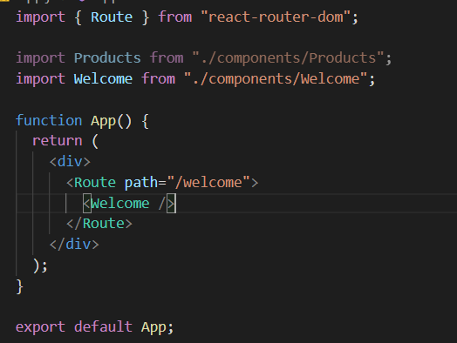

The Route component will make sure that the welcome component is rendered when the url is satisfied.

import { Route } from "react-router-dom";

import Products from "./components/Products";

import Welcome from "./components/Welcome";

function App() {

  return (

    <div>

      {/* Registering Routes */}

      <Route path="/welcome">

        <Welcome />

      </Route>

      <Route path="/products">

        <Products />

      </Route>

    </div>

  );

}

export default App;

Also now we need to wrap the overall app with the browser component to activate the react router and unlock these react router features (like defining routes).

import ReactDOM from "react-dom";

import { BrowserRouter } from "react-router-dom";

import "./index.css";

import App from "./App";

ReactDOM.render(

  <BrowserRouter>

    <App />

  </BrowserRouter>,

  document.getElementById("root")

);

Hence, these 2 paths will render these 2 components. (These components are loaded by the router)

**Working with links**

If we write basic anchor tags and provide links to the new pages, we will get the new pages, however every time we click on one of these links. So, we do send a brand new request to the server. Serving does app. This works, we get the different pages, but it means that we leave the active single-page application. We start a new one. When we click one of these links we lose any application state that we might have in this application. And that is not ideal. That goes against the idea of building a single page application. If we would be managing some cart, some shopping cart for a user, and we would lose all that state. Whenever we navigate between pages this would be a sup-optimal user experience. So it would be better if this browser default of sending a request and requesting a new HTML page would be prevented and we could write our own code for debt.

**Instead of <a href> we use <Link to>**

This package we're using will actually listen to clicks on those links, prevent the browser default and instead manually update the URL for us so that it looks like if we switched the page and it will then also change what we see on the screen. Hence, now we don't send new requests. we stay on this load at single page application. We don't lose any state. And we still give the user the illusion of switching between different pages.

Basically, it still creates an anchored hack catches the click prevents the browser default

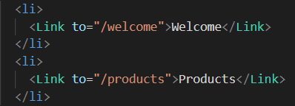

However, we don’t have a method to know which page we are on.



If we use **NavLink** and use the **activeClassName** prop, then this NavLink component will assign css class on the active anchor item.

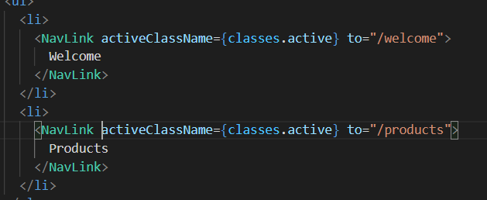



**Dynamic Routes**

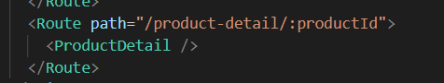

Our-domain.com/product-detail/<any value>

: and then any identifier up-to our choice.

This is a dynamic path segment. It tells React Router that the overall path for which this page should be loaded, will be something like this: our-domain.com/product-detail/<any-value>, and then inside of this component **(ProductDetail)**, we will get access to the concrete value, for this dynamic segment **(product-id)**. This <any-value> is a placeholder/dynamic segment which takes in any value.

**We didn’t use ‘/product-detail’ as a path because we need a way of telling React Router for which specific product this component should be loaded, so that inside of this component (ProductDetail), we can then kind of retrieve that extra data. That extra product data, in this case. And for this, we can define dynamic routes.**

To really utilize this dynamic path feature, we need access to the concrete value entered in the URL inside of the loaded component (Product Detail). Hence, I want to find out for which productid this page was loaded so that I can use it to fetch data or anything particular to it. useParams hook returns a params object which has key value pairs, where the key is dynamic segments leading to that page (productId). Hence, the identifier we used after the colon is provided as a key to us in the params object.

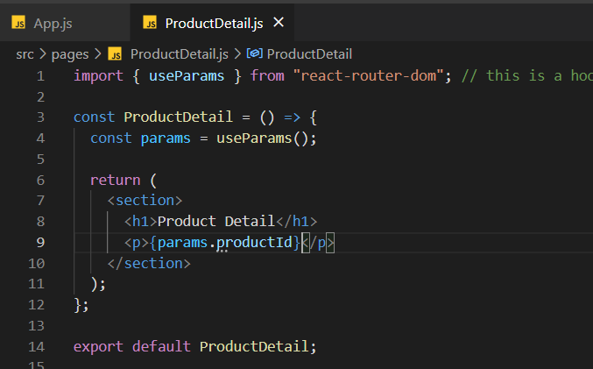

**NOTE: Matching in react router world means that our path starts (url) with the defined path (in js). Hence, it does start with /products aswell as /products/id. Hence, both routes will be active and both are rendered to show the content on the page.**

**Hence, we can use the switch component to wrap our route component so that only 1 route is active at the same time (whichever matches first).**

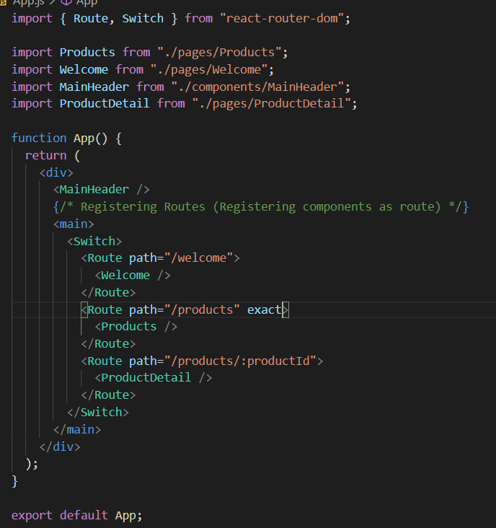

**If the url is** [**http://localhost:3000/products/p2**](http://localhost:3000/products/p2) **and i dont use exact (using switch), then only the first route which matches (Product) is set to active (because matching in react means it has to start similarly). However, if I set the exact prop, then it will only run if it matches exactly, and hence we get our desired output (earlier** [**http://localhost:3000/products/p2**](http://localhost:3000/products/p2) **showed Products because it matched first, now it shows ProductDetail).**

**Nested Routes**

You're not limited to defining routes in one place only, you can define routes wherever you want. And if they are on a component which is currently active, they will be evaluated by React Router DOM. So, if I add a route on the welcome page, if the welcome page is active, this route will be evaluated. If the welcome page is not active, this route will not be evaluated.

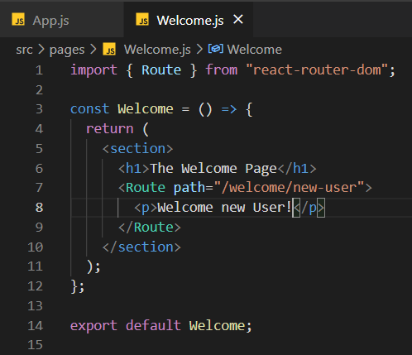

When welcome component is active, this new nested route path will be evaluated and if the url matches, then the para is rendered.

We can define routes in other components, in other routes therefore, and then load more content if we have a more specific path match like we have it here.

**Redirecting**

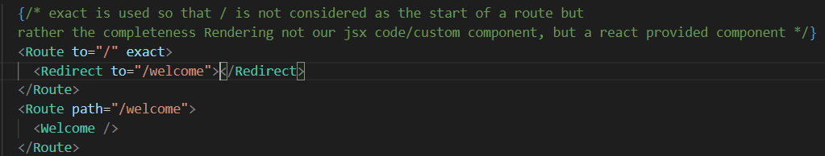

So here we can then redirect to /welcome, which means if we're just visiting /nothing, this will be rendered **(Redirect)** and this will then change the URL to /welcome. And then this route will become active **(Route path = /welcome)**.

**Not Found Page**

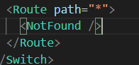

Written at end to match anything if none of the urls matched till now.

**Programmatic Navigation**

But actually here we don't want the link, we want a button which submits the form. So using a link is not an option here. Instead, what we need here is something called programmatic navigation. We wanna trigger a navigation action and navigate the user away programmatically in our code. So it's not a link which the user clicks to navigate away, but it's some action triggered by our code, when some abreaction sending the entered data to a server finished. And in the end we probably wanna trigger this navigation action from inside, the NewQuote page component here.

To navigate programmatically, use the useHistory hook. It gives us a history object to trigger history changing actions (for eg we add a new page). And we can navigate around with the push method here, which pushes a new page on the stack of pages, so a new page on our history of pages, or we can navigate with the replace method that replaces the current page. The difference is that with push, we can go back with the back button to the page we're coming from, with replace we can't. So replace is like a redirect where we changed occurred page, push adds a new page.

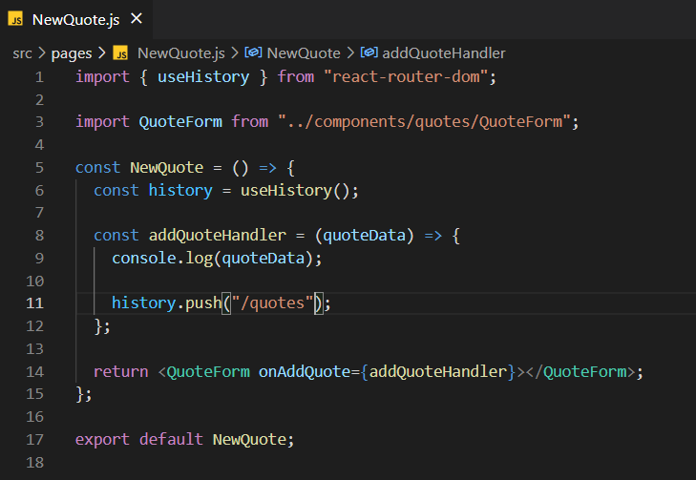

So now we will navigate away if we send our data here at the moment, of course, we're only logging it to the console.

Hence, when we click the Add Quote button after adding a new quote, we are navigated away to a new page.

**Prompt Component**

This is a component which we can render. And then this component will automatically watch if we navigate away. And if then a certain condition is met, it will show a warning before it allows us to leave. It takes in two props: **1) when** it should be shown or not and **2) message** which takes in a function which returns a string with the text we want to show the user when he/she tries to leave the page. This is a function because we get some location object here, which holds information about the page we're trying to go to. This would allow us to include the path we're trying to go to in this message which we're showing.

Below I have implemented the prompt component. **useState** is used to store the state when the form is focussed. If the form was focussed at any point of time and we wish to switch pages, then the browser will give us a prompt warning. Also we need to add a finishEnteringHandler function to set the isEntering state to false else even when we submit the form the browser shows us the prompt window because eventually we will submit the quote and leave that page.

import { useRef, useState } from "react";

import { Prompt } from "react-router-dom"; // component

import { Fragment } from "react/cjs/react.production.min";

import Card from "../UI/Card";

import LoadingSpinner from "../UI/LoadingSpinner";

import classes from "./QuoteForm.module.css";

const QuoteForm = (props) => {

  const [isEntering, setIsEntering] = useState(false);

  const authorInputRef = useRef();

  const textInputRef = useRef();

  function submitFormHandler(event) {

    event.preventDefault();

    const enteredAuthor = authorInputRef.current.value;

    const enteredText = textInputRef.current.value;

    // optional: Could validate here

    props.onAddQuote({ author: enteredAuthor, text: enteredText });

  }

  const finishEnteringHandler = () => {

    setIsEntering(false);

  };

  const formFocusHandler = () => {

    setIsEntering(true);

  };

  return (

    <Fragment>

      <Prompt

        when={isEntering}

        message={(location) =>

          "Are you sure you want to leave? All your entered data will be lost!"

        }

      />

      <Card>

        <form

          onFocus={formFocusHandler}

          className={classes.form}

          onSubmit={submitFormHandler}

        >

          {props.isLoading && (

            <div className={classes.loading}>

              <LoadingSpinner />

            </div>

          )}

          <div className={classes.control}>

            <label htmlFor="author">Author</label>

            <input type="text" id="author" ref={authorInputRef} />

          </div>

          <div className={classes.control}>

            <label htmlFor="text">Text</label>

            <textarea id="text" rows="5" ref={textInputRef}></textarea>

          </div>

          <div className={classes.actions}>

            <button onClick={finishEnteringHandler} className="btn">

              Add Quote

            </button>

          </div>

        </form>

      </Card>

    </Fragment>

  );

};

export default QuoteForm;

**Query Parameters (QuoteList.js)**

The difference compared to regular route parameters, like our **quoteId** parameter, is that the regular parameters, like quoteId, are mandatory. So, the **QuoteDetail** page is only loaded if we have an ID, if we have this segment (**quoteId**).

Whereas query parameters are optional. The question mark thing here does not change the route matching. It has no impact on which route is matched. But whichever route is matched then has access to that query parameter data to, for example, change the behaviour of the page that was loaded.

***Side Note: useHistory hook allows us to change the page history. It allows us to change the URL therefore. And we can use this hook and the history object it returns to add query parameters to the currently loaded page. If we change the url of a page using push then it is rerendered.***

Using the **useHistory** hook we added a query parameter using ‘**?**’ and named the key as **sort**.

**Step1:** Show a button to sort on the page and if I click this button the URL changes and the query parameter is added to the URL.

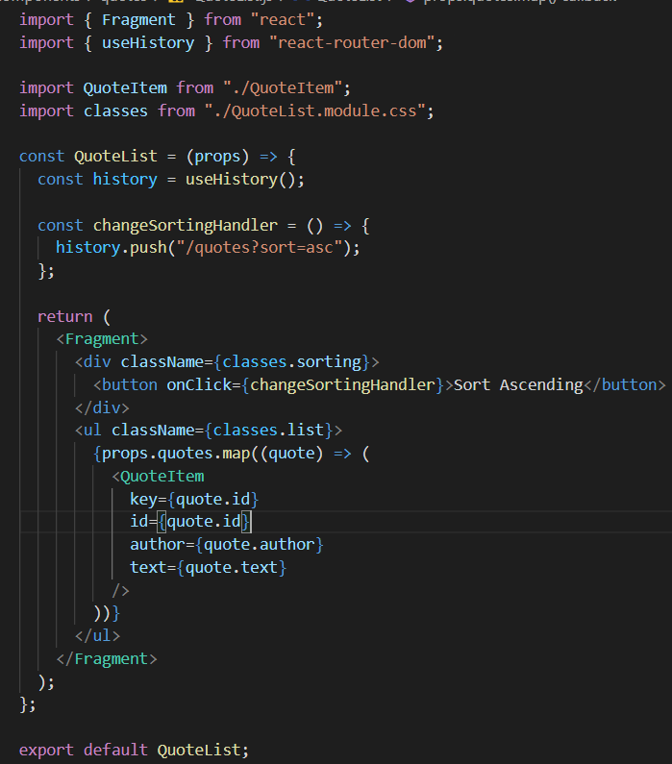

**Step2:** Read the query parameter value and the change the sorting and button label accordingly.

Now, reading query parameter values is also relatively straightforward, but we need to use yet another hook provided by React Router DOM, the useLocation hook. Where useHistory gives us access to the history object, an object that allows us to change and manage the URL, useLocation gives us access to a location object which has information about the currently loaded page, about the currently loaded URL.

Now to access the search property within this object, we can translate this into a JavaScript object, which is a bit easier to use for us than this plain string here, by instantiating a new **URLSearchParams** object. And that's a built-in constructor function built into the browser. So, this is not coming from React Router, not coming from React. This is a default JavaScript constructor function, a default JavaScript class so to say, which we can use in the browser. So, this string here, including the question mark, this is now passed to that constructor. And that will then give us a nice queryParams object. Our object where we can then extract our query parameters by key. So here, for example, I have the sort key with a value of asc and because I'm using URLSearchParams, this queryParams object will now have a sort key, which will hold this asc value. And that's simply a more convenient way of extracting data from the query parameters.

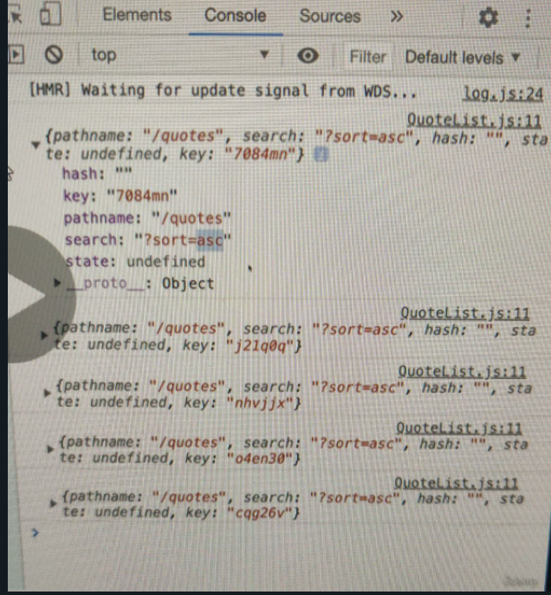

const queryParams = new URLSearchParams(location.search);

import { Fragment } from "react";

import { useHistory, useLocation } from "react-router-dom";

import QuoteItem from "./QuoteItem";

import classes from "./QuoteList.module.css";

const sortQuotes = (quotes, ascending) => {

  return quotes.sort((quoteA, quoteB) => {

    if (ascending) {

      return quoteA.id > quoteB.id ? 1 : -1;

    } else {

      return quoteA.id < quoteB.id ? 1 : -1;

    }

  });

};

const QuoteList = (props) => {

  const history = useHistory();

  const location = useLocation(); // location object (desc in word)

  const queryParams = new URLSearchParams(location.search);

  const isSortingAscending = queryParams.get("sort") === "asc"; // gives the value stored in the 'sort' key (comparing to asc to set bool val)

  const sortedQuotes = sortQuotes(props.quotes, isSortingAscending);

  const changeSortingHandler = () => {

    history.push("/quotes?sort=" + (isSortingAscending ? "desc" : "asc")); // if already asc, then show desc

  };

  return (

    <Fragment>

      <div className={classes.sorting}>

        <button onClick={changeSortingHandler}>

          Sort {isSortingAscending ? "Descending" : "Ascending"}{" "}

        </button>

      </div>

      <ul className={classes.list}>

        {sortedQuotes.map((quote) => (

          <QuoteItem

            key={quote.id}

            id={quote.id}

            author={quote.author}

            text={quote.text}

          />

        ))}

      </ul>

    </Fragment>

  );

};

export default QuoteList;

Hence, the above is the final code for using **query parameters.**

**Nested Routes**

And this is a way of using those nested routes feature to conditionally render different content based on the URL without you having to manage some complex state.

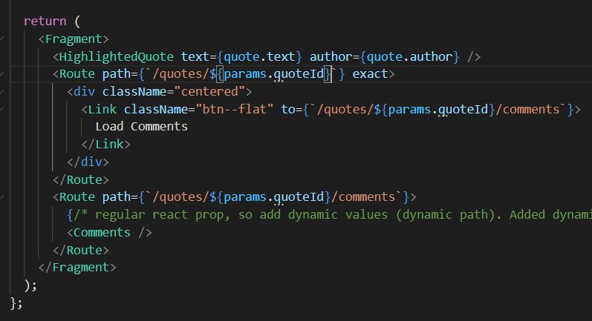

In **QuoteDetail.js** I have used the above code. Note the 4th line where I have used **Route.** It is so that the **Load Comments** link is only visible when the exact url is as specified and after we click on the **Load Comments** link, that link button disappears (earlier it appeared even after we clicked on it and the comments were loaded). Hence, when the link is clicked, we change to the **To** and then then last bit of code where **Comments** is rendered upon reaching that route is displayed.

**Flexible Code**

If we change the url anywhere, we have to change it everywhere, even for nested routing (which is unnecessary as we should be able to fetch that for which url this component was rendered)

**useRouteMatch** is to hook name. It's kind of similar to use location but it has more information about the currently loaded route. Not just about the URL but about some internally managed data React Router is aware of.

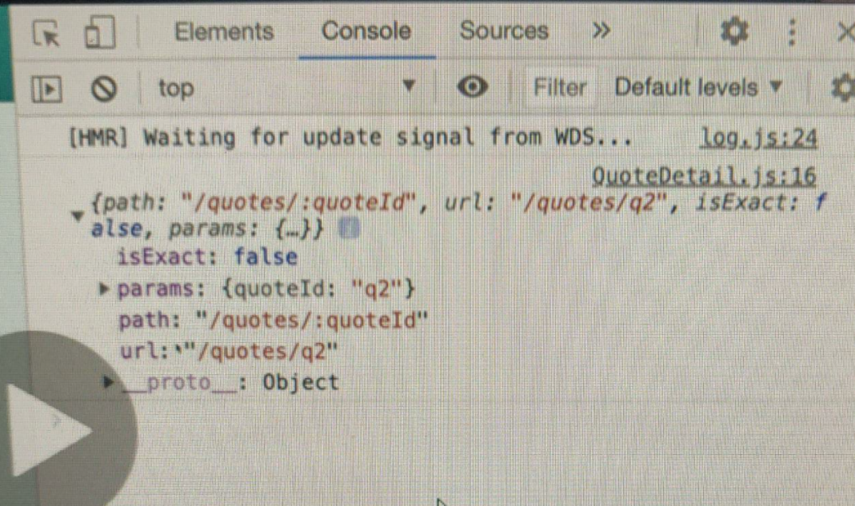

<Route path={`/quotes/${params.quoteId}/comments`}>

The above is changed to the following

<Route path={`${match.path}/comments`}>

Hence, we don’t have to manually create the string but rather extract it from the existing route definition.

Which means that if we now change our route routes from /quotes to /quote (**in App.js**), we don't have to adjust our nested routes, as we extract them dynamically.

**We used this hook and not the useLocation hook because this has path and url.**

**Making more readable urls**

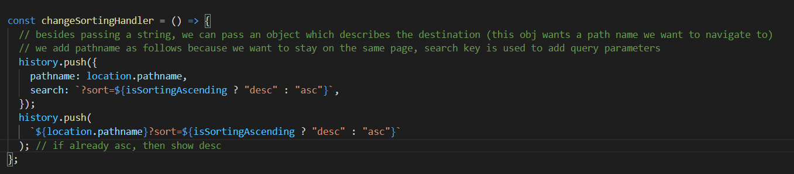

The second string approach can be switched with the first object approach to make it more readable.

**Deployment**

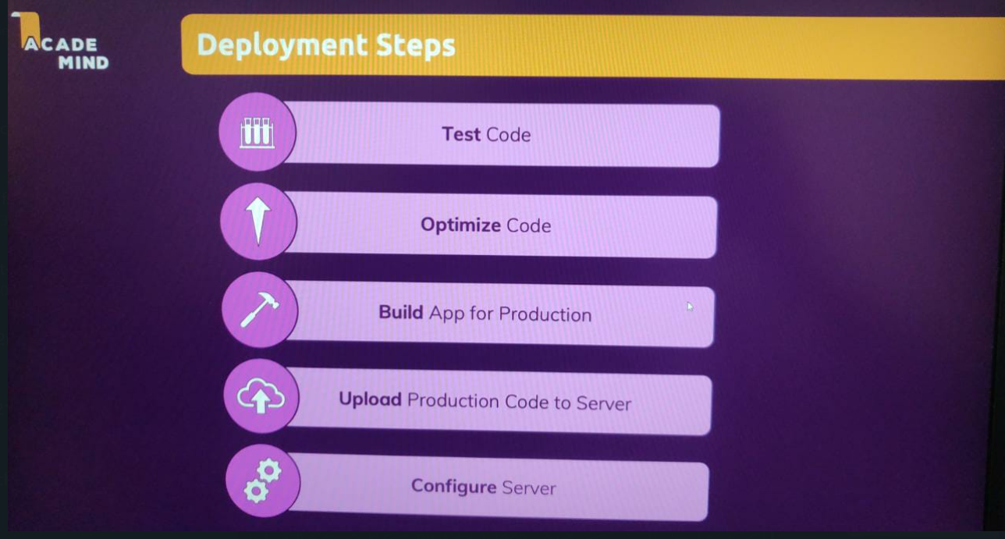

**Optimizing Code: Lazy Loading**

And therefore, we wanna ensure that this initial code bundle this initial first code bundle, which is downloaded is as small as possible and certain parts of our code of for example, the code that is related to adding a quote, is only downloaded if we actually visit this part of the page. Because if I enter low close, free thousand and I only see this starting screen, and I may be never even add a new quote, then there is no need to download all the code that is related to this add a quote feature. It will only make that initial download bigger unnecessarily because we don't need that code. And that's therefore what lazy loading is about. We want to split our code into multiple chunks, into multiple bundles, which are then each only downloaded when they are needed.

And lazy loading is easy to implement if you are using routing because you can then split your code by route. So that the code for a specific route is only downloaded when that route is visited.



Currently I need to download the code for this component even if it is being rendered on the screen or not. However, this will cause the site to load extreme amount of data and therefore we should only load the data for this component when we actually want to use it (when a user really visits the route for this NewQuote component).

So here we use the import statement like this, now we call import as a function. And to this function we pass the path of this import. So, pages new quote, what we previously had up here after from. Now, this function here which we pass to React lazy, will be executed by React, when this new quote component is needed. And that's the key difference. It will not be executed in advance to download the code in advance, but only when it's needed. And that will therefore create a separate code chunk which is only downloaded when this new quote page is visited. Now, I'm still using the new quote component down there, but this component is resolved and loaded dynamically, thanks to React lazy with this anonymous function past to it.

Storing the result of React.lazy in NewQuote and we are passing an anonymous function to React.lazy().



Now, whilst we're downloading this code, React is of course not able to continue, we can't load this component yet until the download completed. And that's why we need to define a fallback UI, some fallback content which can be shown if this download takes a bit longer. Hence, I import the Suspense component. We need to wrap this around the code, where we use React lazy. And then on this suspense component we need to set a fallback prop. Fallback once some JS X code as a value, which is shown as a fallback, for example a paragraph where we say loading,

Hence, we made the initial code bundle smaller (so initial loading of the page is faster).

**Building App for Production**

We can run a script which will take all our code, convert it to JavaScript code that the browser understands and code that is as small and bundled up as possible.

Now for production, we want to run the build command. This will also transform our code, but optimize and shrink it as much as possible. And it will not start a server.

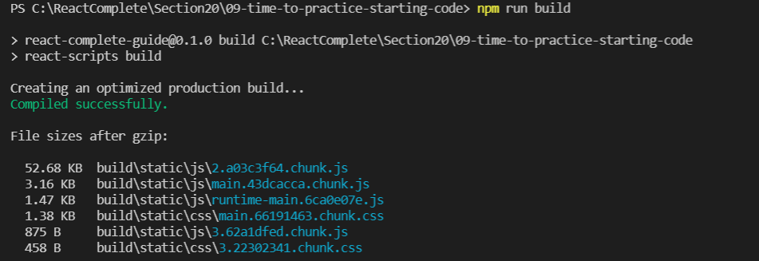

Hence, a new build folder is created which contains all the compressed code ready to be moved to a server.

**Upload Production Code to Server**

Our single page react application involves only browser/client side javascript code and no served side code, and is therefore a static web-app. Hence, we use a static site host/server.

**Configure Server (Video 295)**

You need to configure your servers such that the URL and the path in the URL is ignored on the server, and you always return your Single Page Application code no matter what the URL was. We don’t want to perform server side url things, instead we want our server to always return the same html file which runs the react app which on its own configures which component to render based on the url.

And that's now our React application hosted by a real server. So now, that's not locally on our machine. Instead, that's coming from a real server out there in the web, and anyone could visit this page.

**Section 22: Authentication**

We want to restrict pages on our website and also API endpoints to which we send requests from our react app to protect some authenticated content.

Two-step process:

1) Get access/permission: we provide our credentials which are sent and matched to the database and if it is valid, the server or backend to which the request was sent grants permission.

2) Second request to protected resource

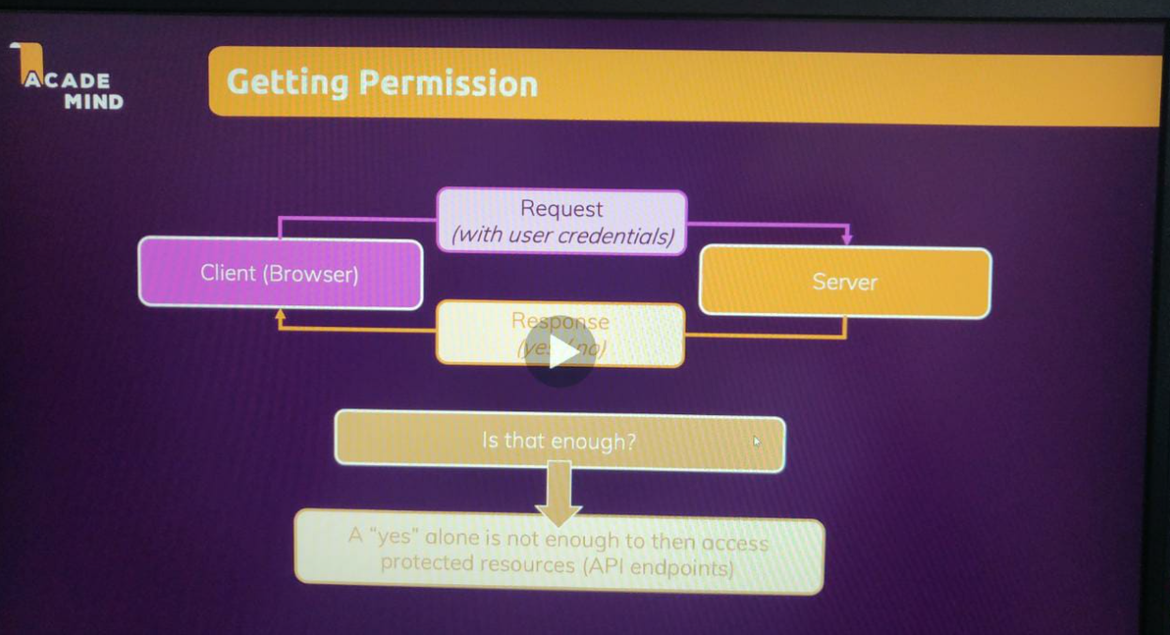

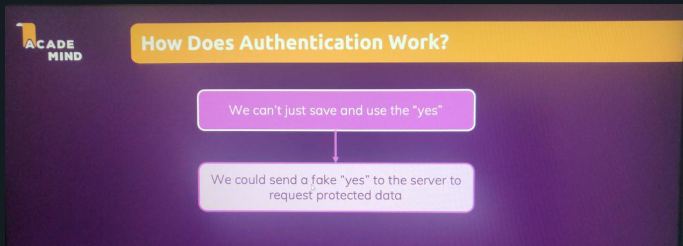

That part with sending and checking the credentials all needs to happen but the response sent back by the server to the client must be more than just a yes or no.

We can either work with server-side sessions or with authentication tokens.

**1) Server-Side Sessions:** With server-side sessions, once a server grants you access, that server stores a unique identifier for your client, so for this specific user who was just granted access. The server generates and stores some unique identifier for this specific client and therefore, every visitor of a website who authenticates gets his or her own identifier stored on the server. But this identifier is not just stored on the server, it's also sent back to the client. So the response of the server is not just this yes or no but instead, it does now also include this unique identifier. So the server and the client, both parties know this identifier. And then it's this identifier, which is attached to future requests to this server and since the server knows this identifier, this identifier can't be faked. If you come up with your own random identifier, the server won't know it and access will be denied for this subsequent request.

But this mechanism has one disadvantage. It works great if your backend, your server and your front end are tightly coupled but if you've got decoupled ends, if you've got your Single Page Application served by server A and you've got your backend application, your REST API served by server B, then there is no tight coupling. The backend API probably should work independent from the front-end Single Page Application and vice versa. Or if you are building an API that is there to be used by many websites, think about something like the Google Maps API, then, of course, this API also can't be tightly coupled and focused on one specific front end. Instead it needs to stay flexible. And that's why then you don't wanna store some identifier on the server. The server should be stateless, as it's called. The server should not store this kind of data about the connected clients. There is a decoupled backend and front-end situation. And you will very often have to deal with that when building Single Page Applications and that's therefore, the part I wanna focus on in this module because in this situation, you can use authentication tokens.

**2) Authentication Tokens:** The general idea still is that you send some credentials, email and password to a server and the server validates those credentials by comparing your email password combination to what's stored in the database. Then if that's valid, the server creates a permission token, which is basically just a very long string with some data encoded into that string. The server will basically use some algorithm to encode some data, like the email address of the user and a bunch of other pieces of data into one string, which can be decoded back into these individual pieces of data. It's really just a way of gluing different pieces of data together. Now, this token will be generated by the server with a specific algorithm and very important, with a key, which will be used for hashing that data into a string, which is only known by the server.

So there is a key involved, which is only known by the server, not by the client. Now, this token is not stored by the server but sent back to the client but only the server knows how to create that token because of that key which is involved. Now, therefore, the client can then use this token, so the React app is able to use that token to attach it to future requests to protected resources on the server. And even though the server hasn't stored this identifier, as it did in the session approach, the server is able to verify that this token was created by it because only the server knows this private key, which was involved in the token creation process and therefore, the incoming token, which is attached to the request for some protected resource can be validated by the server because the server is able to check if that token could have been created by it, by the server. And if the token was faked or created with a different key, then the server will detect this and will deny access. So this is then another secure way of identifying a client to the server. And this is an approach that allows for decoupling of front-end and backend.

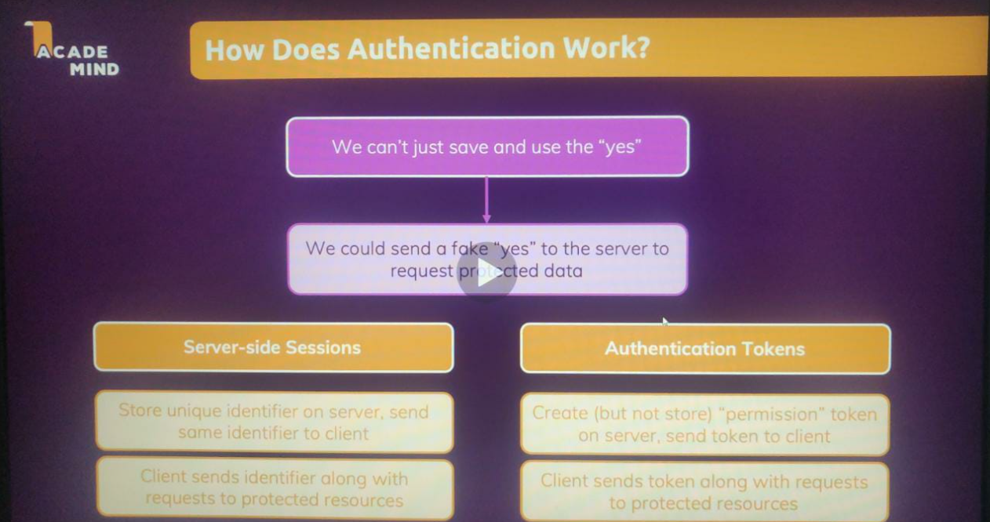

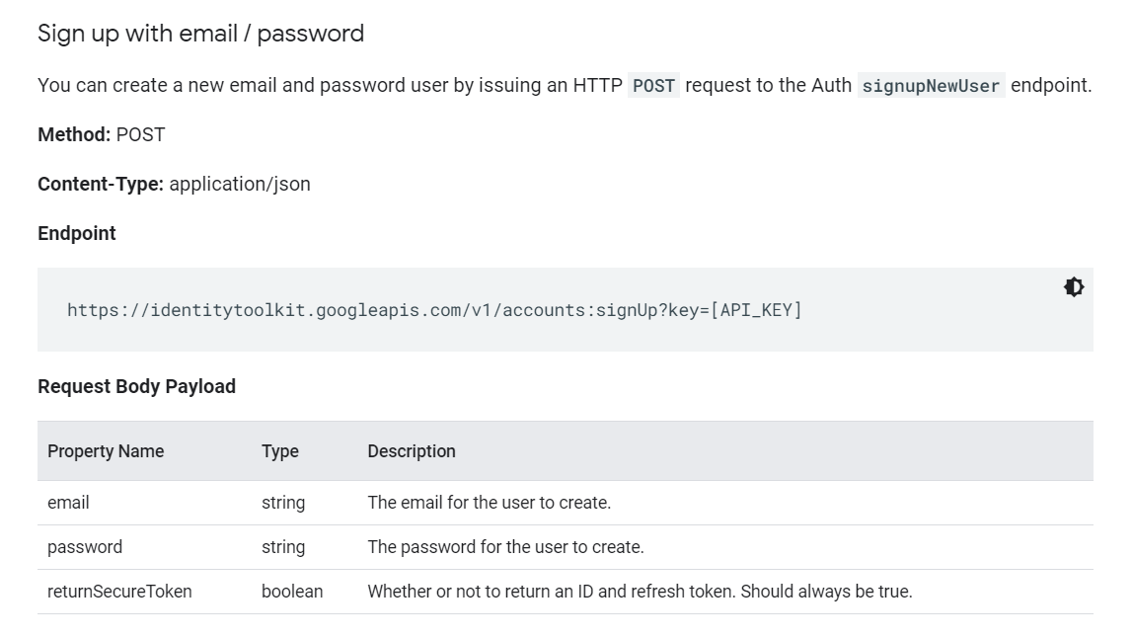

We send a **POST** request to the specified **URL** with the required **Data** to create a new user.

Now in this URL, we got one special thing, this API key thing here. That is a part of this URL, which you should replace with your project specific API key, your Firebase project specific API key. Because this is a generic API endpoint. In order for Firebase to know to which Firebase project this belongs, and for which Firebase project you wanna create a new user, you need to add your Firebase project API key here. And you get that key in the Firebase project console by clicking on this gear icon, Project Settings. And then here, it's this web API key, which you find here. This key, that's what you need to grab here.

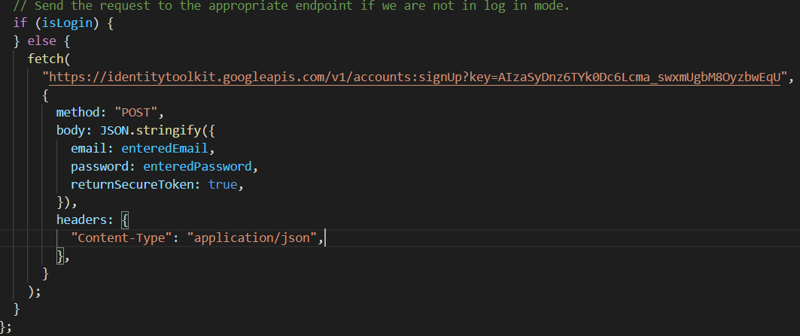

Passing data to **JSON.stringify** so that it is converted to JSON format.

Headers is added so that the API knows it has some JSON incoming data.

This just sends a request. Fetch returns a promise and we can use then to handle normal cases or catch to handle errors.

**res.json** also returns a promise so we need to use **then**.

Here I used promises with then and catch but we can also use async await.

Both signing up and signing in is kind of sending the same data and getting back the similar data from the backend. The only thing which changes is the url to which we are sending our request. Hence, we use a url variable to change the url based on the type of request.

The following token which we get after sending a login request should be managed as an app wide state because it is used to render header bar accordingly and so on. We can use the isLogin state to conditionally render something in the main navigation bar.

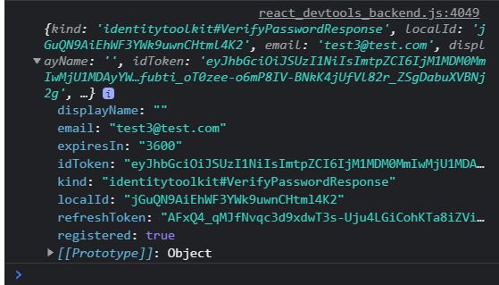

**Adding Navigation Guards**

Upto video 308, we can still access the change password webpage even after logging out just by typing in the url. However, to protect that page we use navigation guards.

It's just about dynamically changing our route configuration here based on whether we are logged in or not, because that is something that we can do. Keep in mind that we can only visit routes which are defined here in our App JS file in this app. Now, if I render these routes conditionally, only under certain conditions, then of course we can only visit a certain route if that condition is true. And that means that we could, of course, use the current authentication status of the user as a condition for certain routes. And we could choose to not render this user profile route configuration at all if the user is not authenticated. In which case there's no way for the user to visit this page if he or she is not authenticated.

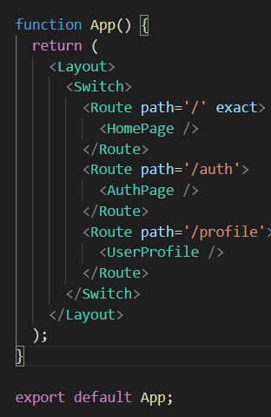

And now my goal is simple, if the user is not logged in, this route configuration for the user profile should simply not be rendered, it should not be part of this route configuration, or put in other words, this route configuration should only be added if the user is logged in. And therefore, we can render this conditionally because this is still just a component that's being rendered. It might sound weird that we conditionally change the route configuration, but since this is just a component, that is something we can do and that is a standard way of solving this problem.

Redirect is added so that if the user enters anything invalid or if the user enters /profile without being logged in then he is redirected.

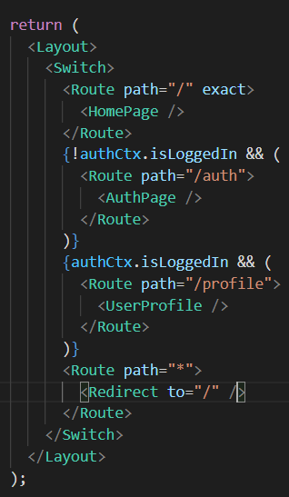

**Before Video 309**

Currently, whenever we refresh the page, we restart our react app and hence we lose all our states in the context.

But at least for this one hour it would be nice if we would stay logged in, so that if I reload the page, we still are logged in. And that means that we need to store the token somewhere outside of our React state. Because when we store it in JavaScript in a variable or anything like that, this will be cleared when the page reloads, because that's only stored in memory. We need to store it somewhere else. And thankfully browsers do have storage mechanisms which we could use, for example, cookies. But an even easier to use storage mechanism is local storage.

So therefore here we will use this local storage mechanism which is a storage built into the browser which allows us to store simple data that will then survive page reloads.

And what we wanna do is rather simple. When we log in, we wanna store that token not just in our state here, we definitely do wanna do that, but not just but also in that browser storage. And when we log out, we wanna clear it there. But in addition, when this page loads, we wanna look into the storage and if a token is found there, we wanna use that token without forcing the user to send a new request first.

**localStorage.setItem() is a built in browser api.**

// to manage context for the Authentication data

import React, { useState } from "react";

const AuthContext = React.createContext({

  token: "",

  isLoggedIn: false,

  login: (token) => {},

  logout: () => {},

});

// AuthContextProvider component responsible for managing the Auth related states

// So that we can use this component overall as a wrapper around other components that then will have access to this context.

// And it's in this AuthContext provider component where I wanna manage the state for that auth data. For this we can import use state from react.

// And then here we can have our state for the token.

export const AuthContextProvider = (props) => {

  const initialToken = localStorage.getItem("token");

  const [token, setToken] = useState(initialToken); // instead of setting token like below, I check if a value for it is already present in store

  //   const [token, setToken] = useState(null);

  const userIsLoggedIn = !!token; // if token is a non-empty string, this returns true

  const loginHandler = (token) => {

    setToken(token);

    localStorage.setItem("token", token); // if the user logged in we store that data (key-value pair)

  };

  const logoutHandler = () => {

    setToken(null);

    localStorage.removeItem("token"); // clears token key in local storage

  };

  const contextValue = {

    token: token,

    isLoggedIn: userIsLoggedIn, // isLoggedIn field which tells whether the user is logged in or not

    login: loginHandler,

    logout: logoutHandler, // when we call logout using authCtx.logout, we call this logoutHandler function

  };

  return (

    <AuthContext.Provider value={contextValue}>

      {props.children}

    </AuthContext.Provider>

  );

};

export default AuthContext;

However, we are not able to automatically logout the user after 1hr. Hence, we do the following changes.

**Video 310: Auto Logout**

// to manage context for the Authentication data

import React, { useState } from "react";

const AuthContext = React.createContext({

  token: "",

  isLoggedIn: false,

  login: (token) => {},

  logout: () => {},

});

const calculateRemainingTime = (expirationTime) => {

  const currentTime = new Date().getTime();

  const adjExpirationTime = new Date(expirationTime).getTime();

  const remainingDuration = adjExpirationTime - currentTime;

  return remainingDuration;

};

// AuthContextProvider component responsible for managing the Auth related states

// So that we can use this component overall as a wrapper around other components that then will have access to this context.

// And it's in this AuthContext provider component where I wanna manage the state for that auth data. For this we can import use state from react.

// And then here we can have our state for the token.

export const AuthContextProvider = (props) => {

  const initialToken = localStorage.getItem("token");

  const [token, setToken] = useState(initialToken); // instead of setting token like below, I check if a value for it is already present in store

  //   const [token, setToken] = useState(null);

  const userIsLoggedIn = !!token; // if token is a non-empty string, this returns true

  const logoutHandler = () => {

    setToken(null);

    localStorage.removeItem("token"); // clears token key in local storage

  };

  const loginHandler = (token, expirationTime) => {

    setToken(token);

    localStorage.setItem("token", token); // if the user logged in we store that data (key-value pair)

    const remainingTime = calculateRemainingTime(expirationTime);

    // when this timer fires we log the user out

    setTimeout(logoutHandler, remainingTime); // calling logout handler as a callback which is executed when the remainingTime gets over

  };

  const contextValue = {

    token: token,

    isLoggedIn: userIsLoggedIn, // isLoggedIn field which tells whether the user is logged in or not

    login: loginHandler,

    logout: logoutHandler, // when we call logout using authCtx.logout, we call this logoutHandler function

  };

  return (

    <AuthContext.Provider value={contextValue}>

      {props.children}

    </AuthContext.Provider>

  );

};

export default AuthContext;

Also in **AuthForm.js** I now have to provide this additional **expirationTime**.

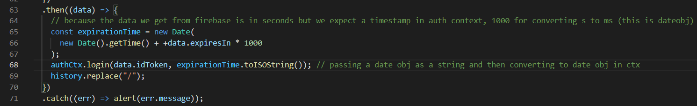

**Video 311**

All combined code of storing and clearing this timeout in the localstorage is in the file auth-context. **Uptill here the code in in auth-context1.**

**React Revision**

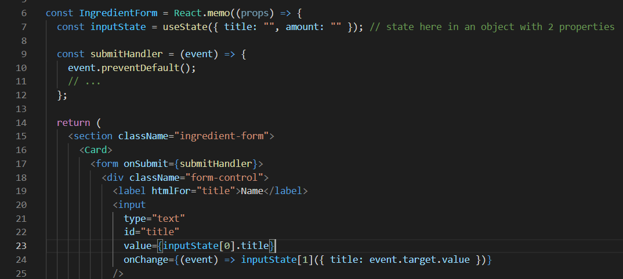

If we do as in line 24, we get error messages. This is because the updating function updates the state by replacing the current state. Hence, whenever we type in the first field, our second property is dropped.

That's different, this updating function. The second element of our array does update the state, but it does so by replacing the current state with this, which in this case means if we type into the title, our new state simply is an object which only has a title property and we drop the amount property. Our new state is an object that simply doesn't have an amount property anymore.

To solve it, to prevent from losing any data and properties we have to define the amount aswell with its latest value.

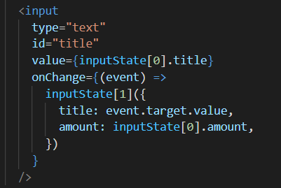

However, this is not 100% correct as the latest amount property which we are setting might not be the latest due to the way react schedules updates. Hence, instead of passing a value to our update function (second element of useState array), we pass a function wherein we get an argument passed automatically to it by react, and that’s the prevstate. It tells react that we want to get the latest state snapshot. And the difference to using input state zero is that we're now not using the latest state, which has been fully committed and which is used in this render cycle of this component, but that we're using the latest state we set with an updating function, no matter if react already recreated the function or not based on that last update. So now here we have to guarantee that we get the latest state at all times.

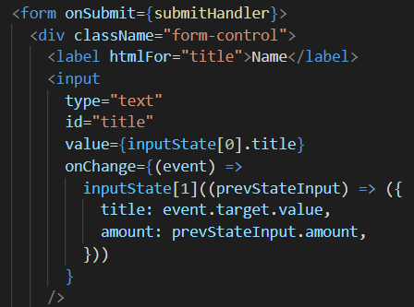

Again the above is not 100% correct. The correct code is as follows (**video 422 8mins**).

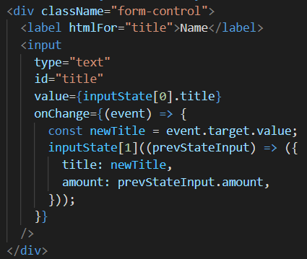

Instead of using a single state which is an object, we can use multiple states so that we don’t have to save the old state when we update something new. In classBased components, state had to be an object and react merged it for us automatically however, in functional components state doesn’t have to be an object and react doesn’t merge it for us. Hence, we register multiple states. So now I don’t have to merge as they are kept independently and if I update any one, the other one survives (states survives re-render cycles / updates of other states).

**SideNote: JSON.stringify() // JSON is a class and stringify is a method which takes in a JS object or array and converts it to valid JSON format. Header is added to tell that we have incoming json data. Fetch returns a promise after this request succeeds.**

**Response.JSON is written to convert the response object from JSON to javascript format. (it returns a promise hence we use return and then write a then again so that we can wait for the body to be parsed)**

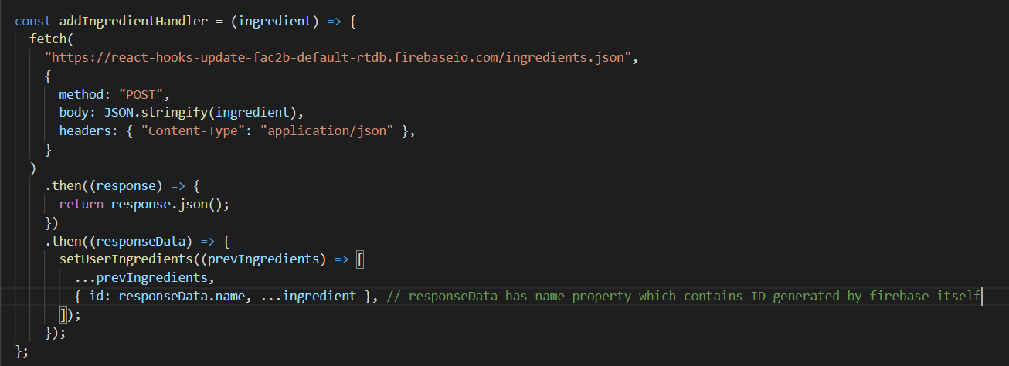

**Instead of using Math.random().toString(), I used the ID generated by firebase itself.**

**We use useState for sending http request and fetching data because if we don’t use it, then after we fetch the request, we update the state then the component re-renders and we again send an http request and this continues.**

**Batch Updates**

**Video 435 last 2 mins.**

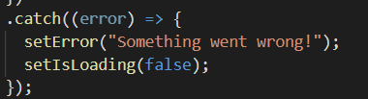

Since this is synchronous, these 2 state updates are batched together and only 1 re-render is performed where both the states are updated rather than having 2 re-renders.